- 数据处理过程中使用的程序
Programs used in data processing: Adobe Photoshop CS6; Origin8; jade6; Microsoft Excel; Microsoft PowerPoint
- 主创作者简介及照片
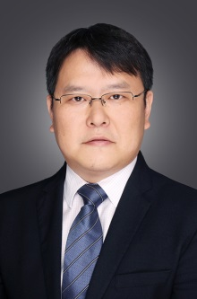
顾冬冬，南京航空航天大学材料科学与技术学院教授、博士生导师，国家“万人计划”科技创新领军人才，国家“万人计划”青年拔尖人才，教育部“长江学者奖励计划”青年学者，国家优秀青年科学基金获得者，德国亚琛工业大学Fraunhofer激光技术研究所洪堡学者。研究领域是高性能难加工金属构件激光精密增材制造及3D打印。担任美国激光学会会刊Journal of Laser Applications副主编，担任International Journal of Machine Tools and Manufacture、Applied Surface Science、International Journal of Precision Engineering and Manufacturing、Additive Manufacturing、Chinese Journal of Mechanical Engineering等5本SCI国际期刊编委，担任中国机械工程学会增材制造技术分会常务委员、中国机械工程学会特种加工分会增材制造(3D打印)技术委员会副主任。主持国家重点研发计划“增材制造与激光制造”专项、国家自然科学基金重点项目、NSFC-DFG中德合作研究项目等20余项。发表SCI收录论文130余篇，SCI他引2600余次，由德国Springer出版英文专著1部。应邀在本领域重要国际学术会议上作主旨/特邀报告28次。申请/授权国家发明专利16项。获2018年德国亚历山大.冯.洪堡基金会Fraunhofer-Bessel Research Award（设奖以来首位中国大陆获奖学者）、2018年德国科学基金会（DFG）Mercator Fellow 奖、英国物理学会“2018 高被引中国作者奖”、2012年德国联邦教育和科研部Green Talents（绿色精英）奖，2017年中国航空学会青年科技奖，2015年高等学校科学研究优秀成果奖（自然科学奖）二等奖、2018年江苏省科学技术奖一等奖（第一完成人）。
Dongdong Gu, is currently a professor and a PhD candidate supervisor at College of Materials Science and Technology, Nanjing University of Aeronautics and Astronautics, China. National "Ten Thousand Plan" science and technology innovation talent, National "Ten thousand plan" for young scholars of talent, The ministry of education " Changjiang Scholars Programme of China " young scholars, National Science Foundation for Distinguished Young Scholars winner, Humboldt scholar at the Fraunhofer institute for laser technology at RWTH aachen university in Germany. His research interests include laser additive manufacturing of high-performance/multi-function metallic components. He is an associate editor of the Journal of Laser Applications, the Journal of the American Laser society. At the same time, he served as the editorial board of five SCI international journals, including International Journal of machine tools and manufacturing, applied surface science, International Journal of precision engineering and manufacturing, additional manufacturing, Chinese Journal of Mechanical Engineering. In addition, he served as the standing committee member of additive manufacturing technology branch of Chinese mechanical engineering society and deputy director of additive manufacturing (3D printing) technology committee of special processing branch of Chinese mechanical engineering society. He has presided over more than 20 national key research and development programs, including "additive manufacturing and laser manufacturing", key projects of the national natural science foundation of China, and China-Germany cooperative research projects of NSFC-DFG. He has published more than 130 SCI papers and 2,600 SCI citations. One English monograph was published by Springer, 28 keynote/guest presentations at major international conferences in this field, 16 national invention patents have been applied/authorized. He was awarded the Fraunhofer Bessel Research Award of Germany in 2018 (the first mainland China award-winning scholar since the establishment of the award), the Mercator Fellow Award of Germany Science Foundation (DFG) in 2018, the "2018 highly cited Chinese author Award" of British physical society, and the green award of German Federal Ministry of education and research in 2012 Talents (green elites) award, 2017 young science and technology award of CAAC, 2015 second prize of excellent scientific research achievement award of institutions of higher learning (Natural Science Award), 2018 first prize of science and technology award of Jiangsu Province (first adult).

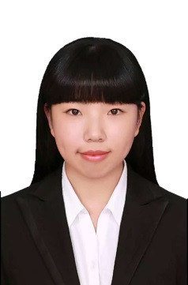
栗钰鑫，1996年生，现为南京航空航天大学材料科学与技术学院硕士研究生，导师顾冬冬教授，主要研究方向为铝合金及其复合材料的选区激光熔化成形。
Yuxin Li, born in 1996, is currently a master candidate at College of Materials Science and Technology, Nanjing University of Aeronautics and Astronautics, China. Her major research is selective laser melting of aluminum alloys and their composites.

- 课题研究过程中遇到的问题及解决办法
- 增强相颗粒团聚问题。加入的增强相颗粒相较基体合金粒径较小，具有较大的比表面积，在激光加工过程中易发生团聚，从而降低 SLM 成形件的力学性能。为有效分散增强相颗粒的分布，我们采用合适的球磨工艺进行混粉，并探索最佳的激光加工工艺参数，最终实现增强相颗粒在基体中的均匀分散。
- 致密化难。铝合金极易氧化，在 SLM 成形TiB₂/AlSi10Mg过程中，熔池边界易形成氧化膜，导致球化现象产生，继而在后续的打印过程中形成缺陷，致密化难度增加。因此，我们将球磨后粉末严格密封，并将其在SLM成形前进行干燥，成形过程中通入高纯氩保护器，严格把控成形腔内的氧含量。同时，我们进行一系列激光工艺参数探索，寻求最适宜成形此种复合材料的加工参数。
- 理论支撑不足。对于部分实验结果因其切实相关的理论知识缺乏，难以有效解释其机理，从而我们查阅国内外大量文献，包含多种加工工艺下相关论文，寻找理论支撑有效探明实验结果机理。
- Agglomeration of enhanced phase particles. Compared with the matrix alloy, the added enhanced phase particles have smaller size and larger specific surface area, which are prone to agglomeration during laser processing, thus reducing the mechanical properties of SLM formed parts. In order to effectively disperse the distribution of the reinforcing phase particles, we adopted a suitable ball-milling process to mix the powder, and explored the optimum laser processing parameters, finally realizing the uniform dispersion of the reinforcing phase particles in the matrix.
- Difficulty in densification. Aluminum alloy is easy to be oxidized. During the process of forming TiB₂/AlSi10Mg by SLM, the edge of the molten pool is easy to form an oxide film, which leads to the occurrence of balling, and then defects are formed in the subsequent printing process, which increases the difficulty of densification. Therefore, the powder after ball grinding was strictly sealed and dried before SLM forming. During the forming process, a high purity argon protector was introduced to strictly control the oxygen content in the forming chamber. At the same time, a series of laser process parameters were explored to find the most suitable processing parameters for the composite.
- Insufficient theoretical support. As for some experimental results, it is difficult to explain their mechanism effectively due to the lack of relevant theoretical knowledge. Therefore, we have consulted a large number of literatures at home and abroad to search for theoretical support and effective exploration of experimental result mechanism, including relevant papers under a variety of processing technologies.

- 实验室或者课题组特色（技术、实验设备等）
江苏省高性能金属构件激光增材制造工程实验室于2017年获江苏省发展和改革委员会批准建设（苏发改高技发[2017]975号）。实验室顺应《国家中长期科学和技术发展规划纲要（2006-2020年）》《中国制造2025》《江苏省“十三五”战略性新兴产业发展规划》等国家及省级系列发展战略规划，围绕增材制造与智能制造产业发展中的高端精密装备核心部件研发、专用普适性耗材研制与标准、高性能关键金属构件一体化制造等内容，建设面向高性能复杂金属构件的激光增材制造及3D打印技术“产学研”成果研发与转化平台，开展激光增材制造粉末设计制备、装备研发、软件集成、工艺和性能调控等方面的研究，突破增材制造专用粉末材料制备、设计软件过程参数及加工信息集成、高端装备核心元器件研发、高性能金属构件直接激光制造等关键技术，提升科技和产业创新能力、促进区域经济可持续发展。
实验室致力于高性能金属构件激光增材制造领域的关键工程化技术研究与应用，在金属激光增材制造核心部件与装备集成制造、增材制造专用金属粉末规模化量产、高性能金属构件激光增材制造工艺集成与优化、高性能金属构件的材料-结构-性能一体化制造等领域积极开展产学研前瞻性创新研究和工程技术成果转化，形成了具有鲜明特色的研发方向。
■金属激光增材制造核心部件与装备集成制造
针对选区激光熔化SLM增材制造技术，实验室研发了大型（400mm）、中型（280mm）及小型（150mm）金属精密增材制造成套装备，设备构建了基板温控系统、成形平台精确定位系统、保护气氛控制及尾气快速净化系统、高效双向铺粉系统、激光束动态聚焦系统、激光增材制造工艺诊断与智能处理系统等多项自主核心技术；针对激光熔化沉积LMD增材制造技术，实验室研制了新型大跨度高精度激光/机械手联合运动控制的LMD增材制造装备，可实现大型复杂构件、深内腔内壁结构的增材制造及修复再制造。实验室研制的增材制造装备连续运行平稳性高，对金属、合金、陶瓷及金属基复合材料等粉末适用性广，已达到目前国际主流增材制造装备的性能水平。
■高性能激光增材制造专用金属粉末的规模化量产
实验室面向航空航天、高端制造等领域重大需求，系统建立了面向激光增材制造的专用钛合金、铝合金、高强钢、镍基高温合金及陶瓷增强金属基复合材料粉末的设计、制备和表征方法，开发了激光增材制造专用微细、球形、高流动性合金及金属基复合材料粉末，形成了具有自主知识产权的激增材制造原材料产品及其制备表征技术，并实现了增材制造专用粉末的专业化、系列化和产业化，可替代国外进口产品，打破国际专利和技术垄断。通过激光增材制造工艺优化及工艺数据库积累，实现了专用金属粉末与不同类型激光增材制造3D打印装备兼容，实现了专用粉末材料及其增材制造工艺的通用化和普适性。
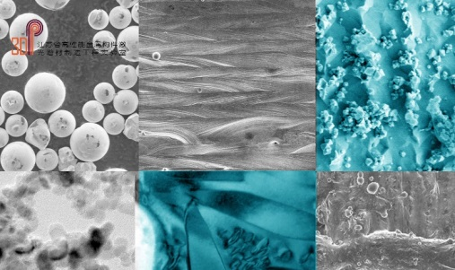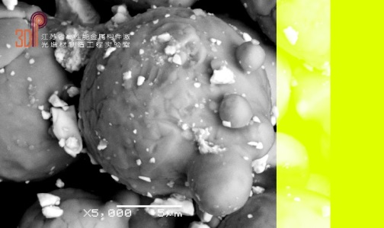
■面向典型工程应用的高性能金属构件激光增材制造工艺优化关键技术
先进航空发动机复杂承力构件激光增材制造冶金热力学/动力学及变形控制技术。研究非平衡激光快速凝固条件下航空发动机合金材料激光增材制造的温度场、速度场及溶质场，提出材料内部显微组织及冶金缺陷形成机理及调控方法；定量描述热应力、组织应力及凝固收缩应力非稳态耦合行为，基于热—力耦合作用机理建立激光增材制造构件内部残余应力多尺度预测模型，提出残余应力演化规律及增材制造零件变形开裂的控制方法、科学机理及其关键技术。
先进航空发动机复杂承力构件选区激光熔化SLM控形控性制造及应用验证。实验室以激光增材制造专用微细、球形、高流动性金属、合金及金属基复合材料粉末设计制备为物质基础，以选区激光熔化SLM、激光熔化沉积LMD先进激光增材制造装备为保障，以激光非平衡熔池冶金热力学和动力学行为、激光成形件内应力演化规律多尺度预测及模拟仿真为基础，结合激光增材制造工艺—显微组织—静力学性能—疲劳性能的一体化评价，实现了航空航天等领域高性能复杂金属构件的低成本、短周期、净成形制造。针对航空航天等领域典型应用对象，面向行业需求，结合应用背景，有针对性地开展了工程实践及应用验证，有力推动了金属零件激光增材制造及3D打印技术的发展和推广。
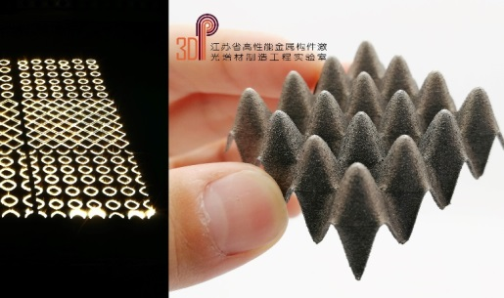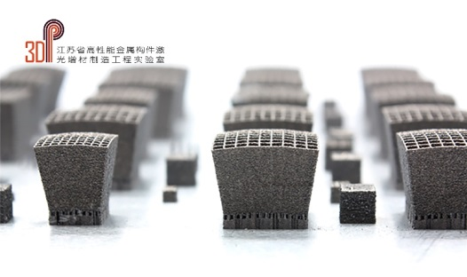

Jiangsu Provincial Engineering Laboratory for laser additive manufacturing of High-performance Metallic Components was approved by Jiangsu province development and reform commission in 2017 (su high technology development [2017] no. 975). Laboratory complies with “National Medium and Long-term Plan for Science and Technology Development (2006-2020) ", "2025" made in China "" The Development Plan of Strategic Emerging Industries in Jiangsu Province during the 13th Five-Year Plan "and other national and provincial series development strategy planning. Around to additive manufacturing and intelligent manufacturing industry in the development of high precision equipment research and development of core parts, general supplies development and standard, key content such as metal component integration, the laboratory aims to fabricate a platform of high performance construction for high-performance complex laser additive manufacturing of metal components and 3D printing results of research. It carries out studies of powders for laser additive manufacturing, equipment research and development, software integration, design process and the regulation of performance. The laboratory works on breakthrough of preparation of powder materials for additive manufacturing and design of the software process parameters and process information integration, high-end equipment research and development of the core components, high-performance metal components such as key technology of laser direct manufacturing. In addition, the laboratory committed to promote science and technology and industry innovation ability, and promote the sustainable development of regional economy.
The laboratory is committed to the research and application of key engineering technologies in laser additive manufacturing of high performance metal components, metal laser in material manufacturing core parts and equipment integrated manufacturing. In the field of metal laser additive manufacturing core components and equipment integrated manufacturing, additive manufacturing special metal powder mass production, integration and optimization of laser additive manufacturing process for high performance metal components and the integration of high performance material - structure - performance of metal components manufacturing production, the laboratory actively carries out forward-looking innovation research and transformation of engineering technology achievements, forming a distinctive feature of research and development direction.
■Metal laser additive manufacturing core components and equipment integrated manufacturing
Aiming at selective laser melting additive manufacturing technology, the laboratory has developed large (400mm), medium (280mm) and small (150mm) metal precision additive manufacturing equipment. The equipment has built a number of independent core technologies, such as substrate temperature control system, precise positioning system of forming platform, protective atmosphere control and exhaust gas rapid purification system, efficient two-way powder laying system, laser beam dynamic focusing system, laser additive manufacturing process diagnosis and intelligent processing system. Aiming at LMD additive manufacturing technology of laser melting deposition, the laboratory has developed a new LMD additive manufacturing equipment with long span and high precision laser/manipulator combined motion control, which can realize additive manufacturing and remanufacturing of large complex components and deep inner wall structures. The additive manufacturing equipment developed in the laboratory has high stability in continuous operation and wide applicability to powders such as metals, alloys, ceramics and metal-based composites, etc., and has reached the performance level of the current international mainstream additive manufacturing equipment.
■High performance laser additive manufacturing special metal powder mass production
The laboratory has systematically established the design, preparation and characterization methods of special titanium alloy, aluminum alloy, high-strength steel, nickel-based superalloy and ceramic-reinforced metal matrix composite powder for laser additive manufacturing. It developed laser material manufacture special micro, spherical, liquid alloy and metal matrix composite powder, formed with independent intellectual property rights in materials manufacturing and characterization technique of preparation raw material products, and implements the increase of material manufacturing the specialization, standardization and industrialization of special powder, which can replace imported products, break the international patent and technical monopoly. The laboratory has developed the powder of laser additive manufacturing special micro, spherical, high fluidity alloy and metal matrix composite material, forming the laser additive manufacturing raw material product with independent intellectual property rights and its preparation characterization technology. Moreover, it has realized the specialization, serialization and industrialization of additive manufacturing powder, which can replace foreign imported products and break the international patent and technology monopoly. Through the optimization of laser additive manufacturing process and the accumulation of process database, the compatibility between special metal powder and different types of laser additive manufacturing 3D printing equipment is realized, and the universality of special powder material and additive manufacturing process are also realized.

■The key technology to optimize the laser additive manufacturing process of high performance metal components for typical engineering applications
Thermodynamics/kinetics and deformation control technology of laser additive manufacturing for advanced aero-engine complex bearing components. The temperature field, velocity field and solute field in the laser additive manufacturing of aero engine alloy material under the condition of non-equilibrium laser rapid solidification were studied; the unsteady coupling behavior of thermal stress, microstructure stress and solidification shrinkage stress is quantitatively described. Based on the mechanism of thermal-force coupling, the multi-scale prediction model of residual stress in laser additive manufacturing components is established, and the evolution law of residual stress and the control method, scientific mechanism and key technology of deformation and cracking of additive manufacturing components are put forward.
Manufacturing and application verification of shape and performance control for complex bearing components of advanced aero-engine manufactured by selective laser melting. Based on the powder design and preparation of fine, spherical, highly mobile metal, alloy and metal matrix composite materials for laser additive manufacturing, and SLM and LMD equipment, supported by non-equilibrium molten pool in laser metallurgical thermodynamics and dynamics behavior, internal stress evolution rule of laser forming the basis of the multi-scale prediction and simulation, combining with the laser gain material manufacturing process, microstructure, static performance, fatigue performance of the integrated evaluation, the laboratory has realized low cost, short cycle and net forming of high performance complex metal components in aerospace field. Aiming at typical application objects in aerospace and other fields, engineering practice and application verification are carried out in accordance with industry requirements and application background, which strongly promotes the development and promotion of laser additive manufacturing for metal parts and 3D printing technology.

