Supplementary material
(This file shows the details of the sampling activity)

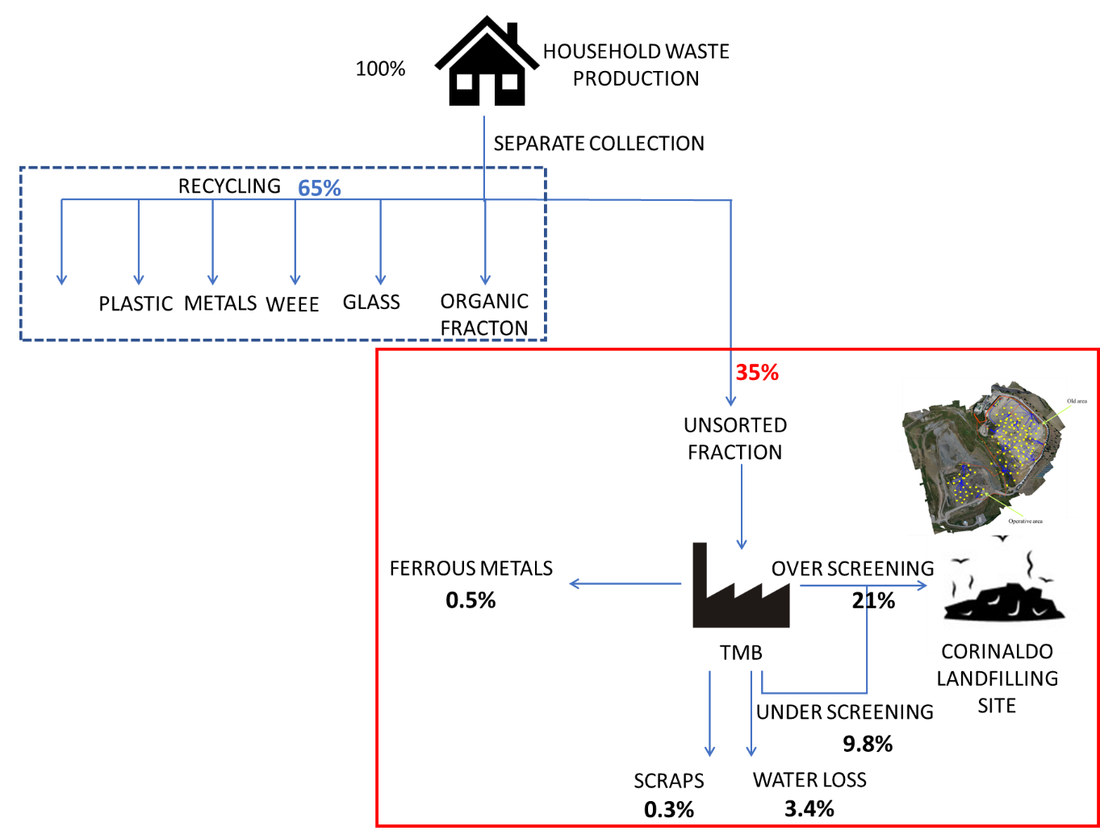
Figure S1. Schema of waste management system under study
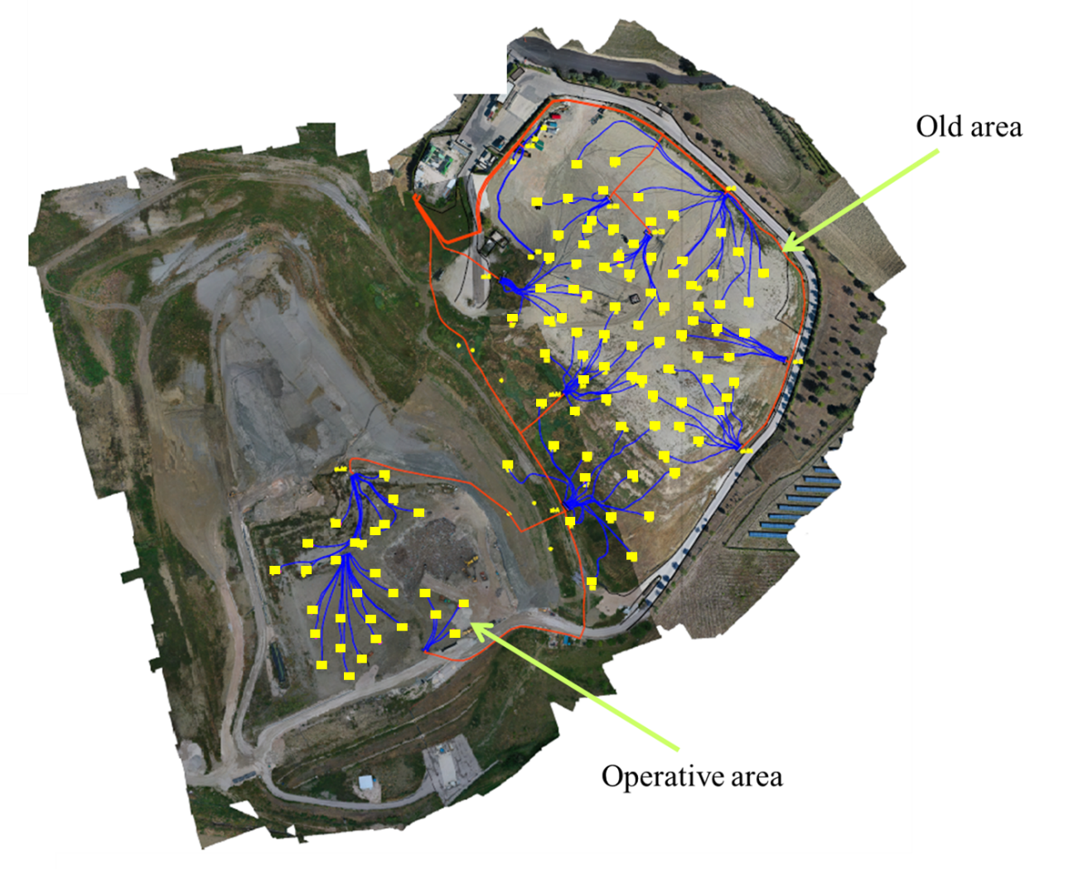
Figure S2. Planimetry of sampling wells at the landfilling site. The points represent the sampling wells and the lines are the supply biogas lines

Table S1. Detail of biogas emission sampling.
Month | Total extracted biogas (cumulative of the considered months)  (m³) | Monthly extracted biogas  (m³) | Disposed waste  (tons) | Age of the site (months) | Index 1  (m³ tons⁻¹) | Index 2  (m³/months)*10³
Operative area
J-19 | 74,400 | 74,400 | 131,494 | 22 | 0.57 | 3.38
F-19 | 141,601 | 67,200 | 137,048 | 23 | 1.03 | 2.92
M-19 | 216,001 | 74,400 | 143,199 | 24 | 1.51 | 3.10
AP-19 | 288,000 | 71,999 | 149,299 | 25 | 1.93 | 2.88
M-19 | 362,400 | 74,400 | 156,513 | 26 | 2.32 | 2.86
JN-19 | 434,400 | 72,000 | 163,101 | 27 | 2.66 | 2.67
JL-19 | 634,121 | 199,721 | 169,842 | 28 | 3.73 | 7.13
AU-19 | 786,641 | 152,519 | 176,358 | 29 | 4.46 | 5.26
S-19 | 917,471 | 130,831 | 181,638 | 30 | 5.05 | 4.36
O-19 | 1,057,342 | 139,871 | 187,850 | 31 | 5.63 | 4.51
N-19 | 1,183,342 | 125,999 | 193,641 | 32 | 6.11 | 3.94
D-19 | 1,321,324 | 137,982 | 199,643 | 33 | 6.62 | 4.18
J-20 | 1,471,753 | 150,429 | 205,292 | 34 | 7.17 | 4.42
F-20 | 1,624,129 | 152,375 | 210,360 | 35 | 7.72 | 4.35
M-20 | 1,805,412 | 181,283 | 216,301 | 36 | 8.35 | 5.04
AP-20 | 1,998,652 | 193,241 | 222,466 | 37 | 8.98 | 5.22
Old site
J-05 | 247,705 | 247,705 | 304,220 | 61 | 0.81 | 4.06
F-05 | 496,379 | 248,674 | 307,135 | 62 | 1.62 | 4.01
M-05 | 769,070 | 272,691 | 310,718 | 63 | 2.47 | 4.33
AP-05 | 1,066,526 | 297,456 | 314,450 | 64 | 3.39 | 4.65
M-05 | 1,382,616 | 316,090 | 318,654 | 65 | 4.34 | 4.86
JN-05 | 1,690,462 | 307,846 | 323,025 | 66 | 5.23 | 4.66
JL-05 | 2,008,925 | 318,463 | 327,740 | 67 | 6.13 | 4.75
AU-05 | 2,314,059 | 305,134 | 332,578 | 68 | 6.96 | 4.49
S-05 | 2,609,735 | 295,676 | 336,561 | 69 | 7.75 | 4.29
O-05 | 2,926,030 | 316,295 | 340,743 | 70 | 8.59 | 4.52
N-05 | 3,239,584 | 313,554 | 344,167 | 71 | 9.41 | 4.42
D-05 | 3,562,624 | 323,040 | 347,096 | 72 | 10.26 | 4.49
J-06 | 3,861,527 | 298,903 | 349,788 | 73 | 11.04 | 4.09

Table S2. Leachate characterization. The average values were assessed considering the 3-year periods 2004-2006 for the old site and 2017-2019 for the new site.
Average values measured at landfilling sites
 | pH | TOC | COD | BOD | BOD/COD | N-NH₄ | Cl⁻
Old landfilling area  Jan/04-Jan/06 | 8.2 | 1350 | 3950 | 764 | 0.18 | 1917 | 2396
New landfilling area  Mar/17-Dec/19 | 8.2 | 1905 | 3417 | 983 | 0.27 | 495 | 1788
Reference ranges (Ehrig 1989)
Acid phase | 4.5-7.5 | 1,500-25,000 | 6,000-60,000 | 4,000-40,000 | 0.7 | 30-3,000 | 100-5,000
Methanogenic phase | 7.5-9 | 200-5000 | 500-4500 | 20-550 | 0.04-0.12 | 30-3,000 | 100-5,000

