Electronic Supporting Information

Modelling of adsorption technologies for controlling indoor air quality

Carlos A. Grande 1,2

1. King Abdullah University of Science and Technology, Division of Physical Sciences and Engineering, Advanced Membranes & Porous Materials Center, Thuwal, 23955-6900, Kingdom of Saudi Arabia.
2. SINTEF AS. Forskningsveien 1, 0373, Oslo, Norway.

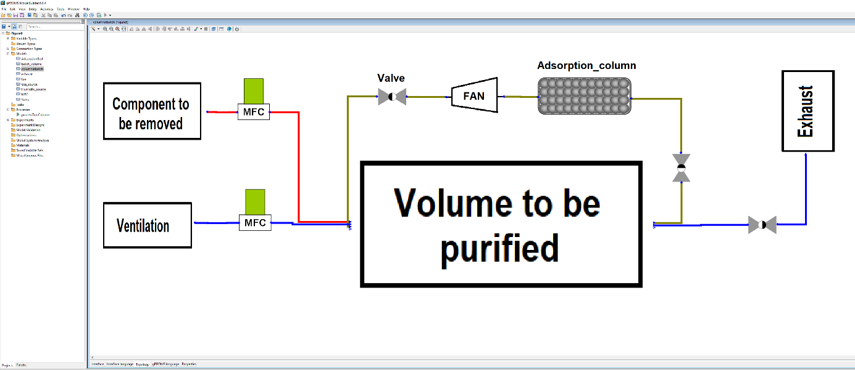

**Figure S1. Topology of the process for water removal implemented in gPROMS ModelBuilder 6.04. Each of the components has a dedicated model. MFC denotes the mass flow controller used to fix the inlet flowrate for the different simulations.**

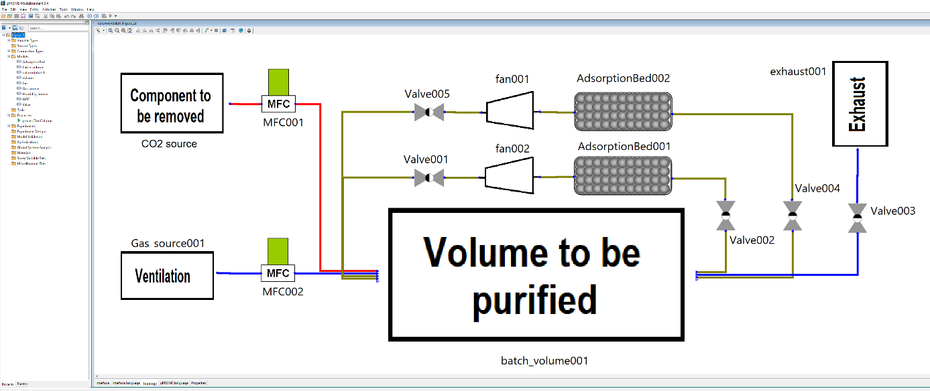

**Figure S2. Topology of the process for CO2 removal implemented in gPROMS ModelBuilder 6.0.4. The names of each of the subcomponents (as appear in the topology definition) are shown.**

Adsorption equilibrium data from literature on commercial adsorbents was used. The CO2 removal was done with zeolite 13X (Cavenati et al., 2004). The isotherm used was the multi-site Langmuir model and the parameters used are listed in Table 6 of the referenced publication. A plot of the isotherms of CO2 at different temperatures is given in Figure S3 and the isotherm of N2 at 298 K is used for comparison to show the high selectivity of this material towards CO2.

Water isotherms on silica gel were also taken from literature (Grande et al., 2020). The isotherm equation used was the Virial model and the parameters used are in Table 1 of the referenced publication. A plot of the H2O isotherms at different temperatures is given in Figure S4. For this example, it was assumed that air does not adsorb in the silica gel.



**Figure S3. Simulated values for isotherms of CO2 at 298, 308 and 318 K on zeolite 13X (Cavenati et al., 2004). Values of adsorption of N2 at 298 K are also shown.**



**Figure S4. Simulated values for isotherms of H2O at 291, 301 and 311 K on silica gel (Grande et al., 2020).**

**Simulation parameters for CO2 removal from tightly closed environments**

Bathroom volume: 25 m3

Bathroom initial temperature: 298 K

System pressure (and exhaust pressure): 101.315 kPa

Pressure gain coefficient for the fan ($G_{f}$): 1.003

Flow coefficient for valve after the fan ($X_{v}$): 10

Flow coefficient for valve before the exhaust ($X_{v}$): 50

Flow coefficient for valve before the column ($X_{v}$): 1000

Flow rate of pure CO2: 0.778 SLPM

Adsorbent column length: 0.150 m

Adsorbent column radius: 0.150 m

Column porosity: 0.40

Pellet (particle) density: 1060 kg/m3

Pellet radius: 1.8 mm (or 1mm in final simulation)

Heat capacity of adsorbent: 920 J/kg/K

Heat capacity of adsorption column: 500 J/kg/K

Heat transfer coefficient between the gas phase and wall (*hW*): 60 W/m2/K

Heat transfer coefficient to the external environment (U): 1 W/m2/K

**Simulation parameters for H2O peak removal from bathrooms**

Bathroom volume: 10 m3

Bathroom initial temperature: 291 K

System pressure (and exhaust pressure): 101.315 kPa

Pressure gain coefficient for the fan ($G_{f}$): 1.0015

Flow coefficient for valve after the fan ($X_{v}$): 10

Flow coefficient for valve before the exhaust ($X_{v}$): 50

Flow coefficient for valve before the column ($X_{v}$): 1000

Flow rate of humidity: 23 SLPM

Adsorbent column length: 0.100, 0.050 and 0.025 m

Adsorbent column radius: 0.04964, 0.0702 and 0.09928 m

Column porosity: 0.40

Pellet (particle) density: 1363 kg/m3

Pellet radius: 2 mm (or 1mm in final simulation)

Heat capacity of adsorbent: 990 J/kg/K

Heat capacity of adsorption column: 500 J/kg/K

Heat transfer coefficient between the gas phase and wall (*hW*): 60 W/m2/K

Heat transfer coefficient to the external environment (U): 1 W/m2/K

**Additional simulation results for water removal**

As stated in the publication, the results using a column length of 0.05m are presented here in Figure S5. In this simulation, the decrease of column length (from 0.1m to 0.05m) contributed to a higher gas velocity inside the column. This allowed a faster cooling of the system and for this reason, the time for reducing the relative humidity in the bathroom is reduced. However, the period where the relative humidity is 100% is still long for this application.







**Figure S5. (a). Relative humidity in the indoor volume with and without water removal with Lc/Rc = 0.71, (b) amount adsorbed along the bed at three different times and (c) temperature along the bed at three different times.**