Supplementary Information
Figure S1 Response curves of the variables included in the final multi-scale models.
Table S1 Sampling information with plot numbers, coordinates, data collection methods and sampling effort.
Table S2 Data sources (stereo aerial imagery and satellite imagery) and references for the methods used to derive forest structure and forest type variables (table 2).
Table S3 Best scale of each variable identified by different evaluation metrics and the scale resulting from the ensemble metric.
Table S4 Performance of multi-scale compared to single-scale models.

Figure S1 Response curves of the variables included in the final multi-scale models.
A. balteatus
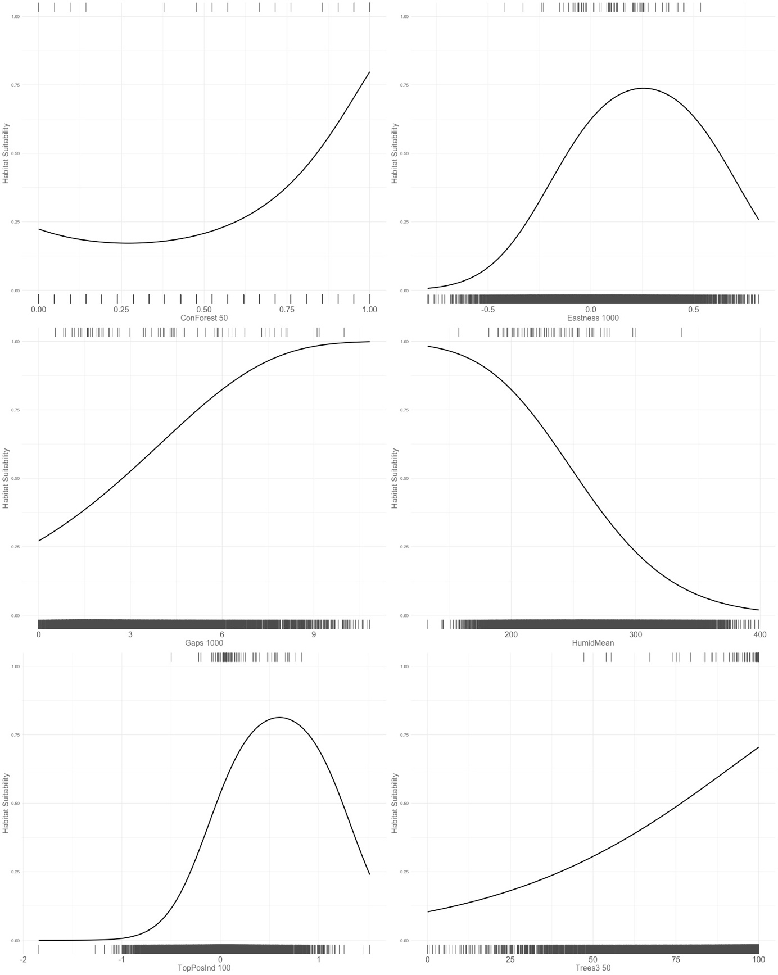
S. ruficollis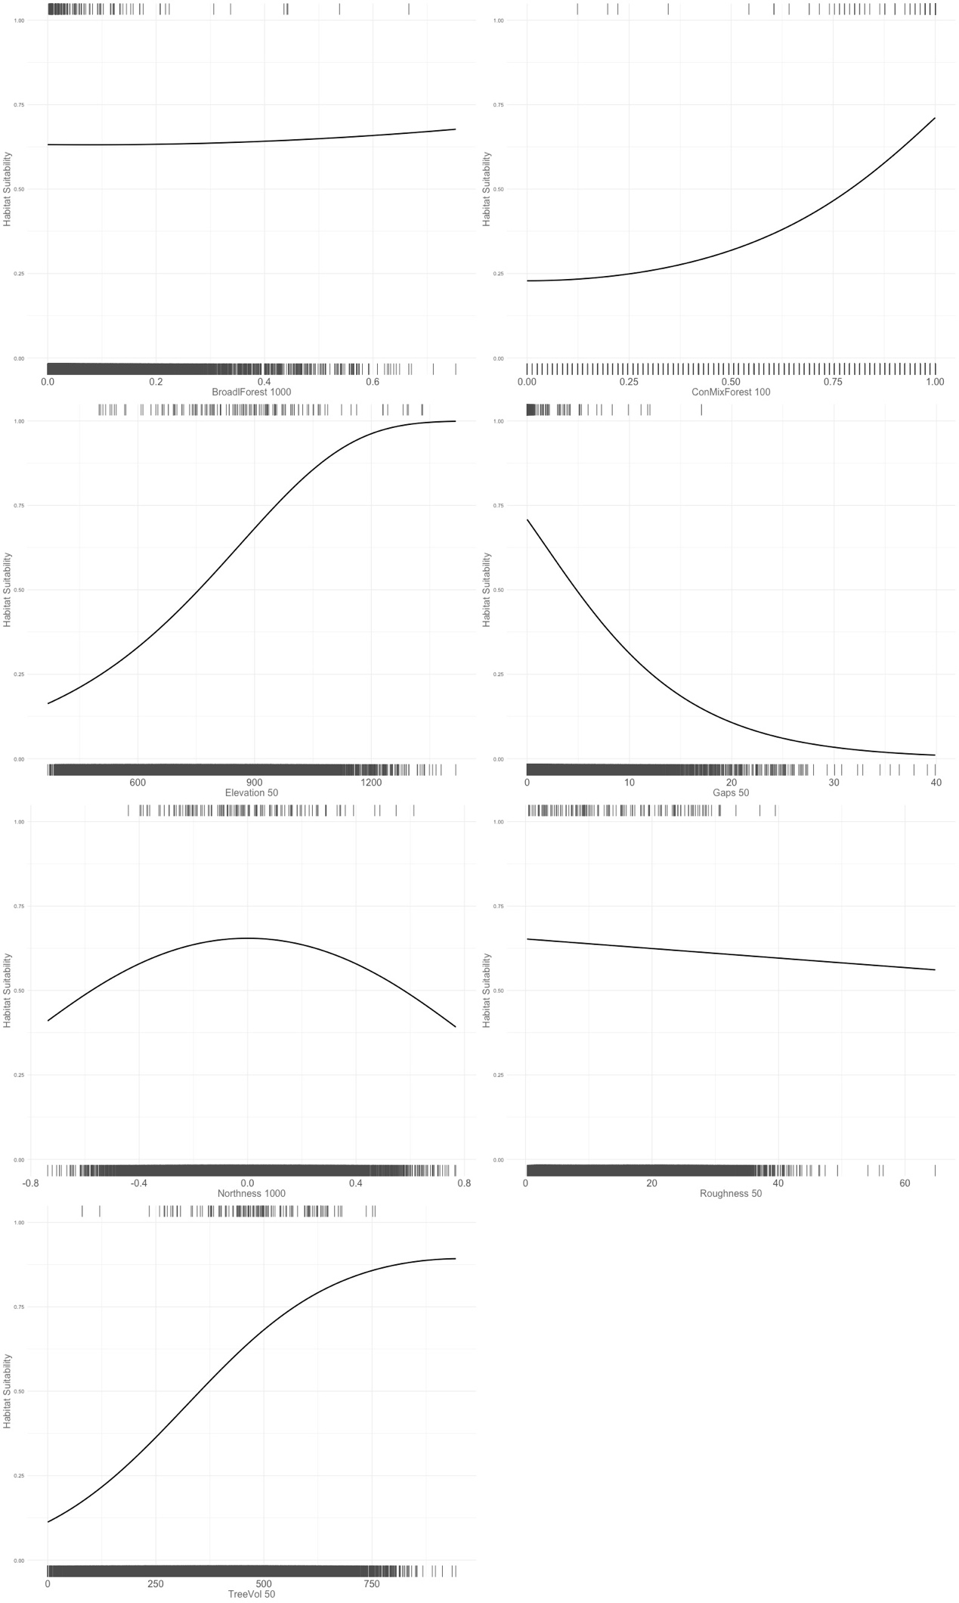
H. imperialis
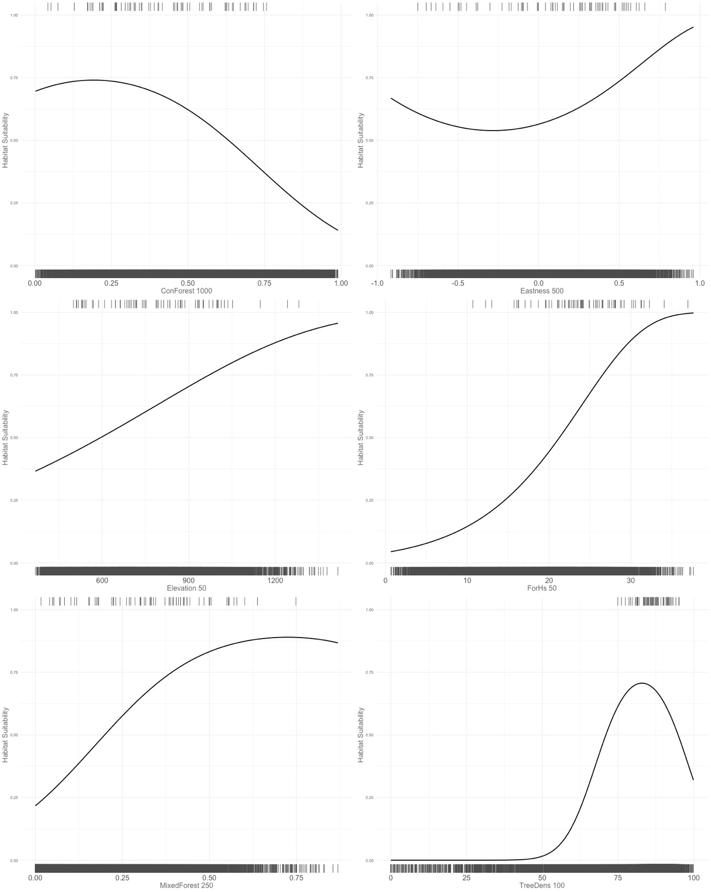
O. ferruginea
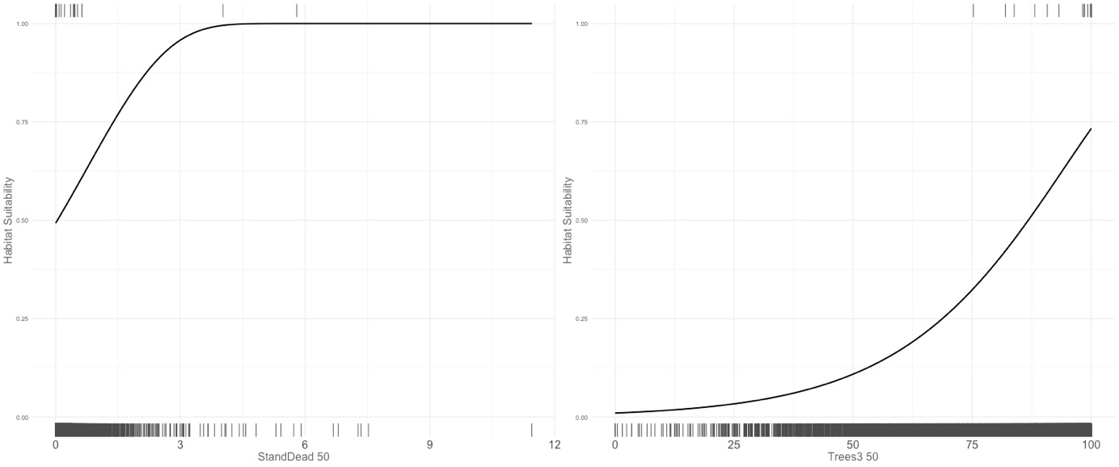

P. pumilio
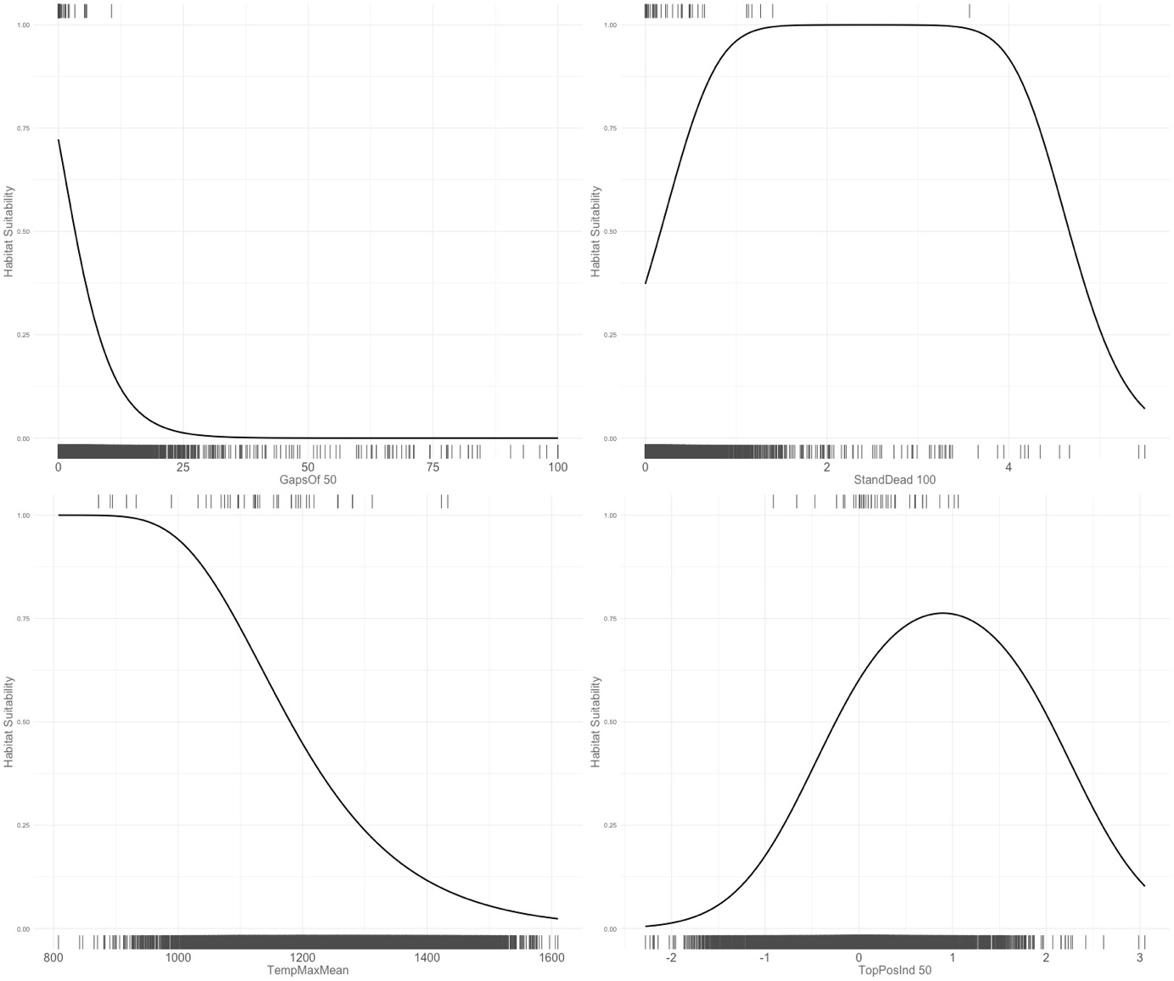
A. micros
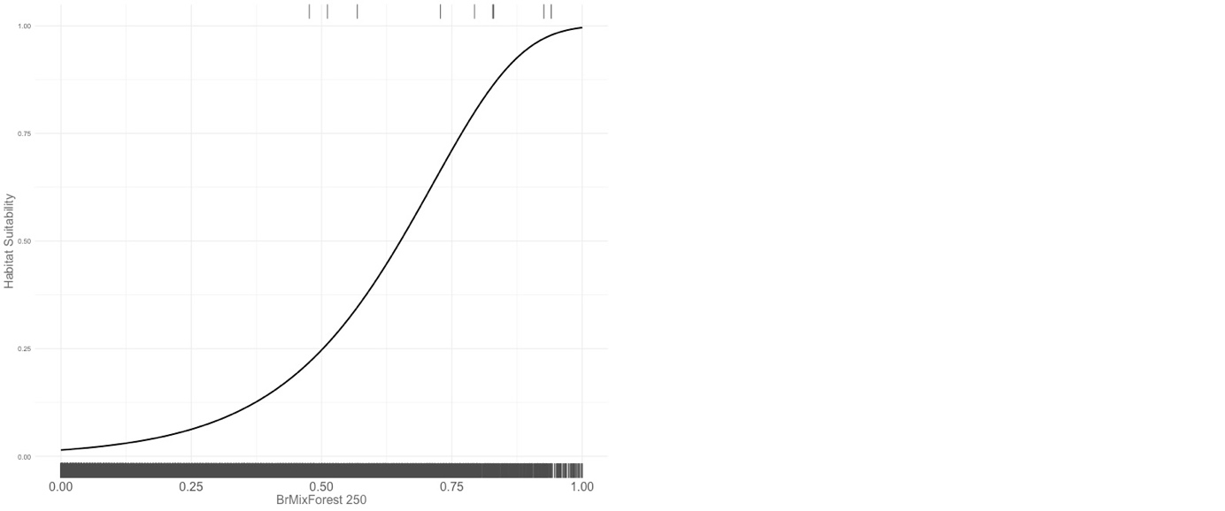

A. scrobipennis
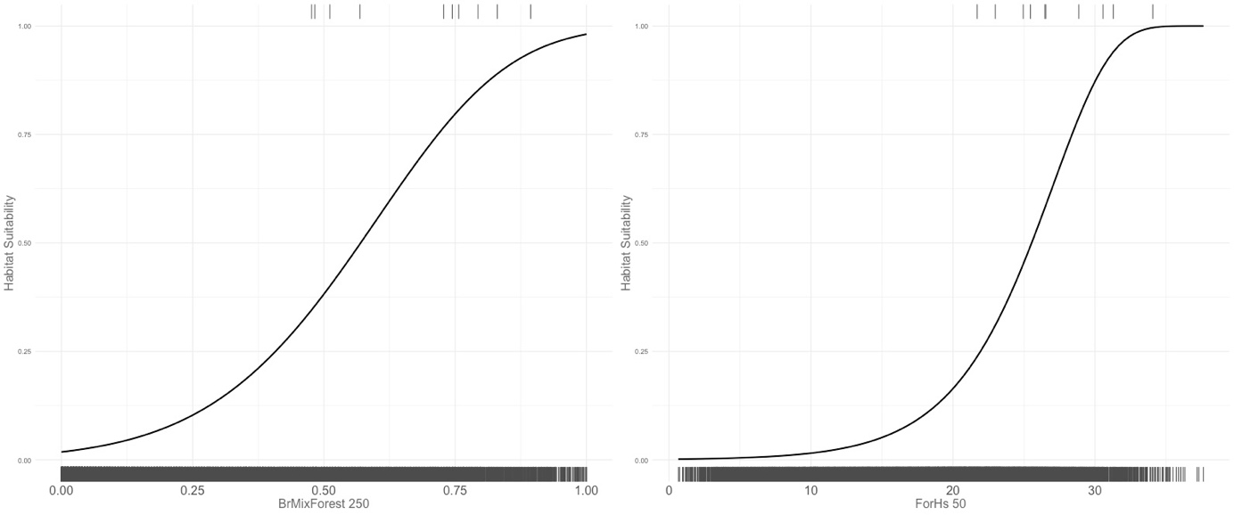
E. hypocrita

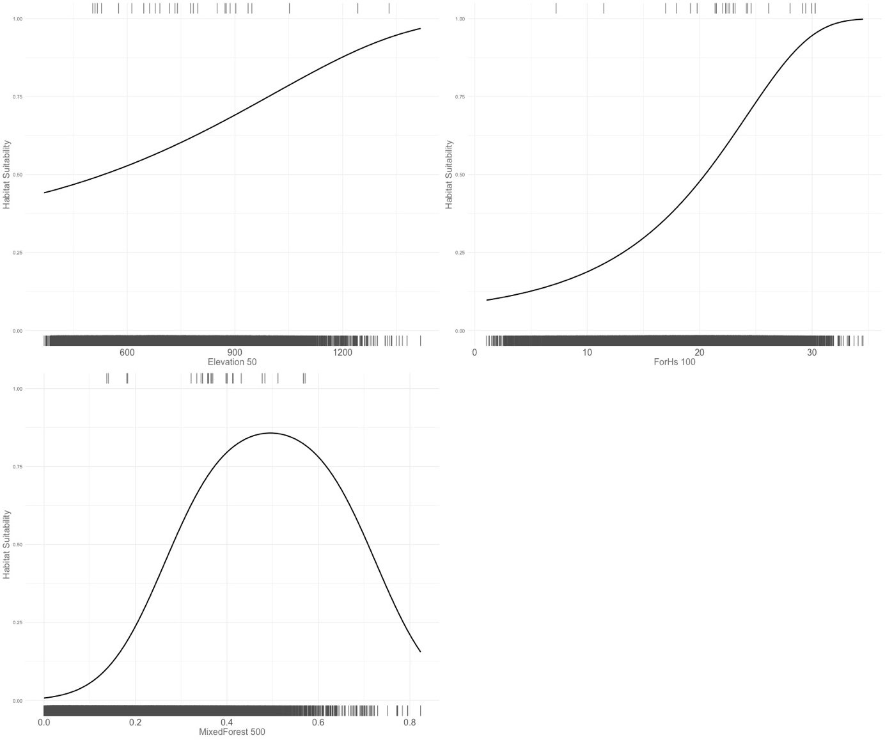

Table S2 Data sources (stereo aerial imagery and satellite imagery) and references for the methods used to derive forest structure and forest type variables (table 2). Aerial images with a ground resolution of 0.2 x 0.2 m were acquired during the vegetation period in the years 2015-2017 by the State Office for Geoinformation and Land Development Baden-Württemberg (“Landesamt für Geoinformation und Landentwicklung Baden-Württemberg (LGL). Geobasisdaten.” 2018). Sentinel 2 data (provided by the Copernicus Open Access Hub https://scihub.copernicus.eu/) used for modelling forest type and tree volume originated from the years 2015-2018 and 2016-2017, respectively. All variables in the table were developed at the Forest Research Institute (FVA) of Baden- Baden-Württemberg and are provided through the project MoBiTools (https://www.fva-bw.de/top-meta-navigation/fachabteilungen/biometrie-informatik/mobitools).

 | Aerial imagery | Aerial imagery | Satellite imagery
 | VHM*  1 x 1 m | Orthophoto  0.5 x 0.5 m | Sentinel 2  10 x 10 m
Variable |  |  |  | Method (Reference)
Forest Height | x |  |  | Schumacher et al. 2019; Ganz et al. 2020
Forest Height  Heterogeneity | x |  |  | Schumacher et al. 2019; Ganz et al. 2020
Tree Volume | x |  | x | Schumacher et al. 2019
Standing Deadwood | x | x |  | Zielewska-Büttner et al. 2020
Gaps | x |  |  | Zielewska-Büttner et al. 2016a, 2017
Open Forest | x |  |  | Zielewska-Büttner et al. 2016a, 2017
Forest Type |  |  | x | Schumacher et al. 2019
*VHM: vegetation height model

References
Ganz, S., Adler, P., and Kändler, G. 2020. Forest Cover Mapping Based on a Combination of Aerial Images and Sentinel-2 Satellite Data Compared to National Forest Inventory Data. Forests 11(12): 1322. doi:10.3390/f11121322.
Landesamt für Geoinformation und Landentwicklung Baden-Württemberg (LGL). Geobasisdaten. 2018. Available from www.lgl-bw.deaz.:2851. [accessed 15 August 2019].
Schumacher, J., Rattay, M., Kirchhöfer, M., Adler, P., and Kändler, G. 2019. Combination of Multi-Temporal Sentinel 2 Images and Aerial Image Based Canopy Height Models for Timber Volume Modelling. Forests 10(9): 746. doi:10.3390/f10090746.
Zielewska-Büttner, K., Adler, P., Ehmann, M., and Braunisch, V. 2016. Automated Detection of Forest Gaps in Spruce Dominated Stands Using Canopy Height Models Derived from Stereo Aerial Imagery. Remote Sensing 8(3): 175. doi:10.3390/rs8030175.
Zielewska-Büttner, K., Adler, P., Ehmann, M., and Braunisch, V. 2017. Erratum: Zielewska-Büttner, K.; Adler, P.; Ehmann, M.; Braunisch, V. Automated Detection of Forest Gaps in Spruce Dominated Stands Using Canopy Height Models Derived from Stereo Aerial Imagery. Remote Sens. 2016, 8, 175. Remote Sensing 9(5): 471. doi:10.3390/rs9050471.
Zielewska-Büttner, K., Adler, P., Kolbe, S., Beck, R., Ganter, L.M., Koch, B., and Braunisch, V. 2020. Detection of Standing Deadwood from Aerial Imagery Products: Two Methods for Addressing the Bare Ground Misclassification Issue. Forests 11(8): 801. doi:10.3390/f11080801.

Table S3 Best scale of each variable identified by different evaluation metrics and the scale resulting from the ensemble metric. Best scale at which the model species selected each variable, as identified by different evaluation metrics and by the ensemble metric. Values of the ensemble metric range between 0 and 5. Zero means that all metrics have identified the same best scale. The larger the value, the larger the differences between the evaluation metrics in terms of scale selection. AUC test values are listed to show which variables are predicting better than random. The variables included in the final multivariate models are highlighted in bold.

 |  |  | scale selected by
Species | Variable | Ensemble metric value | Ensemble scale | AICc | AUC train | AUC test | TSS train | TSS test | AUC test value
A.balteatus | BrMixForest | 0 | 50 | 50 | 50 | 50 | 50 | 50 | 0.5964535
A.balteatus | BroadlForest | 1.09052356 | 1000 | 1000 | 1000 | 500 | 1000 | 500 | 0.5566508
A.balteatus | ConForest | 0 | 50 | 50 | 50 | 50 | 50 | 50 | 0.62364052
A.balteatus | ConMixForest | 0.93535912 | 250 | 100 | 100 | 1000 | 250 | 250 | 0.65101441
A.balteatus | CurvTot | 0 | 100 | 100 | 100 | 100 | 100 | 100 | 0.69235952
A.balteatus | Eastness | 0.61805903 | 1000 | 1000 | 1000 | 250 | 1000 | 1000 | 0.45977617
A.balteatus | Elevation | 0.83442428 | 50 | 50 | 50 | 50 | 50 | 500 | 0.64420252
A.balteatus | ForHs | 0.48960637 | 50 | 500 | 50 | 50 | 50 | 50 | 0.53632832
A.balteatus | ForHsStd | 0 | 50 | 50 | 50 | 50 | 50 | 50 | 0.62321938
A.balteatus | Gaps | 0.13723775 | 1000 | 500 | 500 | 1000 | 1000 | 1000 | 0.61657595
A.balteatus | GapsOf | 0.12554913 | 1000 | 250 | 250 | 1000 | 1000 | 1000 | 0.60521052
A.balteatus | MixedForest | 0 | 50 | 50 | 50 | 50 | 50 | 50 | 0.62462756
A.balteatus | Northness | 1.86306542 | 100 | 100 | 100 | 1000 | 100 | 1000 | 0.46653015
A.balteatus | Roughness | 0.30508202 | 50 | 50 | 50 | 50 | 100 | 50 | 0.5250787
A.balteatus | Slope | 0.13396934 | 50 | 50 | 50 | 50 | 100 | 50 | 0.52902159
A.balteatus | StandDead | 0.32304698 | 100 | 100 | 50 | 50 | 50 | 100 | 0.57996599
A.balteatus | TopPosInd | 0 | 100 | 100 | 100 | 100 | 100 | 100 | 0.66941809
A.balteatus | TreeDens | 1.42917468 | 100 | 100 | 100 | 500 | 100 | 1000 | 0.65208831
A.balteatus | Trees | 2 | 50 | 50 | 50 | 250 | 50 | 500 | 0.58679104
A.balteatus | TreeVol | 0.3413394 | 100 | 50 | 50 | 100 | 50 | 100 | 0.54426148
S.ruficollis | BrMixForest | 0 | 50 | 50 | 50 | 50 | 50 | 50 | 0.63558793
S.ruficollis | BroadlForest | 1.335371 | 1000 | 1000 | 500 | 100 | 1000 | 50 | 0.55452577
S.ruficollis | ConForest | 0.11667377 | 50 | 100 | 50 | 50 | 50 | 50 | 0.62258938
S.ruficollis | ConMixForest | 0 | 100 | 100 | 100 | 100 | 100 | 100 | 0.62409914
S.ruficollis | CurvTot | 0.48088069 | 100 | 50 | 100 | 250 | 500 | 250 | 0.59561372
S.ruficollis | Eastness | 0.26454071 | 500 | 1000 | 500 | 500 | 500 | 500 | 0.557006
S.ruficollis | Elevation | 0.71843542 | 50 | 50 | 50 | 50 | 1000 | 100 | 0.77152187
S.ruficollis | ForHs | 0.1756216 | 50 | 50 | 50 | 1000 | 50 | 100 | 0.59095333
S.ruficollis | ForHsStd | 0 | 50 | 50 | 50 | 50 | 50 | 50 | 0.57118991
S.ruficollis | Gaps | 0 | 50 | 50 | 50 | 50 | 50 | 50 | 0.57442705
S.ruficollis | GapsOf | 0 | 50 | 50 | 50 | 50 | 50 | 50 | 0.57718571
S.ruficollis | MixedForest | 0.54240865 | 50 | 500 | 50 | 500 | 50 | 500 | 0.63937382
S.ruficollis | Northness | 2 | 1000 | 1000 | 1000 | 100 | 1000 | 100 | 0.54287885
S.ruficollis | Roughness | 0.49597366 | 50 | 100 | 100 | 50 | 250 | 50 | 0.45771046
S.ruficollis | Slope | 1.39862615 | 1000 | 100 | 100 | 1000 | 250 | 50 | 0.46116521
S.ruficollis | StandDead | 0.04581774 | 100 | 50 | 100 | 100 | 100 | 100 | 0.70892827
S.ruficollis | TopPosInd | 0.44171951 | 100 | 50 | 100 | 100 | 50 | 250 | 0.59757087
S.ruficollis | TreeDens | 0.61801089 | 100 | 100 | 100 | 250 | 100 | 100 | 0.52282889
S.ruficollis | Trees | 0.46399176 | 50 | 50 | 50 | 100 | 50 | 100 | 0.60696058
S.ruficollis | TreeVol | 0.45140615 | 50 | 50 | 50 | 500 | 50 | 100 | 0.64407611
H.imperialis | BrMixForest | 0.39146249 | 250 | 500 | 500 | 250 | 500 | 250 | 0.73786507
H.imperialis | BroadlForest | 1.89768699 | 1000 | 500 | 500 | 100 | 500 | 100 | 0.67906081
H.imperialis | ConForest | 0.36541037 | 1000 | 1000 | 1000 | 250 | 1000 | 250 | 0.65154531
H.imperialis | ConMixForest | 0.01023654 | 1000 | 1000 | 100 | 1000 | 1000 | 1000 | 0.50681886
H.imperialis | CurvTot | 0.15188555 | 50 | 50 | 50 | 100 | 50 | 100 | 0.67510252
H.imperialis | Eastness | 0.39399863 | 500 | 250 | 250 | 50 | 500 | 50 | 0.53478196
H.imperialis | Elevation | 0.8021677 | 50 | 50 | 50 | 50 | 1000 | 50 | 0.67118424
H.imperialis | ForHs | 0.02638411 | 50 | 50 | 50 | 50 | 50 | 100 | 0.7090068
H.imperialis | ForHsStd | 0.80486165 | 50 | 50 | 50 | 250 | 50 | 500 | 0.61622324
H.imperialis | Gaps | 0 | 50 | 50 | 50 | 50 | 50 | 50 | 0.6865173
H.imperialis | GapsOf | 0 | 50 | 50 | 50 | 50 | 50 | 50 | 0.68832517
H.imperialis | MixedForest | 0.39892064 | 250 | 250 | 250 | 250 | 1000 | 500 | 0.76687838
H.imperialis | Northness | 1.50680857 | 250 | 250 | 250 | 100 | 250 | 100 | 0.55163033
H.imperialis | Roughness | 0.74049587 | 250 | 250 | 250 | 100 | 250 | 50 | 0.68652731
H.imperialis | Slope | 0.64542921 | 250 | 250 | 250 | 100 | 250 | 50 | 0.69528906
H.imperialis | StandDead | 0.790108 | 100 | 100 | 100 | 50 | 100 | 50 | 0.74417383
H.imperialis | TopPosInd | 0.27137866 | 50 | 50 | 50 | 100 | 50 | 100 | 0.67407982
H.imperialis | TreeDens | 1.29384934 | 100 | 100 | 100 | 500 | 100 | 500 | 0.60590618
H.imperialis | Trees | 0 | 50 | 50 | 50 | 50 | 50 | 50 | 0.74010302
H.imperialis | TreeVol | 0.09220954 | 50 | 50 | 50 | 50 | 50 | 100 | 0.64314363
O.ferruginea | BrMixForest | 0.59996921 | 250 | 50 | 1000 | 250 | 1000 | 250 | 0.73291658
O.ferruginea | BroadlForest | 1.23105806 | 50 | 250 | 50 | 50 | 1000 | 50 | 0.5075015
O.ferruginea | ConForest | 1.03420809 | 1000 | 50 | 100 | 500 | 500 | 1000 | 0.74286857
O.ferruginea | ConMixForest | 1.23390989 | 50 | 1000 | 250 | 50 | 250 | 50 | 0.57285457
O.ferruginea | CurvTot | 1.14377852 | 50 | 100 | 250 | 50 | 1000 | 50 | 0.57807562
O.ferruginea | Eastness | 0.50046893 | 50 | 1000 | 50 | 50 | 500 | 500 | 0.6185037
O.ferruginea | Elevation | 1 | 1000 | 1000 | 1000 | 1000 | 1000 | 50 | 0.81012202
O.ferruginea | ForHs | 0 | 50 | 50 | 50 | 50 | 50 | 50 | 0.49889978
O.ferruginea | ForHsStd | 2.19981449 | 50 | 100 | 50 | 100 | 50 | 500 | 0.5
O.ferruginea | Gaps | 1.06539376 | 50 | 1000 | 50 | 100 | 50 | 500 | 0.58492699
O.ferruginea | GapsOf | 0.63314457 | 50 | 250 | 50 | 100 | 50 | 500 | 0.58330666
O.ferruginea | MixedForest | 0.48821793 | 250 | 250 | 500 | 250 | 1000 | 1000 | 0.75805161
O.ferruginea | Northness | 2 | 50 | 50 | 50 | 50 | 50 | 50 | 0.5
O.ferruginea | Roughness | 1.70837196 | 500 | 50 | 50 | 500 | 50 | 250 | 0.56821364
O.ferruginea | Slope | 1.67928069 | 250 | 50 | 50 | 500 | 100 | 250 | 0.55395079
O.ferruginea | StandDead | 1.03705455 | 50 | 100 | 100 | 50 | 100 | 50 | 0.68328666
O.ferruginea | TopPosInd | 1.42232897 | 50 | 100 | 250 | 50 | 1000 | 50 | 0.57265453
O.ferruginea | TreeDens | 2 | 500 | 500 | 500 | 500 | 100 | 50 | 0.5
O.ferruginea | Trees | 0.5362387 | 50 | 50 | 50 | 1000 | 50 | 50 | 0.5
O.ferruginea | TreeVol | 0.04477685 | 50 | 50 | 50 | 50 | 500 | 50 | 0.56839368
P.pumilio | BrMixForest | 1.97321804 | 50 | 250 | 50 | 250 | 50 | 100 | 0.5
P.pumilio | BroadlForest | 1.731622 | 1000 | 100 | 250 | 50 | 500 | 1000 | 0.52053327
P.pumilio | ConForest | 1 | 50 | 50 | 50 | 50 | 50 | 500 | 0.4493232
P.pumilio | ConMixForest | 1.44095596 | 100 | 250 | 250 | 100 | 100 | 1000 | 0.58880109
P.pumilio | CurvTot | 1.0543476 | 50 | 50 | 50 | 100 | 50 | 100 | 0.61195989
P.pumilio | Eastness | 1.7016138 | 50 | 50 | 50 | 250 | 50 | 500 | 0.52230446
P.pumilio | Elevation | 1 | 50 | 50 | 50 | 50 | 500 | 50 | 0.79307528
P.pumilio | ForHs | 0.72295681 | 50 | 50 | 50 | 500 | 50 | 500 | 0.51723678
P.pumilio | ForHsStd | 1.78349712 | 50 | 50 | 50 | 250 | 50 | 500 | 0.67435987
P.pumilio | Gaps | 0.64537496 | 50 | 50 | 50 | 500 | 50 | 500 | 0.6038541
P.pumilio | GapsOf | 0.44895226 | 50 | 50 | 50 | 500 | 50 | 500 | 0.58855104
P.pumilio | MixedForest | 1.83399806 | 50 | 50 | 50 | 1000 | 50 | 500 | 0.77188771
P.pumilio | Northness | 0.32358001 | 1000 | 250 | 1000 | 1000 | 1000 | 1000 | 0.57017237
P.pumilio | Roughness | 1.72289682 | 500 | 500 | 500 | 50 | 1000 | 1000 | 0.61422284
P.pumilio | Slope | 1.69778529 | 500 | 500 | 500 | 50 | 500 | 1000 | 0.61621491
P.pumilio | StandDead | 0.19837685 | 100 | 100 | 100 | 250 | 100 | 50 | 0.77615106
P.pumilio | TopPosInd | 1.05848288 | 50 | 50 | 50 | 100 | 50 | 100 | 0.62445822
P.pumilio | TreeDens | 1.12243746 | 100 | 50 | 50 | 1000 | 50 | 500 | 0.57978262
P.pumilio | Trees | 0.8023676 | 50 | 50 | 50 | 50 | 50 | 1000 | 0.59023888
P.pumilio | TreeVol | 0.02531646 | 50 | 50 | 50 | 50 | 50 | 100 | 0.51672001
A.micros | BrMixForest | 0.97398239 | 250 | 100 | 100 | 500 | 100 | 500 | 0.92835234
A.micros | BroadlForest | 0.58035452 | 500 | 50 | 100 | 500 | 500 | 500 | 0.93633727
A.micros | ConForest | 1.02296638 | 100 | 100 | 100 | 1000 | 100 | 1000 | 0.88227646
A.micros | ConMixForest | 0.37530828 | 50 | 50 | 100 | 50 | 50 | 1000 | 0.85510435
A.micros | CurvTot | 0 | 100 | 100 | 100 | 100 | 100 | 100 | 0.86727345
A.micros | Eastness | 0.44287873 | 1000 | 100 | 1000 | 1000 | 1000 | 1000 | 0.50770154
A.micros | Elevation | 1.81276549 | 500 | 250 | 250 | 1000 | 1000 | 1000 | 0.86593985
A.micros | ForHs | 0.35079547 | 100 | 100 | 100 | 50 | 100 | 50 | 0.96627659
A.micros | ForHsStd | 0.89205641 | 500 | 250 | 250 | 500 | 250 | 500 | 0.54177502
A.micros | Gaps | 0.71678879 | 1000 | 50 | 100 | 1000 | 1000 | 1000 | 0.79382543
A.micros | GapsOf | 0.56257848 | 1000 | 50 | 1000 | 1000 | 1000 | 1000 | 0.81599653
A.micros | MixedForest | 0 | 250 | 250 | 250 | 250 | 250 | 250 | 0.86657331
A.micros | Northness | 0.82278536 | 1000 | 1000 | 1000 | 500 | 1000 | 500 | 0.58695072
A.micros | Roughness | 0.70766773 | 500 | 500 | 500 | 500 | 500 | 250 | 0.63412683
A.micros | Slope | 1.22543036 | 500 | 100 | 100 | 500 | 100 | 250 | 0.63346003
A.micros | StandDead | 2.06787589 | 50 | 100 | 50 | 100 | 50 | 250 | 0.5
A.micros | TopPosInd | 0.00914064 | 100 | 100 | 100 | 100 | 50 | 100 | 0.86140561
A.micros | TreeDens | 0.75987276 | 250 | 50 | 50 | 250 | 250 | 250 | 0.53757418
A.micros | Trees | 0.43162288 | 250 | 100 | 100 | 250 | 250 | 250 | 0.92441822
A.micros | TreeVol | 0.87875176 | 100 | 500 | 250 | 50 | 100 | 100 | 0.7605021
A.scrobipennis | BrMixForest | 1.40496651 | 250 | 100 | 100 | 1000 | 100 | 1000 | 0.89524572
A.scrobipennis | BroadlForest | 2.02470213 | 500 | 100 | 500 | 50 | 500 | 50 | 0.86225578
A.scrobipennis | ConForest | 0.54163087 | 100 | 100 | 100 | 50 | 100 | 50 | 0.84586917
A.scrobipennis | ConMixForest | 0.19498265 | 50 | 50 | 50 | 50 | 100 | 50 | 0.80141028
A.scrobipennis | CurvTot | 0.8528869 | 100 | 50 | 100 | 500 | 100 | 500 | 0.67620191
A.scrobipennis | Eastness | 1 | 1000 | 50 | 1000 | 1000 | 1000 | 1000 | 0.56587984
A.scrobipennis | Elevation | 0.18718917 | 250 | 250 | 250 | 50 | 250 | 50 | 0.71901047
A.scrobipennis | ForHs | 1.15853389 | 50 | 50 | 50 | 250 | 100 | 500 | 0.93502034
A.scrobipennis | ForHsStd | 1.25308793 | 500 | 250 | 250 | 1000 | 500 | 1000 | 0.65053011
A.scrobipennis | Gaps | 1.37855027 | 1000 | 100 | 50 | 1000 | 100 | 1000 | 0.61255584
A.scrobipennis | GapsOf | 0.98617726 | 1000 | 100 | 50 | 1000 | 100 | 1000 | 0.64032807
A.scrobipennis | MixedForest | 0.18347107 | 250 | 250 | 250 | 500 | 250 | 250 | 0.88100954
A.scrobipennis | Northness | 0.62639181 | 250 | 50 | 250 | 250 | 500 | 250 | 0.59891978
A.scrobipennis | Roughness | 0.13192792 | 500 | 500 | 500 | 500 | 500 | 50 | 0.55411082
A.scrobipennis | Slope | 0.62981573 | 500 | 100 | 100 | 500 | 500 | 50 | 0.5505101
A.scrobipennis | StandDead | 0.24997194 | 50 | 1000 | 50 | 50 | 50 | 50 | 0.69828966
A.scrobipennis | TopPosInd | 1.23926376 | 1000 | 50 | 100 | 500 | 100 | 500 | 0.67410149
A.scrobipennis | TreeDens | 1.12783179 | 250 | 50 | 50 | 50 | 250 | 250 | 0.5
A.scrobipennis | Trees | 0.09299961 | 250 | 250 | 50 | 250 | 250 | 250 | 0.85087017
A.scrobipennis | TreeVol | 1.00810462 | 100 | 500 | 50 | 250 | 100 | 250 | 0.81369607
E.hypocrita | BrMixForest | 0 | 500 | 500 | 500 | 500 | 500 | 500 | 0.80080391
E.hypocrita | BroadlForest | 0.92010275 | 500 | 50 | 1000 | 500 | 1000 | 500 | 0.73505951
E.hypocrita | ConForest | 0.96948265 | 500 | 250 | 500 | 100 | 1000 | 100 | 0.66245749
E.hypocrita | ConMixForest | 0.36177235 | 50 | 250 | 50 | 50 | 50 | 1000 | 0.53573215
E.hypocrita | CurvTot | 0.83738214 | 250 | 50 | 250 | 500 | 250 | 100 | 0.64092819
E.hypocrita | Eastness | 1.72178729 | 50 | 1000 | 250 | 50 | 250 | 50 | 0.57395229
E.hypocrita | Elevation | 1.15322731 | 50 | 50 | 50 | 1000 | 1000 | 1000 | 0.45789158
E.hypocrita | ForHs | 0.35120961 | 100 | 50 | 50 | 100 | 50 | 100 | 0.79764703
E.hypocrita | ForHsStd | 0.16596172 | 100 | 100 | 100 | 250 | 100 | 100 | 0.5772342
E.hypocrita | Gaps | 2.02087378 | 250 | 50 | 500 | 250 | 1000 | 250 | 0.55634877
E.hypocrita | GapsOf | 1.2053504 | 50 | 500 | 500 | 50 | 1000 | 100 | 0.60070139
E.hypocrita | MixedForest | 0.02889543 | 500 | 500 | 1000 | 500 | 1000 | 500 | 0.81496924
E.hypocrita | Northness | 1.25910812 | 50 | 100 | 1000 | 50 | 50 | 250 | 0.54618424
E.hypocrita | Roughness | 0.2897094 | 250 | 250 | 250 | 500 | 500 | 250 | 0.87103671
E.hypocrita | Slope | 0.67721296 | 250 | 100 | 250 | 500 | 250 | 500 | 0.86692338
E.hypocrita | StandDead | 0.77177053 | 250 | 250 | 250 | 250 | 250 | 500 | 0.67244699
E.hypocrita | TopPosInd | 1.286107 | 500 | 500 | 250 | 500 | 250 | 100 | 0.67144679
E.hypocrita | TreeDens | 1.15993574 | 250 | 1000 | 1000 | 500 | 250 | 500 | 0.65215543
E.hypocrita | Trees | 0.30797823 | 250 | 100 | 100 | 250 | 250 | 250 | 0.78797009
E.hypocrita | TreeVol | 0.20320201 | 100 | 50 | 50 | 50 | 100 | 100 | 0.71956891

Table S4. Performance of multi-scale compared to single-scale models, evaluated using AUC and AICc. In addition the delta AICc of the single-scale models to the multi-scale model is shown. V1 to V7 are the variables included in the models.

Species | Model | AICc | Delta AICc | AUC | V1 | V2 | V3 | V4 | V5 | V6 | V7
A.balteatus | Multi-scale model | 1963.06993 | 0 | 0.81902095 | ConForest_50 | Eastness_1000 | Gaps_1000 | HumidMean | TopPosInd_100 | Trees_50 | NA
 | Single-scale 50 | 1983.92398 | -20.854055 | 0.77487085 | ConForest_50 | Elevation_50 | NA | NA | NA | NA | NA
 | Single-scale 100 | 1978.49587 | -15.425946 | 0.79507965 | ConMixForest_100 | Elevation_100 | TopPosInd_100 | NA | NA | NA | NA
 | Single-scale 250 | 1988.38552 | -25.315588 | 0.78577303 | ConMixForest_250 | Eastness_250 | Elevation_250 | GapsOf_250 | TopPosInd_250 | NA | NA
 | Single-scale 500 | 2001.36392 | -38.293993 | 0.76236517 | ConForest_500 | Eastness_500 | Elevation_500 | TopPosInd_500 | TreeVol_500 | NA | NA
 | Single-scale 1000 | 2007.56068 | -44.490753 | 0.71457942 | BroadlForest_1000 | Eastness_1000 | Gaps_1000 | NA | NA | NA | NA
S.ruficollis | Multi-scale model | 3886.1926 | 0 | 0.80790432 | BroadlForest_1000 | ConMixForest_100 | Elevation_50 | Gaps_50 | Northness_1000 | Roughness_50 | TreeVol_50
 | Single-scale 50 | 3888.65831 | -2.4657092 | 0.79166559 | ConMixForest_50 | Elevation_50 | Gaps_50 | TopPosInd_50 | Trees_50 | TreeVol_50 | NA
 | Single-scale 100 | 3901.60259 | -15.409984 | 0.77063074 | Elevation_100 | Trees_100 | NA | NA | NA | NA | NA
 | Single-scale 250 | 3939.71173 | -53.519129 | 0.74840613 | BrMixForest_250 | Eastness_250 | Elevation_250 | Northness_250 | TopPosInd_250 | Trees_250 | NA
 | Single-scale 500 | 3956.99004 | -70.797437 | 0.72653724 | Elevation_500 | MixedForest_500 | Northness_500 | Roughness_500 | TopPosInd_500 | NA | NA
 | Single-scale 1000 | 3935.68634 | -49.493743 | 0.7783831 | BroadlForest_1000 | Elevation_1000 | ForHsStd_1000 | Gaps_1000 | MixedForest_1000 | Northness_1000 | TopPosInd_1000
H.imperialis | Multi-scale model | 2073.85994 | 0 | 0.85412456 | ConForest_1000 | Eastness_500 | Elevation_50 | ForHs_50 | MixedForest_250 | TreeDens_100 | NA
 | Single-scale 50 | 2101.72929 | -27.869344 | 0.77769882 | Elevation_50 | ForHs_50 | TopPosInd_50 | NA | NA | NA | NA
 | Single-scale 100 | 2109.39809 | -35.538143 | 0.7665772 | Elevation_100 | ForHs_100 | StandDead_100 | NA | NA | NA | NA
 | Single-scale 250 | 2116.67457 | -42.814621 | 0.7846644 | Eastness_250 | Elevation_250 | ForHs_250 | MixedForest_250 | NA | NA | NA
 | Single-scale 500 | 2129.15091 | -55.290966 | 0.77867215 | BrMixForest_500 | ConForest_500 | Eastness_500 | Elevation_500 | TreeVol_500 | NA | NA
 | Single-scale 1000 | 2139.13161 | -65.271665 | 0.74229323 | BroadlForest_1000 | ConForest_1000 | Eastness_1000 | Elevation_1000 | ForHsStd_1000 | GapsOf_1000 | NA
O.ferruginea | Multi-scale model | 541.167963 | 0 | 0.76520304 | StandDead_50 | Trees_50 | NA | NA | NA | NA | NA
 | Single-scale 50 | 541.167963 | 0 | 0.76520304 | StandDead_50 | Trees_50 | NA | NA | NA | NA | NA
 | Single-scale 100 | 551.148888 | -9.9809249 | 0.69123236 | Slope_100 | Trees_100 | NA | NA | NA | NA | NA
 | Single-scale 250 | 540.573042 | 0.59492111 | 0.78232705 | Elevation_250 | MixedForest_250 | NA | NA | NA | NA | NA
 | Single-scale 500 | 546.094848 | -4.9268851 | 0.71258369 | Gaps_500 | MixedForest_500 | NA | NA | NA | NA | NA
 | Single-scale 1000 | 547.202943 | -6.0349795 | 0.72728075 | MixedForest_1000 | RadHorSum | NA | NA | NA | NA | NA
P.pumilio | Multi-scale model | 1202.0612 | 0 | 0.8261601 | GapsOf_50 | StandDead_100 | TempMaxMean | TopPosInd_50 | NA | NA | NA
 | Single-scale 50 | 1211.22632 | -9.1651253 | 0.83169454 | Elevation_50 | GapsOf_50 | PrecSum | TopPosInd_50 | NA | NA | NA
 | Single-scale 100 | 1218.46902 | -16.407826 | 0.81419874 | Eastness_100 | Elevation_100 | StandDead_100 | TreeDens_100 | NA | NA | NA
 | Single-scale 250 | 1227.53484 | -25.473644 | 0.78261037 | ConMixForest_250 | Elevation_250 | Roughness_250 | NA | NA | NA | NA
 | Single-scale 500 | 1231.38158 | -29.32038 | 0.78097414 | Elevation_500 | RadHorSum | TreeDens_500 | NA | NA | NA | NA
 | Single-scale 1000 | 1231.3936 | -29.332404 | 0.76373993 | Elevation_1000 | Gaps_1000 | Roughness_1000 | StandDead_1000 | NA | NA | NA
A.micros | Multi-scale model | 271.422951 | 0 | 0.90153031 | BrMixForest_250 | NA | NA | NA | NA | NA | NA
 | Single-scale 50 | 273.359932 | -1.9369814 | 0.86398946 | BroadlForest_50 | NA | NA | NA | NA | NA | NA
 | Single-scale 100 | 270.176577 | 1.24637378 | 0.90501434 | BrMixForest_100 | NA | NA | NA | NA | NA | NA
 | Single-scale 250 | 271.422951 | 0 | 0.90153031 | BrMixForest_250 | NA | NA | NA | NA | NA | NA
 | Single-scale 500 | 271.967266 | -0.5443147 | 0.89289525 | BrMixForest_500 | NA | NA | NA | NA | NA | NA
 | Single-scale 1000 | 280.343692 | -8.9207411 | 0.83502256 | ConForest_1000 | NA | NA | NA | NA | NA | NA
A.scrobipennis | Multi-scale model | 298.098293 | 0 | 0.94595919 | BrMixForest_250 | ForHs_50 | NA | NA | NA | NA | NA
 | Single-scale 50 | 296.752756 | 1.3455368 | 0.94766453 | BrMixForest_50 | ForHs_50 | NA | NA | NA | NA | NA
 | Single-scale 100 | 297.717256 | 0.38103669 | 0.94910482 | BrMixForest_100 | ForHs_100 | NA | NA | NA | NA | NA
 | Single-scale 250 | 312.26294 | -14.164647 | 0.87845569 | BrMixForest_250 | Roughness_250 | NA | NA | NA | NA | NA
 | Single-scale 500 | 310.250962 | -12.152669 | 0.88306661 | BrMixForest_500 | ForHsStd_500 | NA | NA | NA | NA | NA
 | Single-scale 1000 | 311.522237 | -13.423944 | 0.85833167 | ConForest_1000 | ForHsStd_1000 | NA | NA | NA | NA | NA
E.hypocrita | Multi-scale model | 802.007899 | 0 | 0.86793513 | Elevation_50 | ForHs_100 | MixedForest_500 | NA | NA | NA | NA
 | Single-scale 50 | 812.910082 | -10.902183 | 0.79296244 | BrMixForest_50 | Elevation_50 | ForHs_50 | NA | NA | NA | NA
 | Single-scale 100 | 807.209242 | -5.2013434 | 0.82512272 | BrMixForest_100 | Elevation_100 | ForHs_100 | NA | NA | NA | NA
 | Single-scale 250 | 806.532578 | -4.5246791 | 0.85794851 | BrMixForest_250 | Elevation_250 | ForHs_250 | NA | NA | NA | NA
 | Single-scale 500 | 814.358005 | -12.350106 | 0.82532276 | ConForest_500 | Elevation_500 | MixedForest_500 | NA | NA | NA | NA
 | Single-scale 1000 | 811.783104 | -9.7752053 | 0.82923508 | ConForest_1000 | Elevation_1000 | MixedForest_1000 | NA | NA | NA | NA

