Electronic Supplementary Material

Cellulose-based eco-friendly wafer-cleaning reagent
Woo Young Kwon,^{a,#} Ji-Hwan Lee,^{b,#} Young Eun Jeon,^{b} and Ki Soo Park^{a,*}
ª Department of Biological Engineering, College of Engineering, Konkuk University, Seoul 05029, Republic of Korea
^{b} R&D Center, SEMES Co., Ltd., Gyeonggi 18383, Republic of Korea
*Corresponding author.
Phone/Fax: +82-2-450-3742
E-mail: akdong486@konkuk.ac.kr; kskonkuk@gmail.com

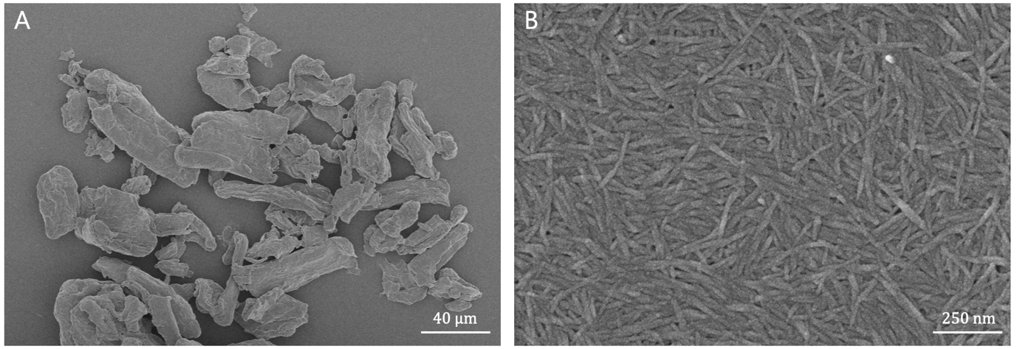
Fig. S1 Field-emission scanning electron microscopy (FE-SEM) image of (A) microcrystalline cellulose (MCC) and (B) cellulose nanocrystals (CNCs) used in the study.
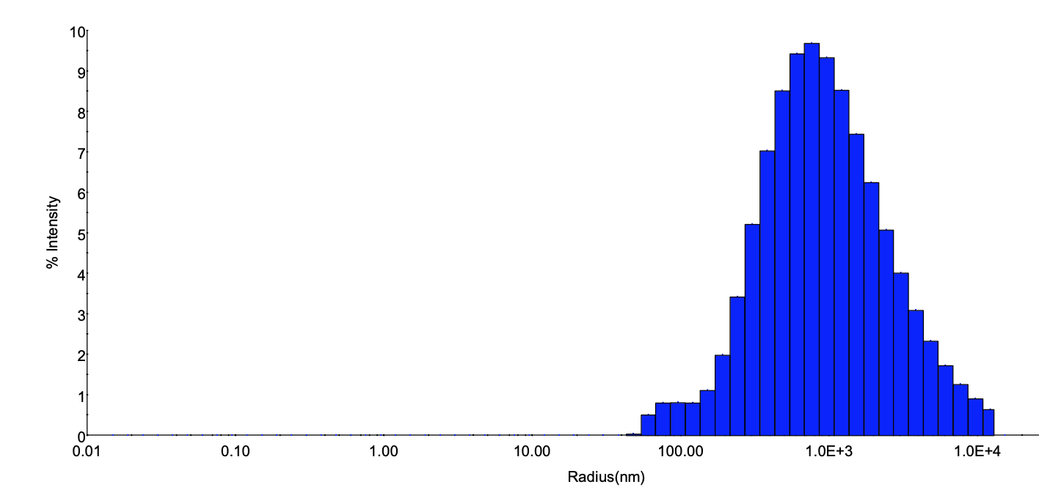
Fig. S2 Size distribution of silica contaminants

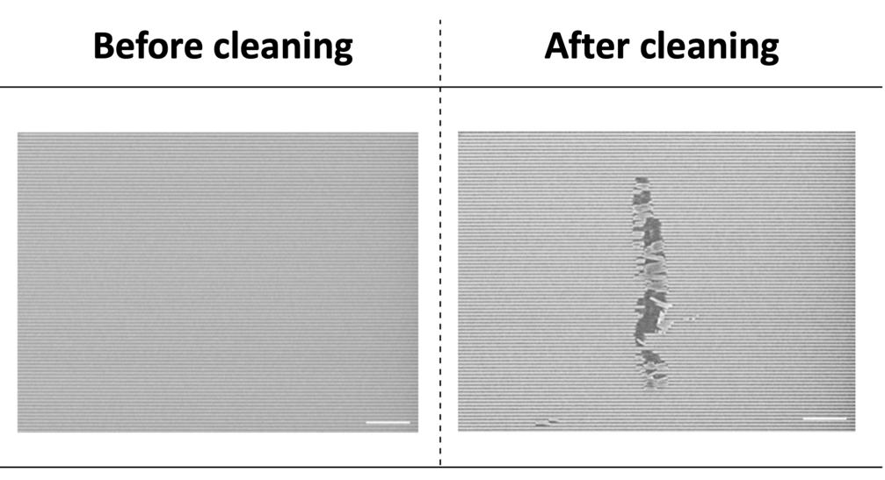
Fig. S3 Optical microscopy images before and after cleaning with 1 wt% MCC (90 µm)-based cleaning solution (Scale bar: 2.5 µm)

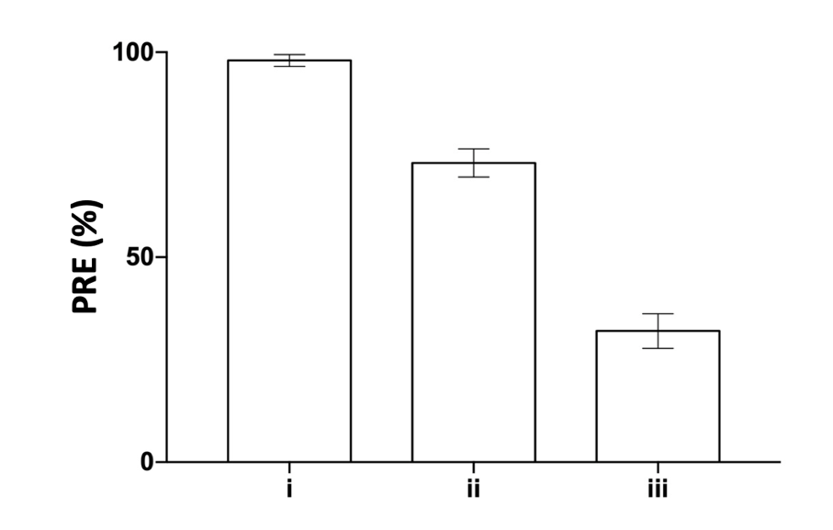

Fig. S4 PRE of the cellulose-based cleaning solutions: (i) 1 wt% MCC (90 µm), (ii) 1 wt% MCC (20 µm), and (iii) 1 wt% CNC (150 nm)

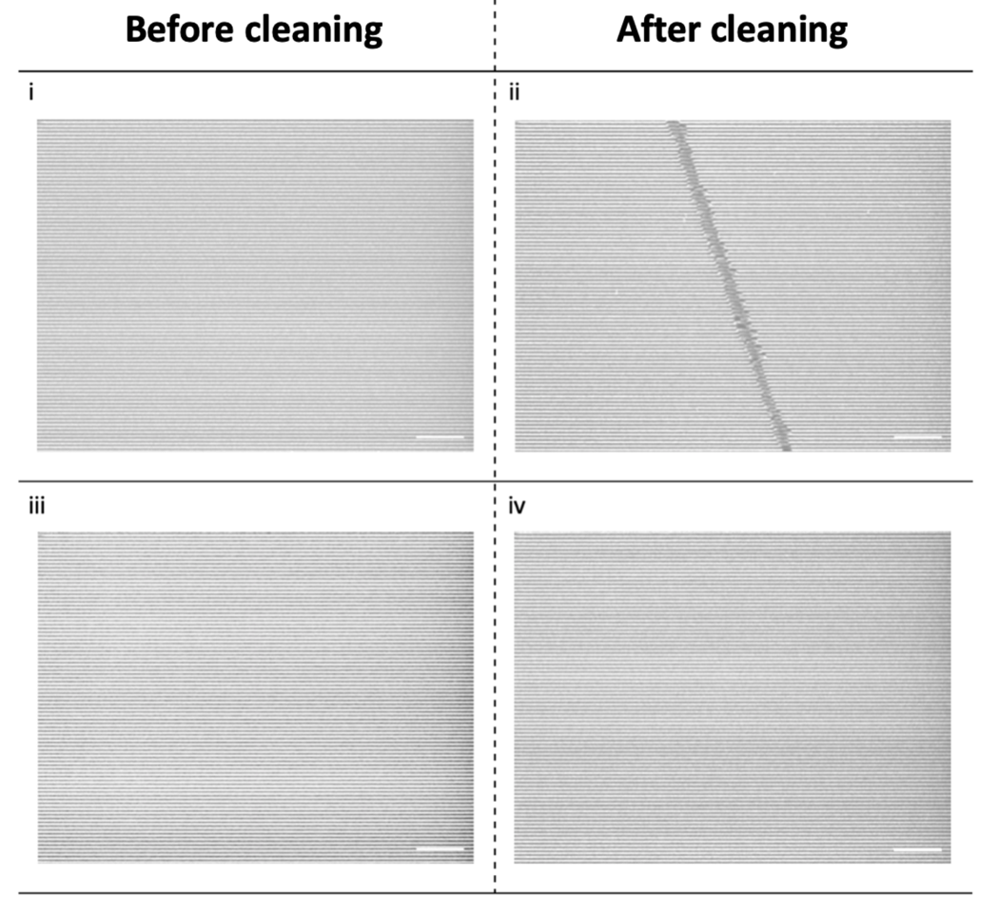

Fig. S5 SEM images of the patterned wafer before and after cleaning using (i and ii) 1 wt% MCC (20 µm) and (iii and iv) 1 wt% CNC (150 μm) (Scale bar: 2.5 µm)

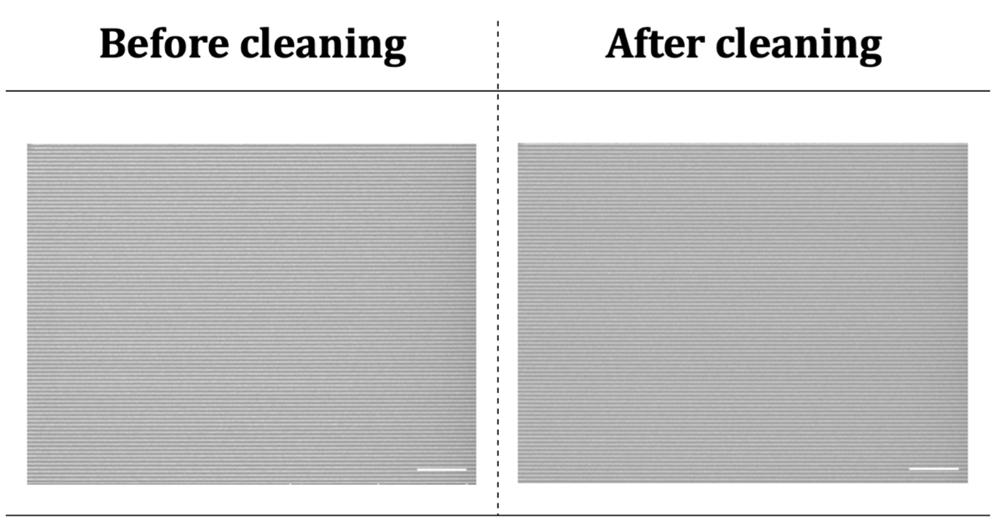
Fig. S6 Enlarged FE-SEM images from Figure 2B (Scale bar: 2.5 µm)

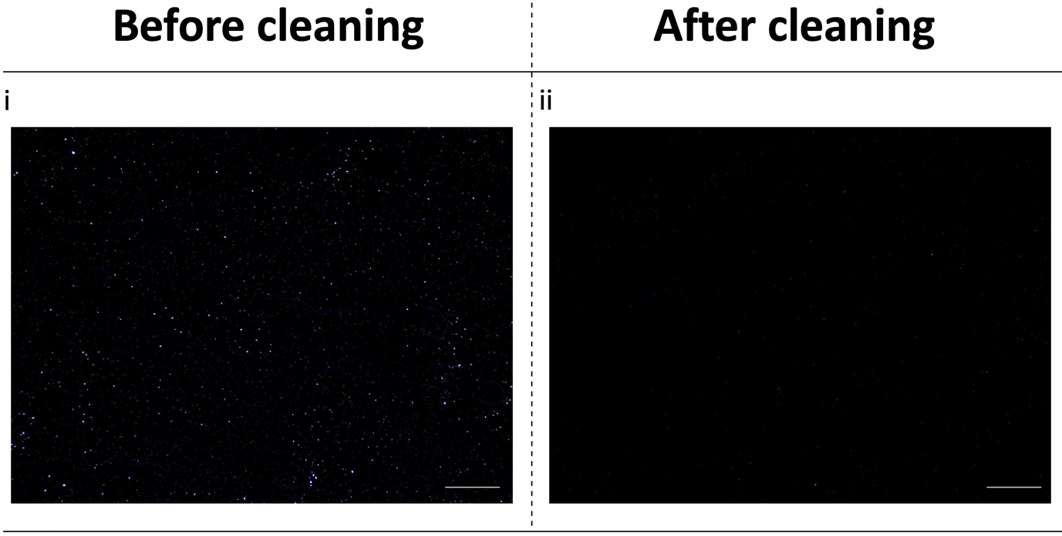
Fig. S7 Enlarged optical microscopy images of (i) and (ii) from Figure 3B (Scale bar: 250 µm)

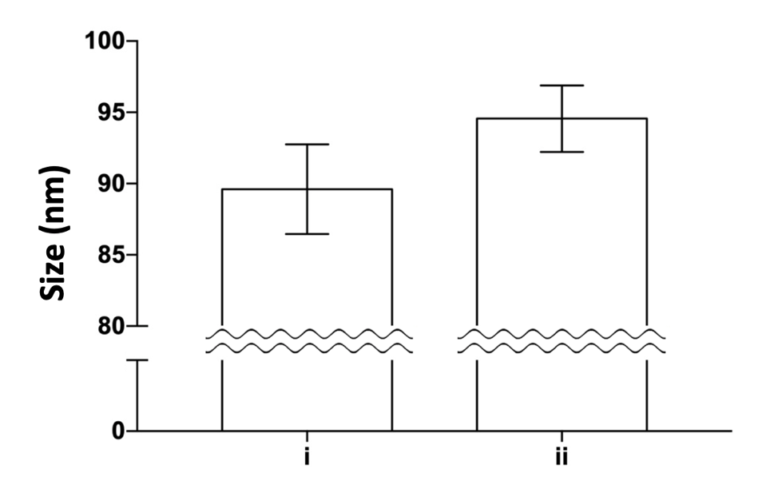

Fig. S8 Size of 1 wt% CNC in (i) absence and (ii) presence of 5 wt% cocamidopropyl betaine (CAPB)

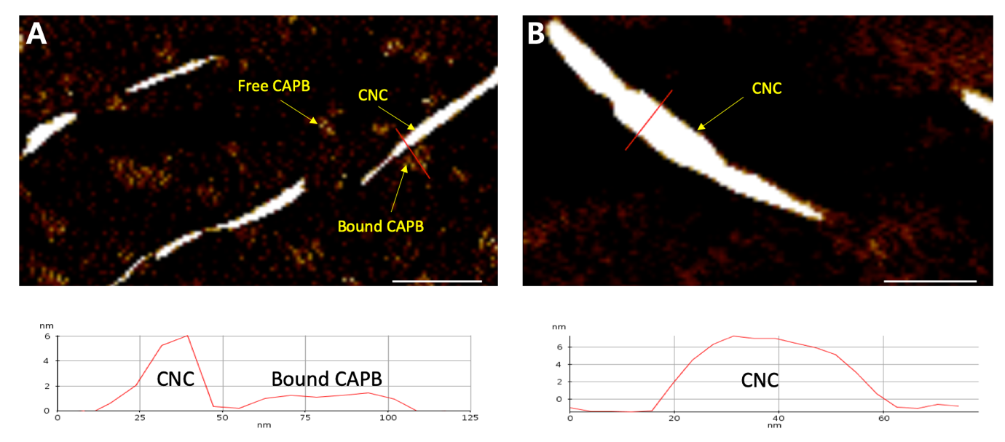

Fig. S9 Atomic force microscopy (AFM) images (top) and height profile (taken along the red line in the AFM images; bottom) of samples containing (A) CNC + CAPB (Scale bar: 250 nm) and (B) CNC only (Scale bar: 100 nm).

Fig. S10 Chemical structures of CAPB and betaine.

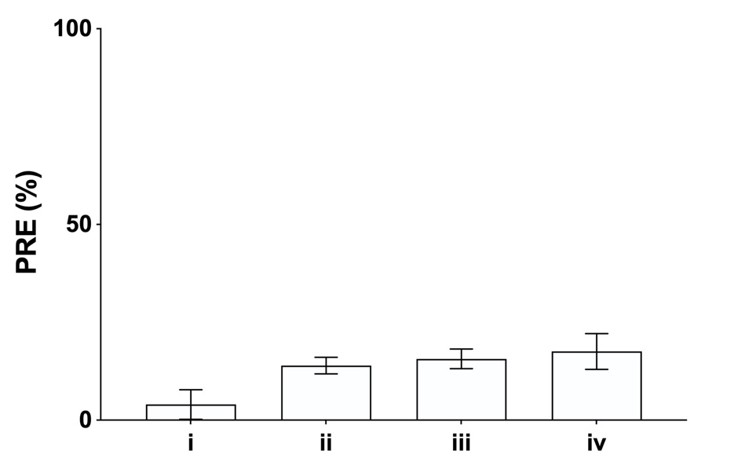

Fig. S11 Particle removal efficiency (PRE) of the surfactants: (i) water alone, (ii) 5 wt% betaine, (iii) 5 wt% CAPB, and (iv) 5 wt% aluminum oxide (15 nm)

Table S1 Comparison of the estimated and experimental PRE. Five different points (a–e) were selected based on the response surface design (Figure 3A)
Point | Concentration (%) |  | Estimated PRE (%) | Actual PRE (%)
 | Nanocellulose | CAPB
a | 0.75 | 5 | 99.4 | 97.9
b | 1 | 5 | 99.9 | 98.9
c | 1.25 | 3 | 100 | 99.3
d | 1.5 | 2 | 100 | 99.9
e | 1.75 | 2 | 96.4 | 93.9

