**Leaching Tests**

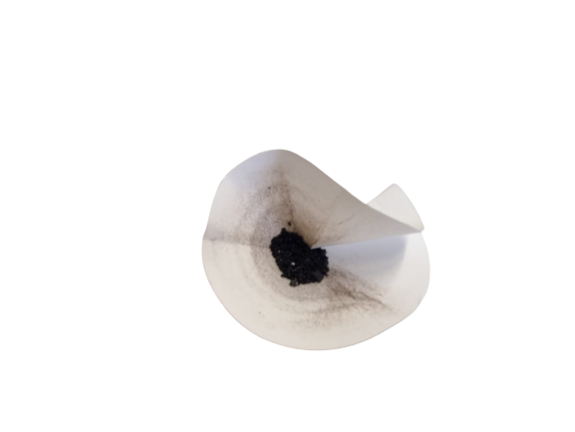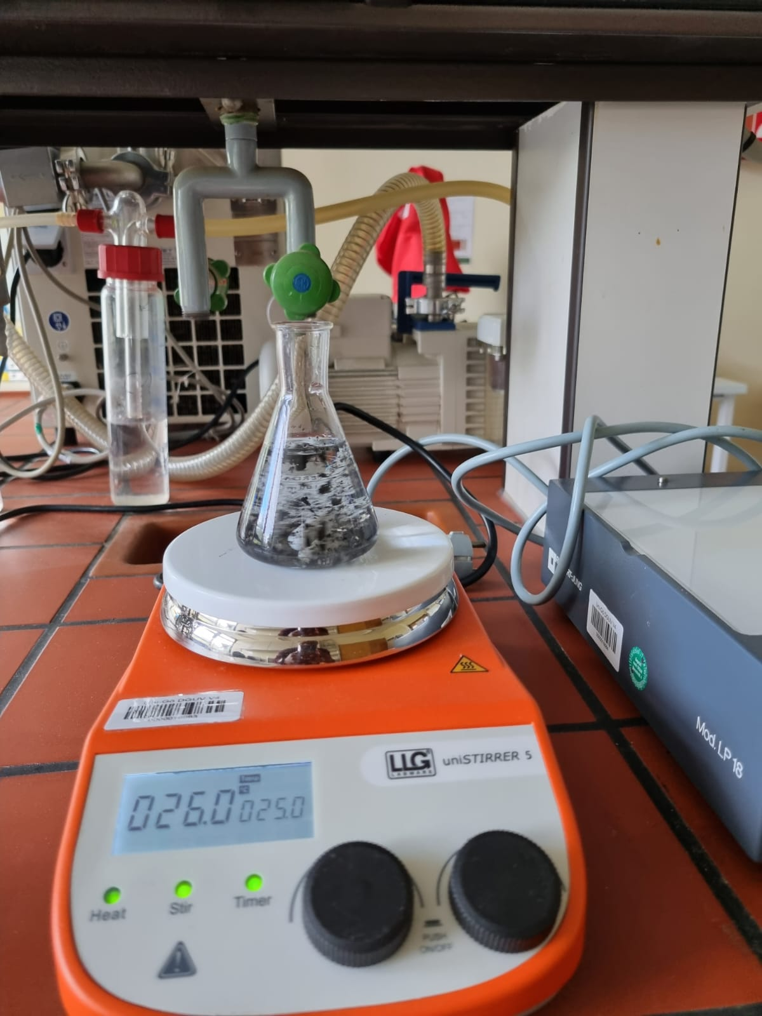

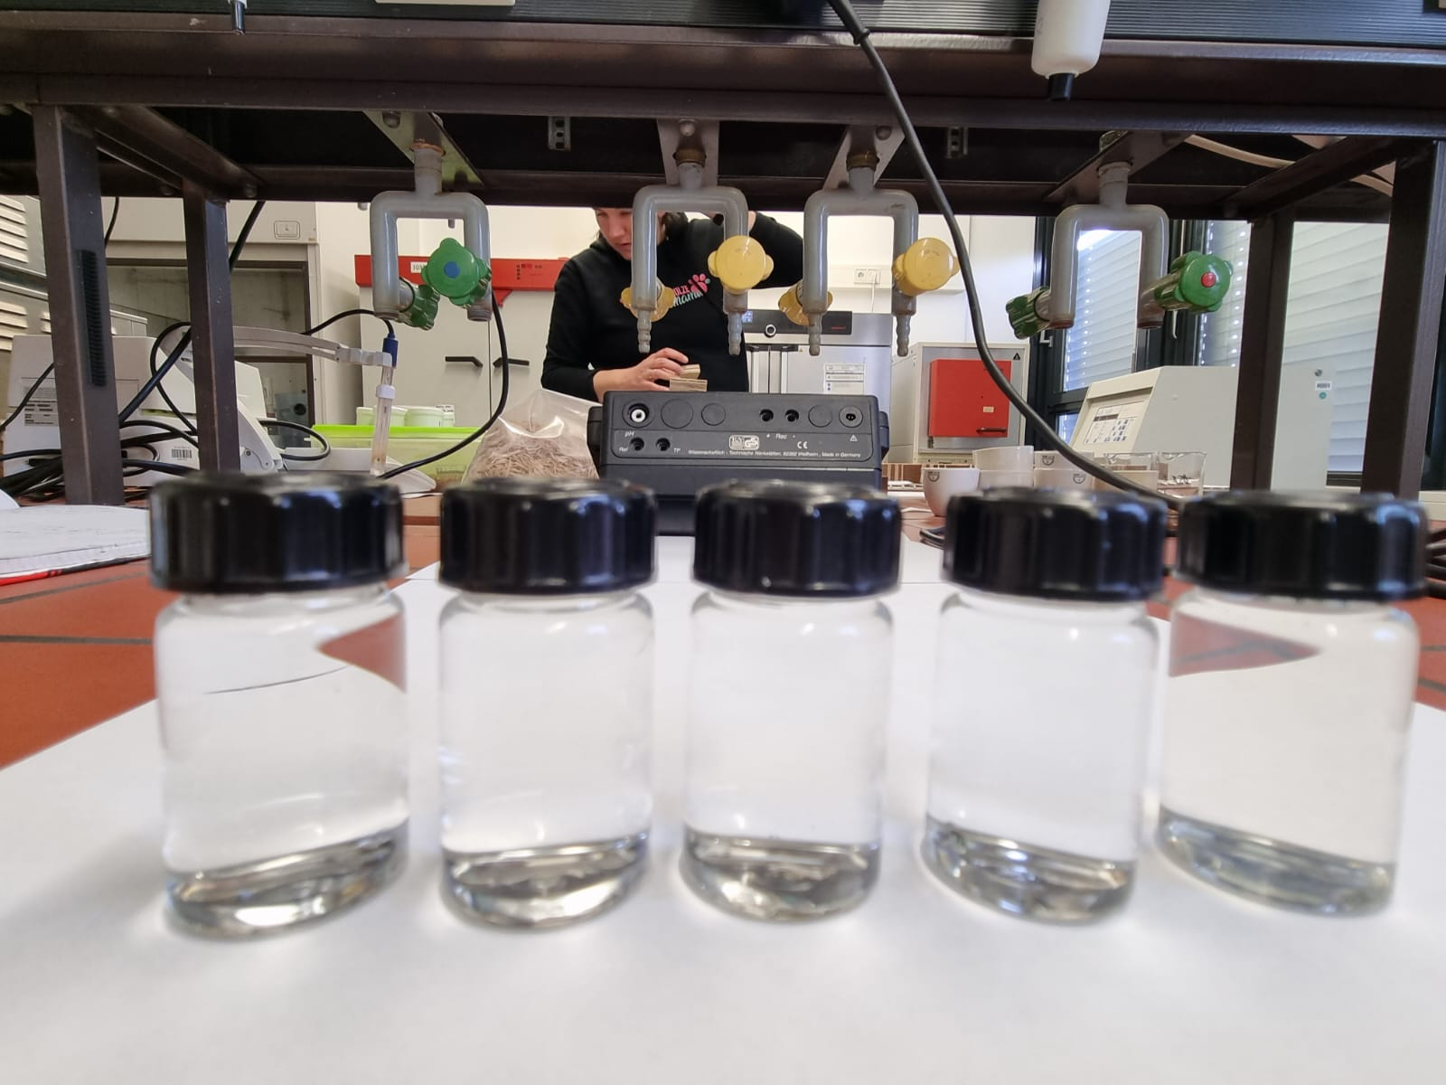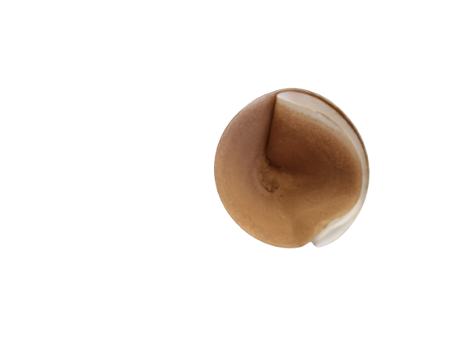

Filtrate of lignin foam from leaching test.

Leachates from the leaching test. From Left to right: **LFI, LF2, LF3, PFA and KL**

Filtrate of kraft lignin (KL) from leaching test.

Sample immersed in water and stirred with magnetic stirrer for 1 hour.