Sea-urchin-like architectures and nanowire arrays of cobalt−manganese sulfides for superior electrochemical energy storage performance
Yuying Zhuª, Haichao Chen^{a,b,}*, Si Chenª, Chao Liª, Meiqiang Fanª, and Kangying Shu^{a,}*
ªCollege of Materials Science & Engineering, China Jiliang University (CJLU), Hangzhou 310018, China.
^{b}Institute of Materials for Energy and Environment, School of Materials Science and Engineering, Qingdao University, Qingdao 266071, China.
*Corresponding authors. E-mail: chenhchust@126.com (H.-C. Chen), shukangying@cjlu.edu.cn (K.Y. Shu)

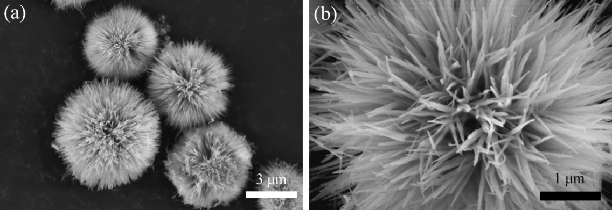
Fig. S1. SEM images of the Co−Mn precursor

Fig. S2 Electrochemical tests in a three-electrode system: (a) CV and (b) GCD curves of the sea-urchin-like Co−Mn sulfide at different scan rates and current densities, respectively; (c) CV and (d) GCD curves of the sea-urchin-like Co−Mn oxide at different scan rates and current densities, respectively; (e) CV and (f) GCD curves of Co−Mn oxide arrays on Ni foam at different scan rates and current densities, respectively.

Fig. S3 CV curves at 5 mV s⁻¹ of Ni foam supported MnCo₂S₄ array sample and pure Ni foam.

