**Photothermal conversion performance of perylene diimide radical anion salts modified with tunable moieties**

Qizhe Lia, Wenlong Houa, b, Fei Pengb, Hailong Wangc, Shuo Zhanga, Danyang Donga, Siyu Wua, Haiquan Zhanga, *

aState Key Laboratory of Metastable Materials Science and Technology, Yanshan University, Qinhuangdao 066004, PR China

b Analysis and Test Center, Hebei Normal University of Science and Technology, Qinhuangdao 066600, PR China

C Institute of Polymer Optoelectronic Materials and Devices, State Key Laboratory of Luminescent Materials and Devices, South China of Technology, Guangzhou 510640, PR China

*Corresponding author. Tel: +8613231394962. E-mail: [hqzhang@ysu.edu.cn](mailto:hqzhang@ysu.edu.cn) (Haiquan Zhang)



Fig. S1 Cyclic voltammograms of DBrPDI and TPPDI recorded in DMF containing 0.1 M n-Bu4NPF6 at 0.1 Vs-1.



Fig. S2 1H NMR spectra of DBrPDI and DBrPDI radical anion salt in (CD3)2SO (400 MHz, 298 K).

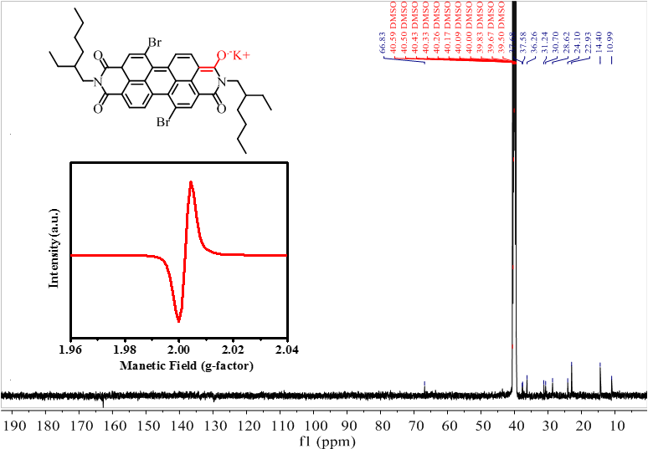

Fig. S3 13C NMR spectra of DBrPDI radical anion salt in (CD3)2SO (100 MHz, 298 K).

1. (b)

 

Fig. S4 (a) UV–vis spectra of TPPDI (red solid line) and its radical anion (black solid line); Fluorescence spectra of TPPDI (red dash line), λex=530 nm , slit width: dex=10 nm, dem=5.0 nm, and its radical anion (black dash line), λex=670 nm , slit width: dex= dem=10 nm, all dissolved in DMF of 2×10-5 M (the inset: EPR of TPPDI and its radical anion) (b) IR spectra for TPPDI and its radical anion.



Fig. S5 1H NMR spectra of TPPDI and TPPDI radical anion salt in (CD3)2SO (400 MHz, 298 K).



Fig. S6 13C NMR spectra of DBrPDI radical anion salt in (CD3)2SO (100 MHz, 298 K).

**1. Preparation of the tested samples**

Before officially starting to measure the photothermal conversion of radical anion in DMF or water, first took 1.5mL DMF or water into a quartz cuvette, the laser power was 0.362 W, the area of the laser was 0.181 cm-2, and the laser power density was 2W/cm2. Then the constant light power was irradiated for 10 minutes to the pure background solvent. When the solvent temperature was constant, it was used as solvent for radical anion salt, meanwhile this temperature elevation was regarded as the photothermal conversion value of the pure solvent. In this condition, as for the subsequent solution tests for the radical anion salt dissolved in different solvents, the temperature elevation generated by the pure solvent was equivalent to zero, so remember that the Qs=0 w. Then DBrPDI and TPPDI radical anion salt were dissolved in DMF with the concentration of 100 μM. Given the limited solubility of the DBrPDI and TPPDI radical anion salt in deionized water, a very small amount of DMF solvent was used as cosolvent, then DBrPDI and TPPDI radical anion salt dissolved in deionized water with the same concentration of 100 μM was configured and tested.

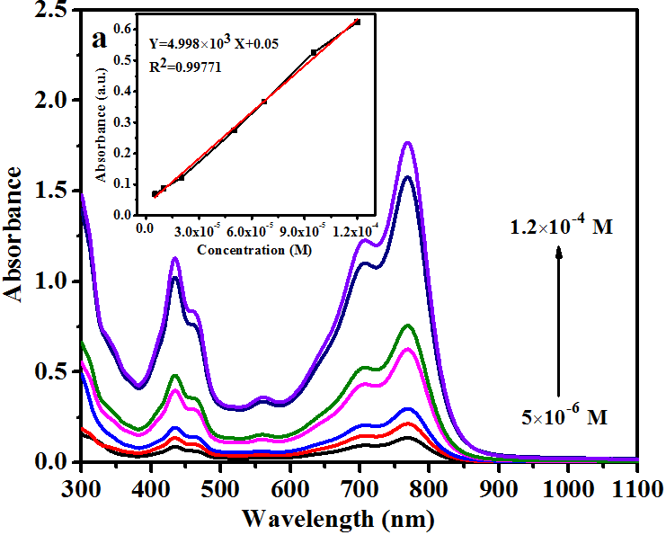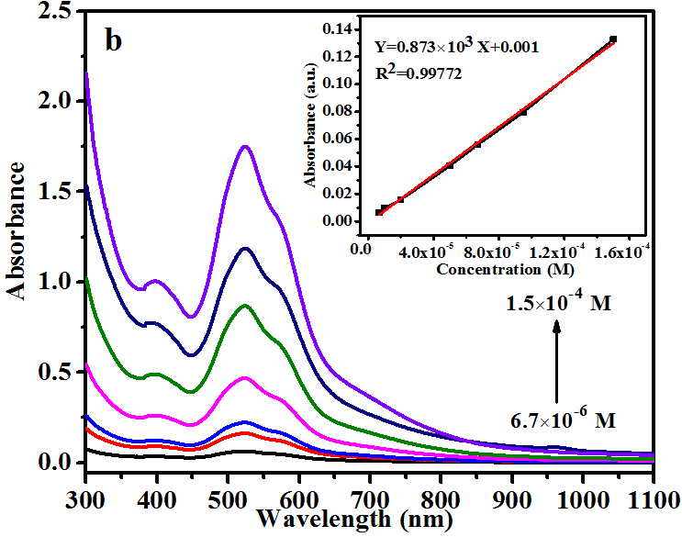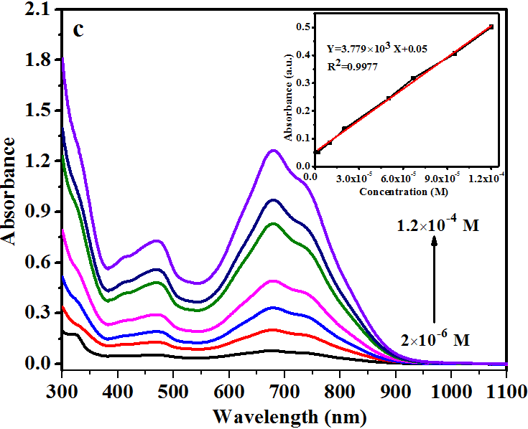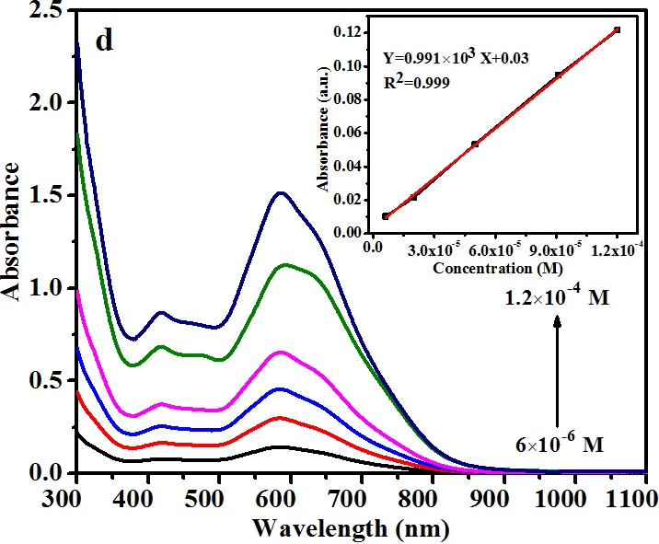

Fig. S7 Absorption curves of (a) DBrPDI radical anion salt in DMF; (b) DBrPDI radical anion salt in water; (c) TPPDI radical anion salt in DMF; (d) TPPDI radical anion salt in water at different concentrations. (the insert showed linear absorbance versus concentration)

Table S1 Molar absorption coefficient (M-1 cm-1) of DBrPDI and TPPDI radical anion salts in different solvents.

|  |  |  |
| --- | --- | --- |
| System | DMF | Water |
| DBrPDI radical anion salt | 4998 | 873 |
| TPPDI radical anion salt | 3779 | 991 |

**2. Calculation of the photothermal conversion efficiency of DBrPDI and TPPDI radical anion salts in DMF and deionized water.**

The photothermal conversion efficiency of DBrPDI or TPPDI radical anion in DMF or deionized water could be calculated from the energy balance during the irradiation. Detailed calculation was given as following:

mCp=Qin,radical+Qin,solvent-Qout

(1)

where *m* and *Cp* are the mass and heat capacity of the solvent (DMF or water) and *T* is the solution temperature.

*Qin,radical* is the photothermal energy input from the radical anions:

(2)



where *I* is the laser power, *A*λ is the absorbance of radical anion in DMF or water at the wavelength of 808 nm, and *η* is the conversion efficiency from the absorbed light energy to thermal energy.

*Qin,solvent* is the heat associated with the light absorbance of the solvent, which is measured independently using pure DMF or water without radical anions.(which could be neglected according to S4).

*Qout* is thermal energy lost to the surroundings:



(3)

Where *h* is the heat transfer coefficient, *A* is the irradiated area of the container, *Tsurr* is the temperature of surrounding (can be regarded as constant) and Δ*T* is the temperature change, which is defined as *T-Tsurr.* When the system reaches at the steady state, the rate of photothermal heating is equal to the rate of heat dissipation to the surrounding, thus achieving the energy balance and the maximal temperature, so that:



(4)

where *ΔTmax* is the temperature change at the maximum steady-state temperature. According to the Eq.2 and Eq.4, the photothermal conversion efficiency (*η*) can be determined:



(5)

In this equation, only *hA* is unknown for calculation. In order to get the *hA*, we herein introduce *θ*, which is defined as the ratio of Δ*T* to Δ*T*max:



(6)

Substituting Eq.6 into Eq.1 and rearranging Eq.1:



(7)

When the laser was shut off, the *Qin,radical*+*Qin,solvent* = 0, Eq.7 changed to:



(8)

Integrating Eq.8 gives the expression:



(9)

Here, C is an integral constant, which could be obtained from the linear fitting curve. Thus, *hA* can be determined by applying the linear time data from the cooling period t vs ln*θ*. Substituting *hA* value into Eq.5, the photothermal conversion efficiency (*η*) of DBrPDI or TPPDI radical anion in DMF or deionized water can be calculated.

First, following the procedure of S4.4, *Qin,solvent* has been measured and automaticly deduced in the following test. Then, took 1.5mL DMF or water solution containing DBrPDI radical anion into a quartz cuvette, the laser power was 0.362 W, the area of the laser was 0.181 cm-2, and the laser power density was 2W/cm2. Then the constant light power was irradiated for 10 minutes to the DMF or water solvent and then the laser was powered off, letting the solution to naturally cool down to room temperature. The temperature elevation was detected, given as follows:

1. (b)



(c) (d)



Fig. S8 (a) the temperature changing curve of DMF solution containing DBrPDI radical anion; (b) the temperature changing curve of DMF solution containing TPPDI radical anion; (c) the temperature changing curve of water solution containing DBrPDI radical anion; (d) the temperature changing curve of water solution containing TPPDI radical anion.

From the data of photothermal experiments, we can achieve the characteristic rate constant mCp/*hA* with the linear fitting method, as shown in Figure S2.

(a) (b)



(c) (d)



Fig. S9 Linear fitting of the irradiation time data *t* versus −ln(θ) to give the characteristic rate constant mCp/*hA* for (a) DBrPDI radical anion in DMF; (b)DBrPDI radical anion in deionized water; (c) TPPDI radical anion in DMF; (d) TPPDI radical anion in deionized water.

The characteristic rate constant mCp/*hA* of DBrPDI or TPPDI radical anion in DMF or deionized water can be attained from the fitting slopes, and then *hA* can also be determined:

Table S2 Detailed information about *hA* ofDBrPDI or TPPDI radical anion in DMF or deionized water .

|  |  |  |  |  |
| --- | --- | --- | --- | --- |
|  | DBrPDI radical anion | | TPPDI radical anion | |
| solvent | DMF | water | DMF | water |
| *hA* | 0.02679 | 0.10347 | 0.01688 | 0.01844 |

Then,according to the Eq.5, photothermal conversion efficiency (*η*) of DBrPDI radical anion in DMF or deionized water was calculated:

Table S3 Detailed information about *η* ofDBrPDI or TPPDI radical anion in DMF or deionized water .

|  |  |  |  |  |
| --- | --- | --- | --- | --- |
|  | DBrPDI radical anion | | TPPDI radical anion | |
| solvent | DMF | water | DMF | water |
| *η* | 82.28% | 37.19% | 51.03% | 48.05% |

(a) (b)



Fig S10 (a) Titration of water with DMF solution (10-5 M) containing DBrPDI radical anion ; (b) Different concentrations of DBrPDI radical anion in water (DBrPDI radical anion in DMF was given as control).

(a)



(b)

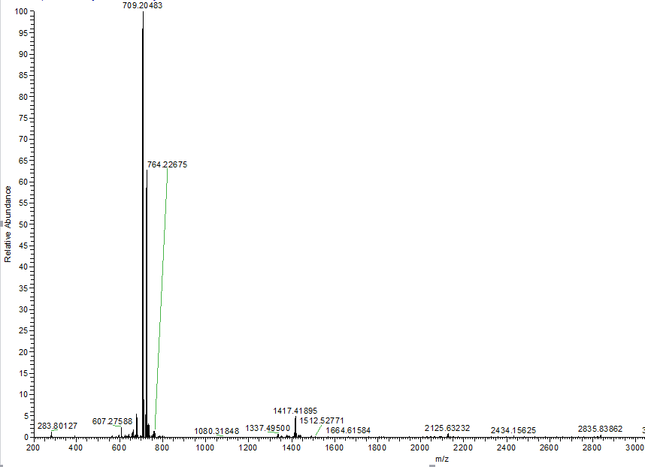

Fig S11 (a) UV–vis spectra of DBrPDI radical anion dissolved in DMF (black solid line) and in DCM (red solid line); Fluorescence spectra of DBrPDI radical anion dissolved in DMF (black dash line) and in DCM (red dash line), with the same concentration of 10-4 M (the inset: EPR of DBrPDI radical anion dissolved in DMF and DCM). (b) The mass spectrum of DBrPDI radical anion dissolved in DCM.

1. (b)



Fig S12 (a)Temperature elevation of DMF and aqueous solutions containing TPPDI radical anions as a function of time (0–600 s) under irradiation by an 808 nm laser at a power density of 2 W/cm-2. (b) UV–vis spectra of TPPDI radical anion in DMF and deionized water with the concentration of 10-4 M.

1. (b)



Fig S13. (a) Titration of DMF solution containing DBrPDI radical anion (10-5 M) with water; (b) Titration of DMF solution containing TPPDI radical anion (10-5 M) with water.

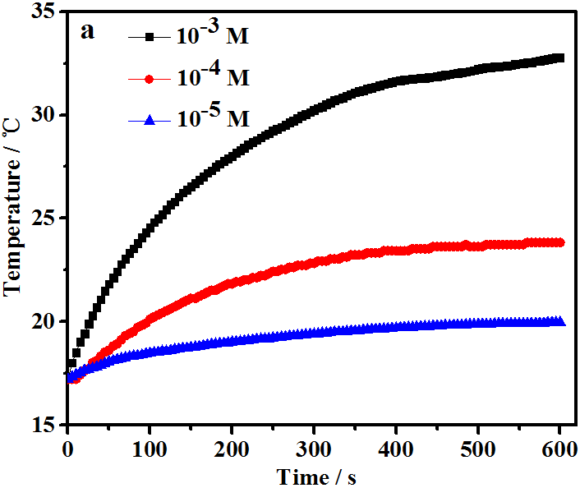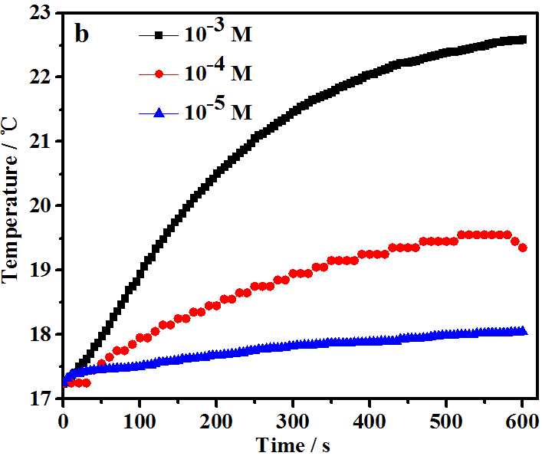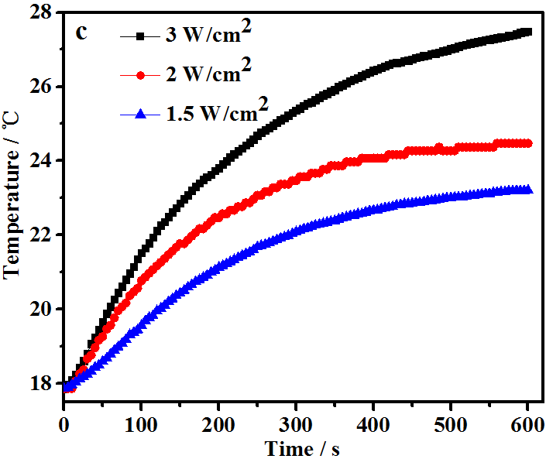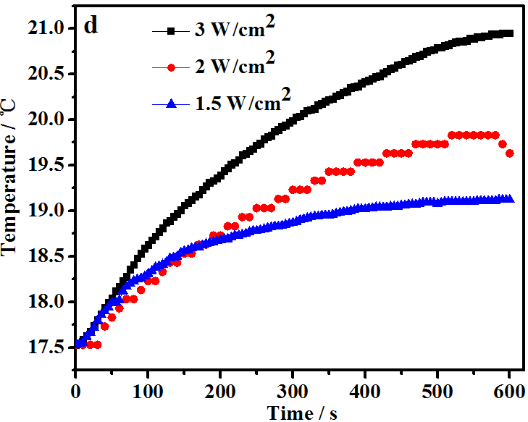

Fig. S14 (a) Photothermal profiles of TPPDI radical anion salt in DMF with different concentrations after 808 nm laser irradiation (2W/cm2) (b) Photothermal profiles of TPPDI radical anion salt in water with different concentrations after 808 nm laser irradiation (2 W/cm2) (c) Photothermal profiles of TPPDI radical anion salt in DMF (10-4 M) after 808 nm laser irradiation with different power density (d) Photothermal profiles of TPPDI radical anion salt in water (10-4 M) after 808 nm laser irradiation with different power density.

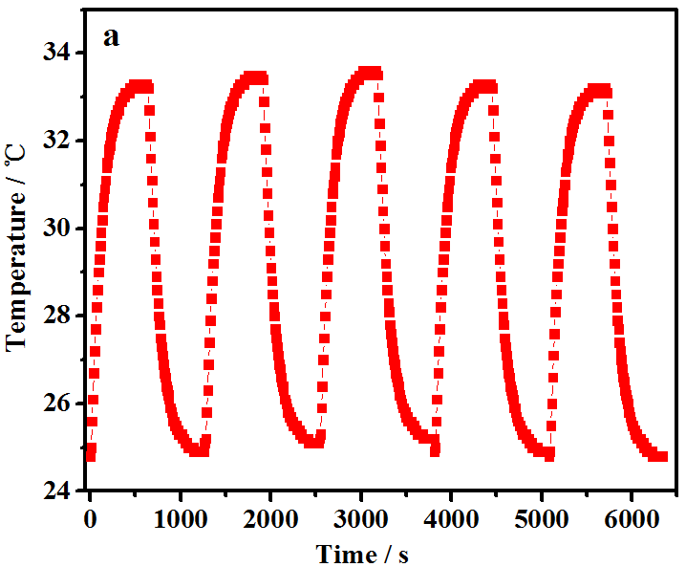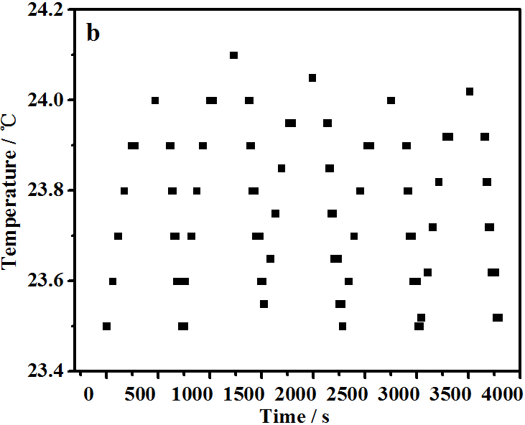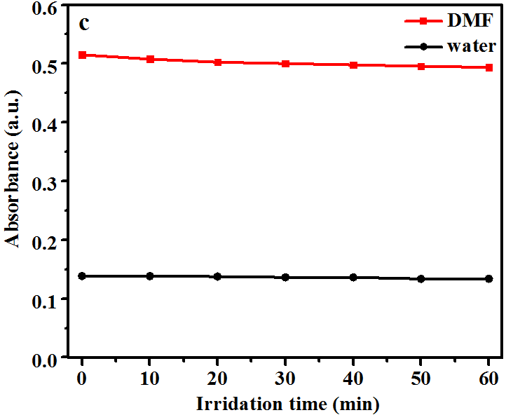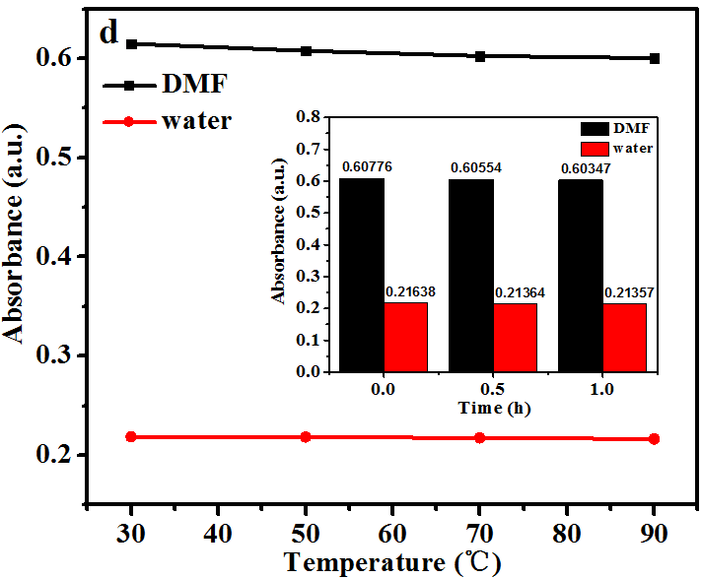

Fig. S15 (a) The temperature change curves after multiple cycles of exposure to the NIR laser (808 nm, 2 W/cm2) of DBrPDI radical anion dissolved in DMF (b) The temperature change curves after multiple cycles of exposure to the NIR laser (808 nm, 2 W/cm2) of DBrPDI radical anion dissolved in water (c) Photostability of DBrPDI radical anion dissolved in DMF and water (d) Thermal stability of DBrPDI radical anion dissolved in DMF and water. (All were with the same concentration: 10-4 M, all used the absorbance at 808 nm as index)

**3. Recalculation of the photothermal conversion efficiency based on the method used by Xi Zhang et al.**

Referring to the calculation method reported by Xi Zhang et al (*Chemical science*, 2015, 6(7): 3975-3980) or Shuo Bai et al (*Chemical Communications*, 2018, 54(18): 2208-2211), found that Xi Zhang or Shuo Baiand coworkers considered *hA* was determined by applying the linear time data from the heating (laser irradiation) period, while in our report, referring to the calculation method reported by Lehui Lu and coworkers(Advanced materials, 2013, 25(9): 1353-1359), *hA* can be determined by applying the linear time data from the cooling period. Detailed calculation method could be referred to the literature reported by Xi Zhang and coworkers. A detailed cross-comparison of these two calculations was carried out. Here, we presented the results obtained by using the same method, as displayed below:

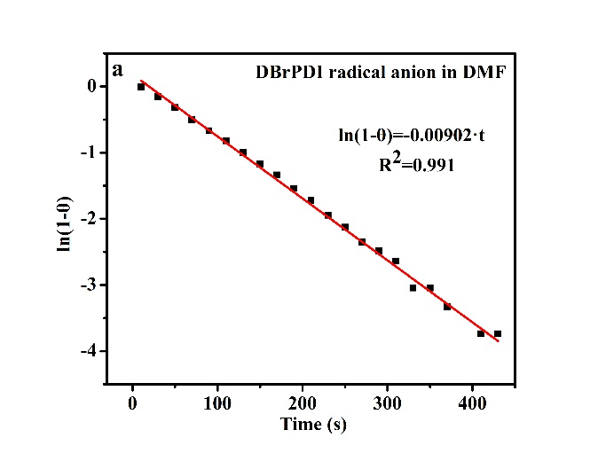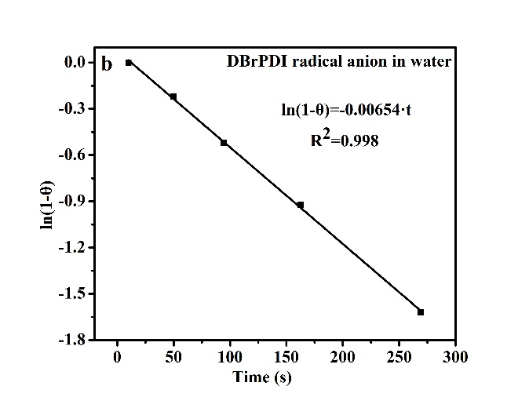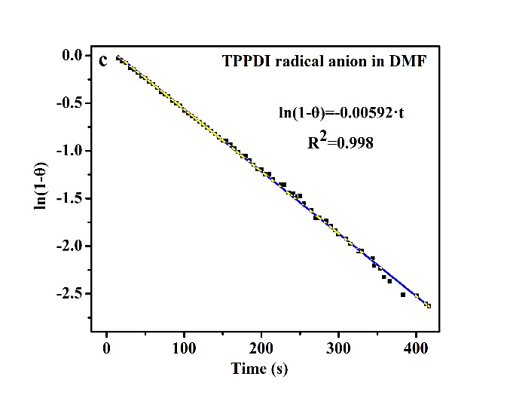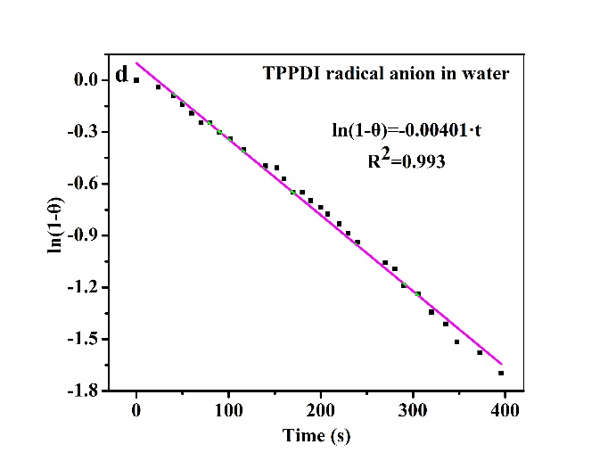

Fig. S16 Linear fitting of the irradiation time data ln(1-θ) versus *t* to give the characteristic rate constant mCp/*hA* for (a) DBrPDI radical anion in DMF; (b)DBrPDI radical anion in deionized water; (c) TPPDI radical anion in DMF; (d) TPPDI radical anion in deionized water.

Table S4 Detailed information about *hA* ofDBrPDI or TPPDI radical anion in DMF or deionized water

|  |  |  |  |  |
| --- | --- | --- | --- | --- |
|  | DBrPDI radical anion | | TPPDI radical anion | |
| solvent | DMF | water | DMF | water |
| *hA* | 0.02736 | 0.04120 | 0.01796 | 0.01930 |

Table S5 Detailed information about *η* ofDBrPDI or TPPDI radical anion in DMF or deionized water

|  |  |  |  |  |
| --- | --- | --- | --- | --- |
|  | DBrPDI radical anion | | TPPDI radical anion | |
| solvent | DMF | water | DMF | water |
| *η* | 84.30% | 14.81% | 54.46% | 50.45% |