Journal of Materials Science

SUPPLEMENTARY MATERIAL

Synthesis and stability of quasicrystalline phase in Al-Cu-Fe-Si mechanically alloyed powders
Mikołaj Mitka, Anna Góral, Lidia Lityńska-Dobrzyńska*
Institute of Metallurgy and Materials Science Polish Academy of Sciences, 30-059 Krakow, 25 Reymonta St., Poland
* Corresponding author e-mail: l.litynska@imim.pl

For the calculation of e/a, we assumed the nominal compositions of the examined powders. For the quaternary Al-Cu-Fe-Si compositions the EDX studies were carried out in TEM. The examples of the STEM-HAADF images and spectra obtained for the marked areas for Si1 and Si2 are shown in Fig. 1. The results of the quantitative microanalysis, when only the main elements were taken into account, were: for Si1 Al59.7-Cu17.7-Fe-12.4-Si10.2 and for Si2 Al54.3-Cu19.9-Fe16.7-Si9.1 (in at.%), which are similar to the planned powders compositions. In both spectra the signals from carbon and oxygen are visible; the EDX results showed about 30 at.% and 5 at.% of these elements, respectively. However, the carbon signal comes mainly from the carbon layer on the nickel grid (line from Ni is also visible), on which the powders for TEM observation have been deposited. The signal from oxygen is usually present on the TEM samples due to the oxide layer on Al containing alloys.
Taking into account that the alloy compositions after milling were similar to the initial compositions (although slight fluctuations were observed), we assumed that we can use nominal composition values for the calculations.

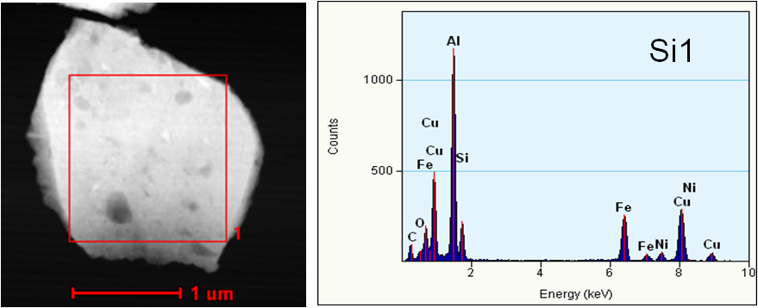

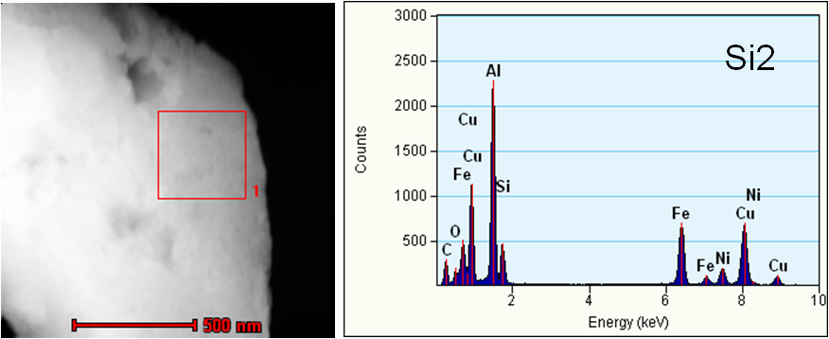

Fig.1. STEM-HAADF images and EDX spectra obtained for the marked areas for Si1-Al_{58.5}Cu₁₈Fe_{13.5}Si₁₀ and Si2-Al_{53.5}Cu_{19.5}Fe₁₇Si₁₀ powders after 10 h of milling

