Supplementary data

Silver Nanoparticles in Complex Biological Media: assessment of colloidal stability and protein corona formation

Simona Argentiere*, Claudia Cella*†‡, Maura Cesaria§, Paolo Milani† and Cristina Lenardi†

* Fondazione Filarete, Viale Ortles 22/4, 20139 Milan (Italy)

† CIMAINA and Dipartimento di Fisica, Università degli Studi di Milano, via Celoria 16, 20133 Milano, Italy

‡ SEMM, European School of Molecular Medicine, Campus IFOM-IEO, via Adamello 16, 20139 Milano, Italy

§ Dipartimento di Matematica e Fisica “Ennio De Giorgi”, Università del Salento, Via per Arnesano, 73100 Lecce (Italy)

simona.argentiere@fondazionefilarete.com

claudia.cella@unimi.it

paolo.milani@mi.infn.it

cristina.lenardi@mi.infn.it

maura.cesaria@le.infn.it

Dr. Simona Argentiere and Claudia Cella contributed equally.

Supplementary methods

Quality control of silver nanoparticles (AgNPs).

In order to prevent contamination, measurements were run using disposable plastic cuvettes. The AgNPs were tested immediately after their delivery.

Dynamic Light Scattering (DLS). The actual size of AgNPs in dispersion was measured by DLS. All the nanoparticles were diluted 1:100 with the exception of 10 nm-sized AgNPs. Indeed, due to their small size, the 10 nm AgNPs presented increased absorption and lower scattering intensity compared to 40 nm and 100 nm AgNPs. Accordingly, the 10 nm AgNPs were diluted 1:50. All measurements were run at room temperature for at least three times.

UV-visible (UV-vis) Spectrophotometry. The UV-Vis spectra were acquired in the 300-800 nm range using a Cary 100 (Agilent) spectrophotometer. All the nanoparticles were diluted 1:100 with the exception of 10 nm AgNPs, which were diluted 1:200 because of their increased UV-Vis absorbance with respect to larger nanoparticles. All measurements were run at room temperature for at least three times.

Transmission Electron Microscopy (TEM). Formvar coated copper TEM grids (cod. PE1GC300, Pelco) were pre-treated with 20 µl of poly-L-lysine 0.01% (w/v) (Sigma Aldrich) for 15 minutes. After washing twice with MilliQ water, 3 µL of AgNPs suspensions were deposited onto the grid for 5 minutes and then rinsed with 3 µl of 2-propanol (Sigma Aldrich). According to the manufacturer’s advice, 100 and 40 nm AgNPs were used at the concentration of 1.0 mg/ml, while 10 nm AgNPs were diluted up to 0.1 mg/ml before use. The grids were allowed to dry overnight at room temperature in a covered crystallizing dish. TEM (FEI Tecnai G2, Eindhoven) images were analyzed with the ImageJ software to obtain the nanoparticles dimensional distribution. In particular, small objects due to background and overlapping nanoparticles were omitted by using proper cut-off filters and Feret diameter (intended as the larger diameter of the NP projection) was used to evaluate the size of the particles. For each sample, a minimum of about 250 nanoparticles was considered.

TEM measurements

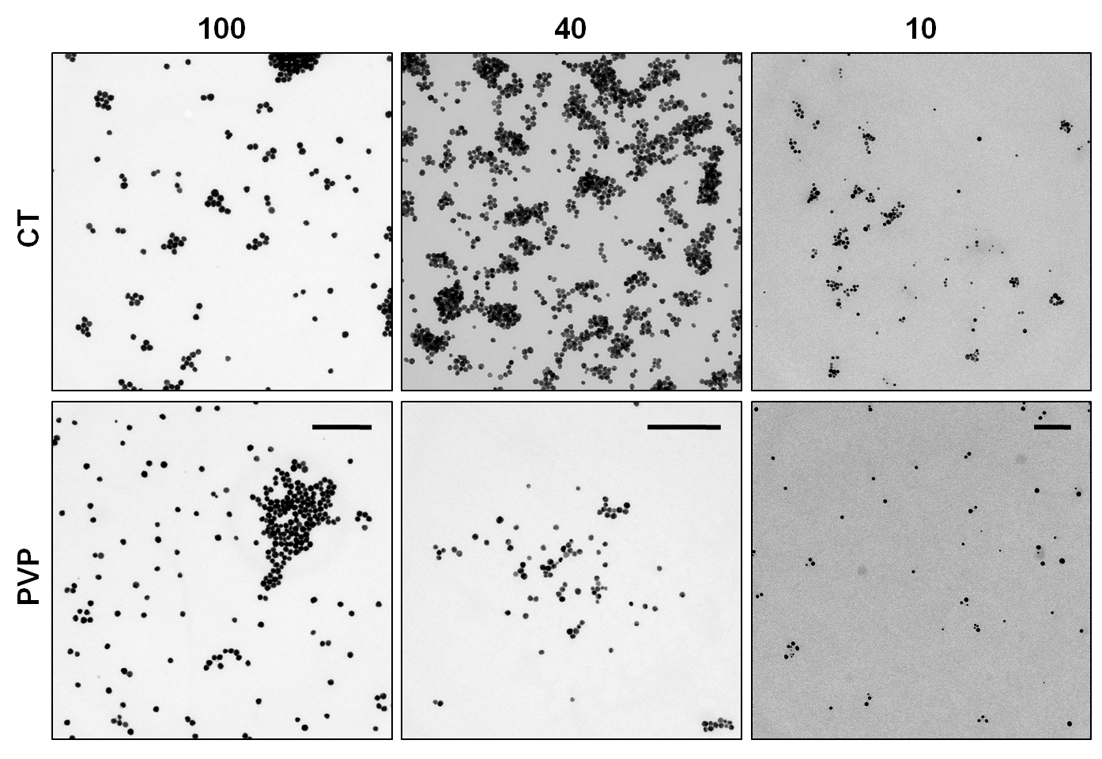

Fig. S1. TEM images of 10 nm, 40 nm and 100 nm-sized AgNPs coated with citrate (CT) and polyvinylpyrrolidone (PVP). Scale bars are: 1 µm for 100CT and 100PVP100 nm-sized AgNPs; 500 nm for 40CT and 40PVP40 nm-sized AgNPs; 100 nm for 10CT and 10PVP10 nm-sized AgNPs.

Particle size analysis

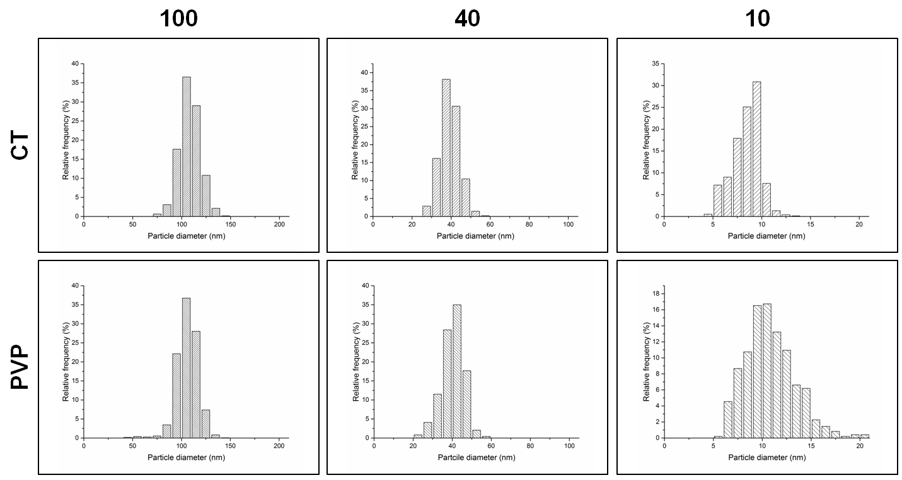

Fig. S2. Feret diameter distributions of 10, 40, 100 nm-sized AgNPs coated with CT or PVP.

Table S1.
 | DLS |  | UV-vis
 | z-average | Polydispersion Index | H_{max} | λ_{max}
10CT | na | na | 145.5 | 392
40CT | 38.79 | 0.153 | 174.8 | 409
100CT | 88.96 | 0.184 | 49.3 | 484
10PVP | na | na | 175.8 | 391
40PVP | 50.60 | 0.236 | 135.5 | 411
100PVP | 104.4 | 0.137 | 46 | 490

Table S1. DLS and UV-vis results after quality control. DLS data for 10 nm-sized AgNPs were not available (na). The H_{max} values were calculated considering the AgNPs dilutions.

The effect of mouse plasma (MP) concentration on 100 and 40nm AgNPs samples: DLS results.

Except the 40PVP sample, the higher the MP content in the suspending medium, the higher was the increase in the hydrodynamic diameter, as shown in Fig. S3.

Overall, the increase in diameter of CT-coated AgNPs was found to be higher than PVP-coated ones, further confirming that AgNPs after PVP coating were stealth.

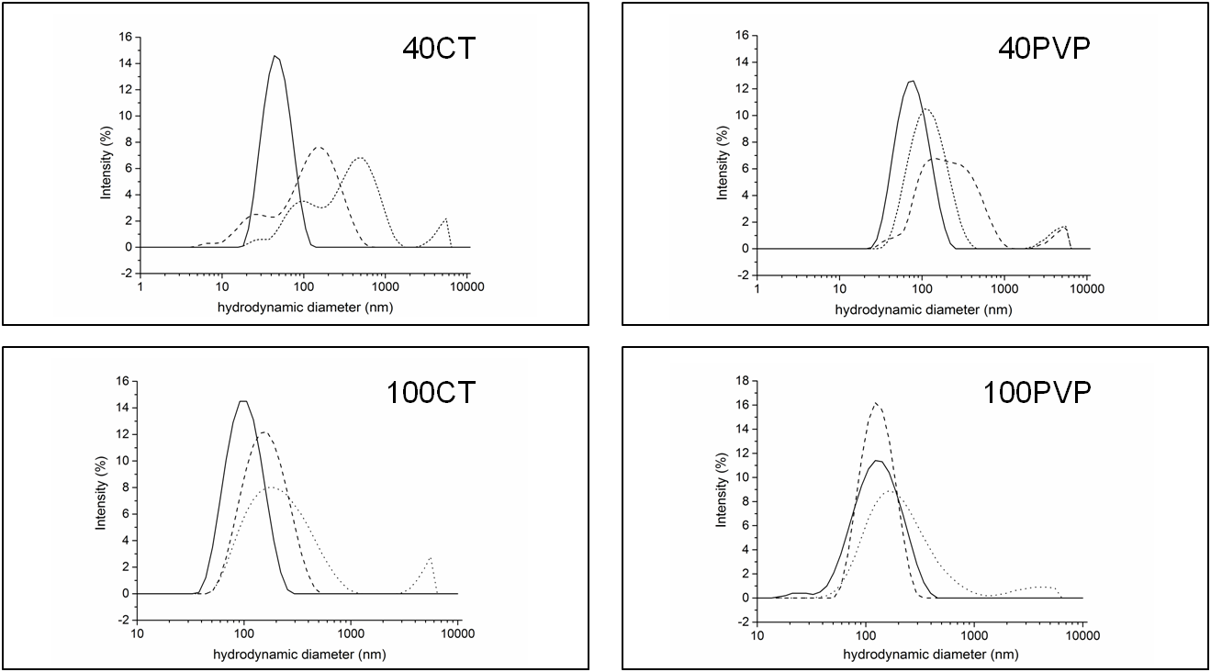

Fig.S3. Size distributions of 40 and 100 nm-sized AgNPs, coated with either CT or PVP after 24h incubation with 10% MP (dash) and 100% MP (dot). The concentration of AgNPs was 50.0 µg/ml. Controls are reported as solid line.

