**Online appendix[1]**

*“***Decision-Making in International Organizations: Institutional Design and Performance***”*

**Figures and Tables**

*Figure A.1: Short-term performance*

*Figure A.2: Long-term performance*

*Figure A.3: Measures of decision-making performance, 30 IOs 1980-2011*

*Figure A.4: Marginal effects of pooling, short-term and long-term performance*

*Figure A.5: Marginal effects of delegation, short-term and long-term performance*

*Figure A.6: Predicted means of DM performance for interaction of delegation and TNA access*

*Figure A.7: Predicted means of DM performance for interaction of pooling and delegation (agenda-sett.)*

*Figure A.8: Comparison of DM performance indices and measure for annual change*

*Table A.1: Selection of IOs and decision-making bodies*

*Table A.2: Distribution of IOs in sample, issue and region*

*Table A.3: Overview resource data (author)*

*Table A.4: Robustness checks, disaggregated index for delegation, independent effects*

*Table A.5: Robustness checks, disaggregated index for delegation, interdependent effects*

*Table A.6: Robustness checks, alternative model specification, part 1*

*Table A.7: Robustness checks, alternative model specification, part 2*

*Figure A.1: Short-term performance*



*Figure A.2: Long-term performance*



*Figure A.3: Measures of decision-making performance, 30 IOs 1980-2011*



*Figure A.4: Marginal effects of pooling, short-term and long-term performance*

**

*Figure A.5: Marginal effects of delegation, short-term and long-term performance*

**

*Figure A.6: Predicted means of DM performance for interaction of delegation and TNA access*

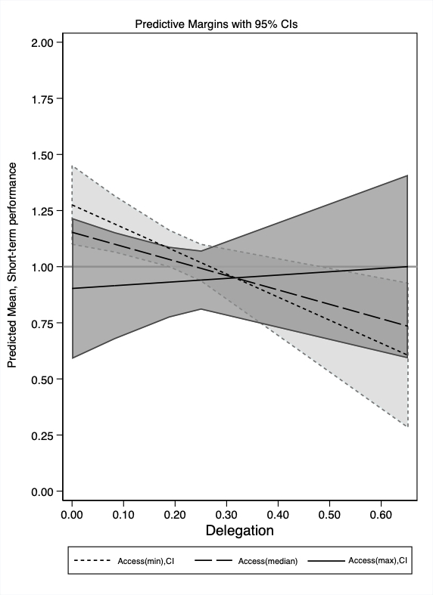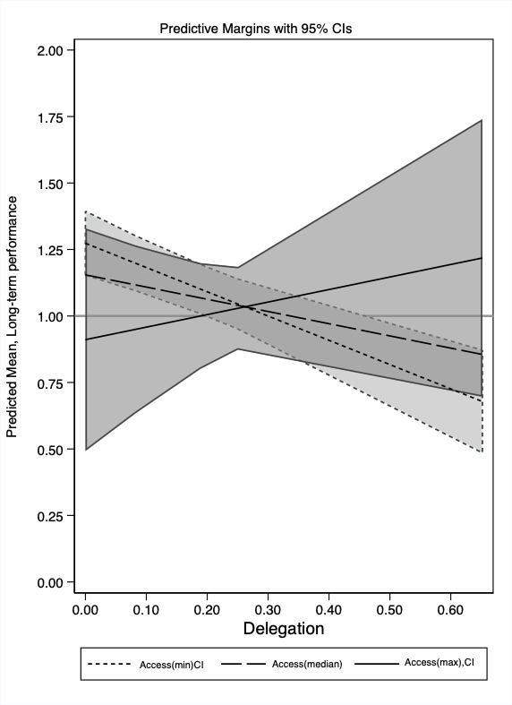

*Figure A.7: Predicted means of DM performance for interaction of pooling and delegation of agenda-setting*

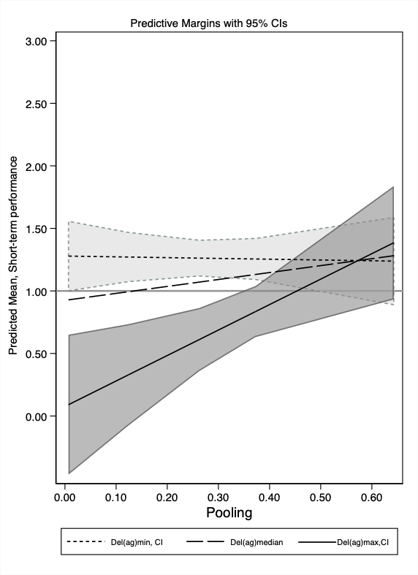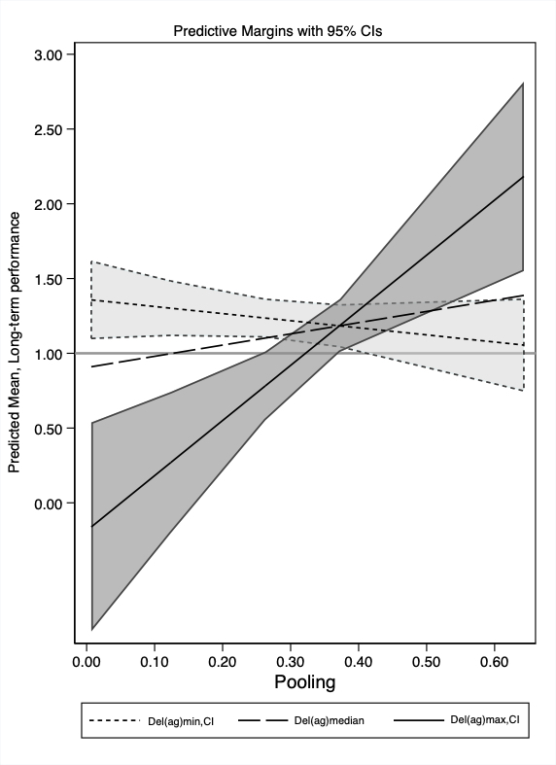

*Figure A.8: Comparison of DM performance indices and measure for annual change*



*Table A.1: Selection of IOs and decision-making bodies*

|  |  |  |  |  |
| --- | --- | --- | --- | --- |
| **IO** |  | **IO Body** | **Data**  **since** | **Average membership**  **size** |
| AMU | Arab Maghreb Union | Presidential Council | 1989 | 5 |
| APEC | Asia-Pacific Economic Cooperation | Leaders’meeting | 1989 | 18 |
| ASEAN | Association of Southeast Asian Nations | Summit | 1980 | 8 |
| AU | African Union | Assembly of the AU | 1980 | 50 |
| CAN | Andean Community | Commission | 1980 | 4 |
| CARICOM | Caribbean Community | Ministerial Councils | 1980 | 13 |
| CoE | Council of Europe | Committee of Ministers | 1980 | 35 |
| CommonW | Commonwealth Secretariat | Heads of Government | 1980 | 49 |
| EU | European Union | Ministerial Council | 1980 | 17 |
| FAO | Food and Agriculture Organization | Council | 1980 | 166 |
| ICC | International Criminal Court | Assembly of State Parties | 2002 | 105 |
| ILO | International Labour Organization | General Conference | 1980 | 164 |
| IMF | International Monetary Fund | Board of Governors | 1980 | 169 |
| IWC | International Whaling Commission | Commission | 1980 | 54 |
| NAFO | Northwest Atlantic Fisheries Organization | Fisheries Commission | 1980 | 14 |
| NAFTA | North American Free Trade Agreement | Free Trade Commission | 1997 | 3 |
| NATO | North Atlantic Treaty Organization | North Atlantic Council | 1980 | 20 |
| NCM | Nordic Council of Ministers | Council | 1980 | 5 |
| OAS | Organization of American States | General Assembly | 1980 | 34 |
| OECD | Organization for Economic Co-operation and Development | Council | 1980 | 28 |
| OIC | Organization of Islamic Cooperation | Conference of Foreign  Ministers | 1980 | 50 |
| OSCE | Organization for Security and Co-operation in Europe | Permanent Council / FSC | 1994 | 54 |
| PIF | Pacific Islands Forum | Heads of State and Government | 1980 | 11 |
| SADC | Southern African Development Community | Heads of State and Government | 1980 | 12 |
| SCO | Shanghai Co-operation Organization | Council of Heads of Member States | 1996 | 6 |
| UN | United Nations | General Assembly | 1980 | 178 |
| UNEP | United Nations Environmental Program | General Council/Assembly | 1980 | 176 |
| UNESCO | UN Educational, Scientific and Cultural Organization | General Conference | 1980 | 173 |
| WHO | World Trade Organization | World Health Assembly | 1980 | 176 |
| WTO | World Trade Organization | General Council | 1995 | 122 |

*Table A.2: Distribution of IOs in sample, issue area and region*

|  |  |  |  |  |  |  |  |
| --- | --- | --- | --- | --- | --- | --- | --- |
|  | **Issue** | | | | | | |
|  |  | Multi-issue | Task-specific | | | | |
| **Region** |  |  | Environment  and Agriculture | Human rights  and Security | Social,  Health,  Culture | Trade  and Finance |  |
| Global | COMW  OECD  OIC  UN | FAO  IWC  NAFO  UNEP | ICC | UNESCO  WHO  ILO | APEC  IMF  WTO | 15 |
| Africa | AMU  AU  SADC |  |  |  |  | 3 |
| Americas | CAN  CARICOM  OAS |  |  |  | NAFTA | 4 |
| Asia | ASEAN  PIF  SCO |  |  |  |  | 3 |
| Europe | EU  NCM |  | COE  OSCE | NATO |  | 5 |
|  |  | 15 | 15 | | | | 30 |

*Table A.3: Overview resource data*

|  |  |  |  |  |  |
| --- | --- | --- | --- | --- | --- |
| **IO** | **Staff in 2015** |  | **Staff category** |  | **Source** |
| ASEAN | 50 |  | Professional staff |  | UIA1; ASEAN secretariat protocols |
| AMU | 40 |  | Secretariat staff |  | UIA, www.libe.me |
| APEC | 21 |  | Professional staff member |  | APEC Administrative Committee |
| AU | 1438 |  | Staff |  | UIA; OAU CM and AU/Assembly |
| CAN | 150 |  | Full time general secretariat |  | UIA |
| CARICOM | 238 |  | Secretariat staff, profess. & support |  | UIA, CARICOM annual report |
| CoE | 1982 |  | Permanent civil servants |  | UIA; COE annual reports and budget |
| Comw | 288 |  | Total secretariat staff |  | Commonwealth library; UIA |
| EU | 24426 |  | Commission total |  | EU commission; AEI3 |
| FAO | 3249 |  | Profess. and gen. service |  | UN Yearbook; FAO reports |
| ICCt | 790 |  | Total staff |  | ICC resolutions |
| ILO | 2895 |  | Full time staff |  | UN Yearbook; ILO reports |
| IMF | 2611 |  | Professional and assistant |  | UN Yearbook; IMF publications |
| IWC | 16 |  | Total staff |  | IWC secretariat annual reports |
| NAFO | 11 |  | Staff |  | NAFO annual report, UIA |
| NAFTA | 4 |  | FTE Canada |  | NAFTA secretariat - Canadian Section |
| NATO | 4200 |  | International staff |  | UIA; US budget; German federal budget |
| OAS | 551 |  | Total staff |  | OAS archive |
| OECD | 2880 |  | All paid staff |  | OECD SG reports; financial statements |
| OIC | 200 |  | Paid staff |  | UIA; OIC resolutions |
| OSCE | 284 |  | OSCE posts |  | OSCE annual reports |
| PIF | 84 |  | Secretariat staff |  | PIF annual reports |
| SADC | 92 |  | Staff |  | UIA |
| UN | 20303 |  | Secretariat staff |  | UN yearbook; UN digital library |
| UNEP | 869 |  | Paid staff |  | UIA |
| UNESCO | 2113 |  | Profess. and gen. service |  | UN Yearbook; UNESCO library |
| WHO | 6237 |  | Full-time staff |  | UN Yearbook; WHO documents |
| WTO | 647 |  | Regular staff |  | WTO annual report; UIA; GATT archive |

The categories of staff vary across organization. We chose the category where the data quality was for over time within IO-comparisons. 1 UIA = Yearbookof International Organizations, Union of International Associations.

2 http://mddb.apec.org/Documents/2015/MM/AMM/15_amm_014.pdf  3Archive of European Integration, University of Pittsburgh.

*Table A.4 Robustness checks, disaggregation for delegation measure, independent effects (Table 1)*

|  |  |  |  |  |  |  |
| --- | --- | --- | --- | --- | --- | --- |
|  | 13 | 14 | 15 | 16 | 17 | 18 |
| Pooling | 0.504 | 0.189 | 0.231 | 0.650 | 0.565 | 0.523 |
|  | [0.311] | [0.305] | [0.292] | [0.291]* | [0.228]* | [0.240]* |
| Delegation on agenda-setting | -0.740 |  |  | -0.285 |  |  |
|  | [0.325]* |  |  | [0.374] |  |  |
| Delegation on final decisions |  | -0.537 |  |  | 0.069 |  |
|  |  | [0.332] |  |  | [0.411] |  |
| Delegation on dispute settlement |  |  | -0.165 |  |  | -0.192 |
|  |  |  | [0.113] |  |  | [0.067]** |
| TNA access | -0.049 | -0.066 | -0.046 | 0.005 | -0.002 | 0.021 |
|  | [0.096] | [0.095] | [0.093] | [0.100] | [0.100] | [0.096] |
| Membership | 0.001 | 0.003 | 0.002 | -0.002 | -0.002 | -0.002 |
|  | [0.002] | [0.002] | [0.002] | [0.003] | [0.003] | [0.003] |
| Policy scope | -0.001 | 0.005 | 0.003 | -0.004 | -0.004 | -0.002 |
|  | [0.007] | [0.010] | [0.007] | [0.005] | [0.008] | [0.005] |
| IO staff | 0.013 | -0.002 | 0.002 | 0.028 | 0.023 | 0.024 |
|  | [0.030] | [0.038] | [0.038] | [0.026] | [0.032] | [0.030] |
| Relevant IOs in system | 0.004 | 0.004 | 0.003 | 0.013 | 0.013 | 0.012 |
| [0.003]+ | [0.003] | [0.003] | [0.005]** | [0.005]** | [0.005]* |
| Unchallenged major power | -0.127 | -0.158 | -0.172 | -0.097 | -0.109 | -0.126 |
| [0.131] | [0.133] | [0.134] | [0.080] | [0.083] | [0.082] |
| Democratic density | -0.319 | -0.322 | -0.343 | 0.333 | 0.344 | 0.291 |
|  | [0.259] | [0.271] | [0.291] | [0.238] | [0.242] | [0.266] |
| UNGA preferences | -0.366 | -0.284 | -0.393 | 0.049 | 0.054 | -0.006 |
|  | [0.433] | [0.409] | [0.438] | [0.358] | [0.347] | [0.360] |
| Media coverage | 0.018 | 0.013 | 0.014 | 0.011 | 0.009 | 0.010 |
|  | [0.014] | [0.013] | [0.013] | [0.012] | [0.012] | [0.011] |
| N. of decisions | -0.058 | -0.064 | -0.058 | 0.057 | 0.057 | 0.059 |
|  | [0.028]* | [0.028]* | [0.028]* | [0.030]+ | [0.030]+ | [0.031]+ |
| Bindingness | 0.339 | 0.319 | 0.311 | 0.209 | 0.199 | 0.195 |
|  | [0.229] | [0.240] | [0.238] | [0.086]* | [0.089]* | [0.089]* |
| Communiqué-based | 1.262 | 1.099 | 1.071 | 2.033 | 2.049 | 1.819 |
|  | [0.438]** | [0.455]* | [0.481]* | [0.484]** | [0.523]** | [0.558]** |
| Constant | -0.298 | -0.104 | 0.119 | -3.327 | -3.334 | -2.869 |
|  | [1.017] | [1.068] | [1.178] | [1.340]* | [1.358]* | [1.461]* |
| N | 579 | 579 | 579 | 579 | 579 | 579 |
| Ll | -11.95 | -14.40 | -13.85 | 139.52 | 138.81 | 141.04 |
| AIC | 73.9 | 78.8 | 77.7 | -229.0 | -227.6 | -232.1 |

+ p<0.1; * p<0.05; ** p<0.01 GLM estimator (STATA 16.1), clustered by IOs; Robust standard errors in parentheses. IO-dummies, year dummies and trend included, but not displayed.

*Table A.5: Robustness checks, disaggregation for delegation measure, interdependent effects (Table 2)*

|  |  |  |  |  |  |  |  |  |  |  |  |  |
| --- | --- | --- | --- | --- | --- | --- | --- | --- | --- | --- | --- | --- |
|  | 19 | 20 | 21 | 22 | 23 | 24 | 25 | 26 | 27 | 28 | 29 | 30 |
| Pooling | -0.063 | 0.248 | 0.474 | 0.538 | 0.213 | 0.243 | -0.475 | 0.547 | 0.303 | 0.727 | 0.576 | 0.535 |
|  | [0.448] | [0.311] | [0.449] | [0.315]+ | [0.305] | [0.290] | [0.406] | [0.237]* | [0.376] | [0.282]** | [0.225]* | [0.229]* |
| Delegation on agenda-setting | -1.700 |  |  | -0.815 |  |  | -2.187 |  |  | -0.454 |  |  |
|  | [0.561]** |  |  | [0.349]* |  |  | [0.668]** |  |  | [0.401] |  |  |
| Delegation on final decision |  | 0.027 |  |  | -1.655 |  |  | -0.098 |  |  | -0.462 |  |
|  |  | [0.514] |  |  | [0.985]+ |  |  | [0.569] |  |  | [0.485] |  |
| Delegation on dispute settlement |  |  | -0.024 |  |  | -0.292 |  |  | -0.320 |  |  | -0.327 |
|  |  |  | [0.221] |  |  | [0.125]* |  |  | [0.181]+ |  |  | [0.095]** |
| TNA access | -0.054 | -0.089 | -0.035 | -0.144 | -0.065 | -0.252 | -0.005 | 0.005 | 0.011 | -0.211 | -0.002 | -0.198 |
|  | [0.092] | [0.107] | [0.092] | [0.178] | [0.099] | [0.136]+ | [0.084] | [0.100] | [0.095] | [0.178] | [0.101] | [0.162] |
| Pooling * delegation(agenda) | 2.967 |  |  |  |  |  | 5.882 |  |  |  |  |  |
|  | [1.415]* |  |  |  |  |  | [1.841]** |  |  |  |  |  |
| Pooling * delegation(final) |  | -2.234 |  |  |  |  |  | 0.661 |  |  |  |  |
|  |  | [2.176] |  |  |  |  |  | [2.074] |  |  |  |  |
| Pooling * delegation(dispute) |  |  | -0.546 |  |  |  |  |  | 0.495 |  |  |  |
|  |  |  | [0.879] |  |  |  |  |  | [0.825] |  |  |  |
| Delegation(agenda) * access |  |  |  | 0.308 |  |  |  |  |  | 0.699 |  |  |
|  |  |  |  | [0.433] |  |  |  |  |  | [0.467] |  |  |
| Delegation(final) * access |  |  |  |  | 1.234 |  |  |  |  |  | 0.586 |  |
|  |  |  |  |  | [0.956] |  |  |  |  |  | [0.380] |  |
| Delegation(dispute) * access |  |  |  |  |  | 0.380 |  |  |  |  |  | 0.404 |
|  |  |  |  |  |  | [0.227]+ |  |  |  |  |  | [0.266] |
| Membership | 0.001 | 0.003 | 0.002 | 0.001 | 0.003 | 0.002 | -0.003 | -0.002 | -0.003 | -0.003 | -0.002 | -0.002 |
|  | [0.001] | [0.002] | [0.002] | [0.002] | [0.002]+ | [0.002] | [0.003] | [0.003] | [0.003] | [0.003] | [0.003] | [0.003] |
| Policy scope | -0.005 | 0.005 | 0.003 | -0.002 | 0.002 | 0.002 | -0.012 | -0.004 | -0.001 | -0.007 | -0.005 | -0.002 |
|  | [0.007] | [0.010] | [0.007] | [0.007] | [0.011] | [0.007] | [0.005]* | [0.008] | [0.005] | [0.005] | [0.008] | [0.005] |
| IO staff | 0.029 | -0.003 | -0.004 | 0.015 | 0.003 | 0.011 | 0.059 | 0.024 | 0.030 | 0.031 | 0.026 | 0.033 |
|  | [0.024] | [0.038] | [0.039] | [0.030] | [0.040] | [0.040] | [0.023]* | [0.032] | [0.036] | [0.026] | [0.033] | [0.032] |
| Relevant IOs in system | 0.005 | 0.004 | 0.003 | 0.004 | 0.004 | 0.004 | 0.014 | 0.013 | 0.012 | 0.013 | 0.013 | 0.013 |
| [0.003]+ | [0.003] | [0.003] | [0.003]+ | [0.003] | [0.003] | [0.005]** | [0.005]** | [0.005]* | [0.005]** | [0.005]** | [0.006]* |
| Unchallenged major power | -0.130 | -0.160 | -0.181 | -0.126 | -0.149 | -0.146 | -0.102 | -0.109 | -0.117 | -0.094 | -0.105 | -0.097 |
| [0.130] | [0.132] | [0.141] | [0.131] | [0.119] | [0.135] | [0.078] | [0.083] | [0.086] | [0.079] | [0.078] | [0.084] |
| Democratic density | -0.373 | -0.346 | -0.366 | -0.322 | -0.317 | -0.304 | 0.226 | 0.351 | 0.312 | 0.327 | 0.346 | 0.332 |
|  | [0.244] | [0.276] | [0.314] | [0.258] | [0.260] | [0.291] | [0.227] | [0.243] | [0.281] | [0.241] | [0.241] | [0.267] |
| UNGA preferences | -0.495 | -0.248 | -0.333 | -0.383 | -0.335 | -0.426 | -0.206 | 0.044 | -0.060 | 0.012 | 0.030 | -0.041 |
|  | [0.428] | [0.404] | [0.395] | [0.435] | [0.426] | [0.442] | [0.385] | [0.349] | [0.371] | [0.364] | [0.353] | [0.367] |
| Media coverage | 0.017 | 0.015 | 0.015 | 0.018 | 0.013 | 0.011 | 0.007 | 0.008 | 0.009 | 0.010 | 0.009 | 0.007 |
|  | [0.013] | [0.013] | [0.014] | [0.014] | [0.013] | [0.014] | [0.012] | [0.012] | [0.012] | [0.012] | [0.012] | [0.012] |
| N. of decisions | -0.062 | -0.064 | -0.059 | -0.057 | -0.061 | -0.061 | 0.049 | 0.056 | 0.060 | 0.061 | 0.058 | 0.056 |
|  | [0.029]* | [0.028]* | [0.027]* | [0.029]* | [0.029]* | [0.029]* | [0.030] | [0.030]+ | [0.031]+ | [0.031]* | [0.031]+ | [0.031]+ |
| Bindingness | 0.322 | 0.316 | 0.315 | 0.337 | 0.337 | 0.317 | 0.175 | 0.200 | 0.191 | 0.205 | 0.207 | 0.202 |
|  | [0.240] | [0.240] | [0.244] | [0.229] | [0.251] | [0.234] | [0.095]+ | [0.089]* | [0.089]* | [0.085]* | [0.093]* | [0.087]* |
| Communiqué-based | 1.404 | 0.942 | 1.067 | 1.252 | 1.003 | 1.140 | 2.313 | 2.096 | 1.822 | 2.011 | 2.004 | 1.892 |
|  | [0.405]** | [0.465]* | [0.489]* | [0.444]** | [0.413]* | [0.462]* | [0.444]** | [0.531]** | [0.546]** | [0.480]** | [0.493]** | [0.536]** |
| Constant | -0.210 | 0.062 | 0.143 | -0.264 | 0.049 | -0.146 | -3.153 | -3.383 | -2.891 | -3.250 | -3.261 | -3.151 |
|  | [1.047] | [1.082] | [1.223] | [1.015] | [1.046] | [1.105] | [1.341]* | [1.400]* | [1.459]* | [1.321]* | [1.339]* | [1.529]* |
| N | 579 | 579 | 579 | 579 | 579 | 579 | 579 | 579 | 579 | 579 | 579 | 579 |
| Ll | -10.72 | -14.16 | -13.61 | -11.82 | -13.35 | -12.59 | 147.81 | 138.84 | 141.38 | 140.69 | 139.21 | 143.48 |
| AIC | 71.4 | 78.3 | 77.2 | 73.6 | 76.7 | 75.2 | -245.6 | -227.7 | -232.8 | -231.4 | -228.4 | -237.0 |

+ p<0.1; * p<0.05; ** p<0.01 GLM estimator (STATA 16.1), clustered by IOs; Robust standard errors in parentheses. IO-dummies, year dummies and trend included, but not displayed.

*Table A.6: Robustness checks, alternative model specification part 1*

|  |  |  |  |  |  |  |  |  |  |  |
| --- | --- | --- | --- | --- | --- | --- | --- | --- | --- | --- |
|  | 31 | 32 | 33 | 34 | 35 | 36 | 37 | 38 | 39 | 40 |
|  | Change(t-1) | LT | ST | LT | ST | LT | ST | LT | ST | LT |
|  | log | no Log | No extreme | | OLS | | no Year-FE | | No IO-FE | |
| Pooling | 1.039 | 344.155 | 0.073 | 0.251 | 0.267 | 0.561 | 0.058 | 0.237 | 0.037 | 0.166 |
|  | [0.343]** | [92.977]** | [0.104] | [0.124]* | [0.304] | [0.254]* | [0.269] | [0.203] | [0.093] | [0.163] |
| Delegation | -1.166 | -368.111 | -0.270 | -0.612 | -0.746 | -0.582 | -0.498 | -0.485 | -0.182 | -0.557 |
|  | [0.286]** | [132.455]** | [0.147]+ | [0.110]** | [0.355]* | [0.170]** | [0.283]+ | [0.178]** | [0.153] | [0.230]* |
| TNA access | 0.173 | 86.685 | 0.005 | 0.023 | -0.031 | 0.026 | -0.051 | -0.004 | 0.040 | 0.166 |
|  | [0.143] | [49.853]+ | [0.032] | [0.064] | [0.096] | [0.104] | [0.086] | [0.103] | [0.065] | [0.074]* |
| Membership | -0.001 | 1.639 | -0.000 | -0.001 | 0.002 | -0.002 | -0.000 | -0.003 | -0.001 | -0.004 |
|  | [0.006] | [0.797]* | [0.001] | [0.002] | [0.002] | [0.003] | [0.002] | [0.003] | [0.001] | [0.001]** |
| Policy scope | -0.019 | 2.367 | -0.005 | 0.000 | 0.005 | -0.001 | 0.001 | -0.005 | -0.000 | -0.014 |
|  | [0.014] | [2.815] | [0.004] | [0.004] | [0.007] | [0.006] | [0.006] | [0.007] | [0.005] | [0.004]** |
| IO staff | 0.114 | 12.253 | -0.001 | 0.011 | 0.005 | 0.026 | 0.007 | 0.026 | 0.009 | 0.072 |
|  | [0.046]* | [5.842]* | [0.011] | [0.010] | [0.037] | [0.030] | [0.034] | [0.030] | [0.025] | [0.024]** |
| Relevant IOs in system | -0.002 | 3.077 | -0.001 | 0.003 | 0.003 | 0.012 | 0.003 | 0.005 | 0.000 | -0.001 |
| [0.006] | [1.683]+ | [0.002] | [0.002] | [0.003] | [0.005]* | [0.002]+ | [0.003]+ | [0.001] | [0.001] |
| Unchallenged major power | -0.273 | 21.349 | 0.011 | -0.039 | -0.169 | -0.117 | -0.148 | -0.102 | -0.022 | -0.178 |
| [0.125]* | [32.696] | [0.039] | [0.048] | [0.139] | [0.086] | [0.145] | [0.087] | [0.062] | [0.053]** |
| Democratic density | -0.113 | 77.734 | 0.106 | 0.276 | -0.381 | 0.278 | -0.335 | 0.273 | -0.109 | -0.408 |
|  | [0.490] | [117.072] | [0.126] | [0.151]+ | [0.317] | [0.286] | [0.275] | [0.250] | [0.093] | [0.097]** |
| UNGA preferences | -0.294 | 229.009 | 0.110 | 0.093 | -0.408 | 0.004 | -0.398 | -0.064 | -0.074 | -0.694 |
|  | [0.410] | [128.313]+ | [0.128] | [0.144] | [0.473] | [0.394] | [0.419] | [0.344] | [0.147] | [0.192]** |
| Media coverage | 0.021 | 2.855 | 0.018 | 0.016 | 0.017 | 0.012 | 0.008 | 0.001 | 0.003 | -0.017 |
|  | [0.025] | [5.652] | [0.005]** | [0.007]* | [0.014] | [0.012] | [0.013] | [0.013] | [0.010] | [0.014] |
| N. of decisions | -0.440 | 26.366 | -0.048 | 0.065 | -0.058 | 0.059 | -0.066 | 0.053 | -0.006 | 0.019 |
|  | [0.087]** | [12.543]* | [0.012]** | [0.023]** | [0.030]+ | [0.033]+ | [0.029]* | [0.032]+ | [0.011] | [0.018] |
| Bindingness | 0.239 | 37.022 | 0.083 | 0.123 | 0.319 | 0.203 | 0.344 | 0.232 | 0.054 | 0.165 |
|  | [0.142]+ | [36.220] | [0.040]* | [0.065]+ | [0.253] | [0.094]* | [0.252] | [0.090]* | [0.045] | [0.039]** |
| Communiqué-based | 1.514 | 599.443 | 0.098 | 0.491 | 0.911 | 1.763 | 0.742 | 1.135 | 0.037 | 0.060 |
|  | [0.841]+ | [161.825]** | [0.220] | [0.265]+ | [0.525]+ | [0.594]** | [0.451] | [0.484]* | [0.040] | [0.041] |
| Constant | 0.517 | -1,427.762 | 1.272 | -0.205 | 0.376 | -2.219 | 0.611 | -0.492 | 1.154 | 2.025 |
|  | [1.621] | [485.999]** | [0.611]* | [0.591] | [1.017] | [1.272]+ | [0.479] | [0.619] | [0.214]** | [0.261]** |
| N | 576 | 598 | 515 | 521 | 579 | 579 | 579 | 579 | 579 | 579 |
| Ll | -278.28 | -3,464.64 | 509.49 | 422.04 | -12.19 | 141.53 | -30.22 | 121.75 | -47.86 | 60.25 |
| AIC | 606.6 | 6979.3 | -971.0 | -796.1 | 74.4 | -233.1 | 88.4 | -215.5 | 149.7 | -66.5 |

+ p<0.1; * p<0.05; ** p<0.01 GLM estimator (STATA 16.1), clustered by IOs; Robust standard errors in parentheses. IO-dummies, year dummies and trend included, but not displayed.

*Table A.7: Robustness checks, alternative model specification part 2*

|  |  |  |  |  |  |  |  |  |  |
| --- | --- | --- | --- | --- | --- | --- | --- | --- | --- |
|  | 41 | 42 | 43 | 44 | 45 | 46 | 47 | 48 | 49 |
|  | ST | LT | LT | ST | LT | ST | LT | ST | LT |
|  | LDV | | | No communiqué-based IOs | | No 1980s | | No UN, EU | |
| LDV | 0.243 | 0.280 | 0.269 |  |  |  |  |  |  |
|  | [0.101]* | [0.198] | [0.111]* |  |  |  |  |  |  |
| Pooling | 0.387 | 0.655 | 0.656 | -0.023 | 0.646 | 0.052 | 0.586 | 0.322 | 0.573 |
|  | [0.228]+ | [0.207]** | [0.204]** | [0.449] | [0.358]+ | [0.357] | [0.222]** | [0.301] | [0.259]* |
| Delegation | -0.629 | -0.621 | -0.627 | -1.280 | -0.926 | -1.029 | -0.806 | -0.744 | -0.530 |
|  | [0.314]* | [0.209]** | [0.193]** | [0.459]** | [0.171]** | [0.529]+ | [0.279]** | [0.333]* | [0.180]** |
| TNA access | -0.016 | 0.077 | 0.076 | 0.148 | 0.124 | -0.094 | -0.077 | -0.050 | 0.041 |
|  | [0.101] | [0.076] | [0.076] | [0.115] | [0.121] | [0.108] | [0.117] | [0.111] | [0.101] |
| Membership | 0.002 | -0.000 | -0.000 | 0.004 | -0.000 | 0.002 | -0.001 | 0.001 | -0.004 |
|  | [0.002] | [0.003] | [0.002] | [0.003] | [0.004] | [0.002] | [0.004] | [0.002] | [0.004] |
| Policy scope | -0.003 | -0.005 | -0.005 | 0.003 | -0.010 | 0.007 | -0.000 | 0.002 | -0.008 |
|  | [0.006] | [0.006] | [0.005] | [0.010] | [0.008] | [0.009] | [0.008] | [0.012] | [0.010] |
| IO staff | 0.051 | 0.059 | 0.058 | 0.044 | 0.172 | 0.018 | 0.024 | 0.010 | 0.040 |
|  | [0.027]+ | [0.023]* | [0.018]** | [0.065] | [0.111] | [0.042] | [0.026] | [0.043] | [0.034] |
| Relevant IOs in system | -0.000 | 0.007 | 0.007 | 0.001 | 0.009 | -0.003 | 0.001 | 0.002 | 0.012 |
|  | [0.002] | [0.005] | [0.004]+ | [0.004] | [0.006] | [0.006] | [0.005] | [0.003] | [0.005]* |
| Unchallenged major power | -0.173 | -0.106 | -0.104 | -0.210 | -0.058 | -0.279 | -0.162 | -0.180 | -0.142 |
|  | [0.109] | [0.069] | [0.062]+ | [0.180] | [0.120] | [0.234] | [0.143] | [0.139] | [0.086] |
| Democratic density | -0.433 | -0.053 | -0.051 | -0.175 | 0.582 | -0.924 | -0.200 | -0.436 | 0.235 |
|  | [0.212]* | [0.245] | [0.235] | [0.513] | [0.438] | [0.275]** | [0.375] | [0.314] | [0.274] |
| UNGA preferences | -0.412 | -0.061 | -0.057 | -0.078 | 0.761 | -0.732 | -0.447 | -0.442 | -0.132 |
|  | [0.373] | [0.359] | [0.340] | [0.706] | [0.546] | [0.355]* | [0.276] | [0.544] | [0.428] |
| Media coverage | -0.004 | -0.006 | -0.006 | 0.003 | -0.007 | 0.019 | 0.026 | 0.017 | 0.012 |
|  | [0.012] | [0.009] | [0.009] | [0.020] | [0.015] | [0.015] | [0.013]+ | [0.014] | [0.012] |
| N. of decisions | -0.115 | -0.006 |  | -0.087 | 0.068 | -0.074 | 0.021 | -0.065 | 0.049 |
|  | [0.043]** | [0.060] |  | [0.035]* | [0.033]* | [0.031]* | [0.035] | [0.032]* | [0.034] |
| Bindingness | 0.299 | 0.196 | 0.195 | 0.424 | 0.191 | 0.549 | 0.366 | 0.338 | 0.246 |
|  | [0.177]+ | [0.061]** | [0.054]** | [0.298] | [0.094]* | [0.279]* | [0.080]** | [0.256] | [0.092]** |
| Communiqué-based | 0.745 | 1.407 | 1.411 |  |  | 0.427 | 1.185 | 0.821 | 1.678 |
|  | [0.383]+ | [0.547]* | [0.523]** |  |  | [0.773] | [0.723] | [0.506] | [0.572]** |
| Constant | 0.938 | -1.875 | -1.913 |  |  | 2.397 | 0.378 | 0.734 | -2.526 |
|  | [1.003] | [1.493] | [1.298] |  |  | [1.978] | [1.686] | [1.293] | [1.519]+ |
| N | 551 | 551 | 551 | 426 | 426 | 446 | 446 | 519 | 519 |
| Ll | 8.13 | 172.42 | 172.40 | -31.59 | 100.58 | 10.35 | 138.77 | -36.31 | 104.40 |
| AIC | 31.7 | -296.8 | -296.8 | 97.2 | -167.2 | 27.3 | -229.5 | 118.6 | -162.8 |

+ p<0.1; * p<0.05; ** p<0.01 GLM estimator (STATA 16.1), clustered by IOs; Robust standard errors in parentheses. IO-dummies, year dummies and trend included, but not displayed.

1. The online appendix is available on the *Review of International Organization*s' webpage.