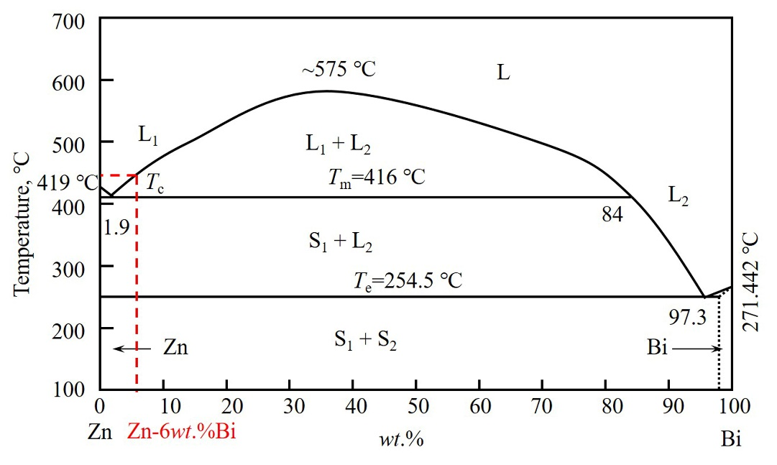
Supplementary figure 1: Phase diagram of Zn-Bi. T_{c} is the critical temperature, T_{m} is the monotectic reaction temperature, and T_{e} is the eutectic reaction temperature. L₁ is the liquid Zn-rich phase L₂ is the liquid Bi-rich phase, S₁ is the solid Zn-rich phase and S₂ is the solid Bi-rich phase.

