Supplementary Materials

Interfacial effect on the deformation mechanism of bulk nanolaminated graphene−Al composites

Lei Zhaoª, Qiang Guo^{a, *}, Yan Shiª, Yu Liuª, Shmuel Osovski^{b}, Zhiqiang Liª, Ding-Bang Xiongª, Yishi Suª, Di Zhang^{a, *}

ªState Key Lab of Metal Matrix Composites, Shanghai Jiao Tong University, 800 Dongchuan Road, Shanghai, 200240, China.
^{b}Faculty of Mechanical Engineering, Technion- Israel Institute of Technology, Haifa, 32000, Israel.

* Corresponding authors: guoq@sjtu.edu.cn (Guo Q); zhangdi@sjtu.edu.cn (Zhang D)
(Tel: +86-21-34202634; Fax: +86-21-34202749)

Experimental details
Bulk laminated RGO–Al composites with approximately 1 μm, 500 nm and 200 nm Al lamella thicknesses were fabricated via a modified powder metallurgy route, developed in our previous work [1,2]. First, RGO (99% purity, Nanjing XFNano Material Tech Co. Ltd., China) was added to an effective non-ionic surfactant TNWDIS (Chengdu Organic Chemical Co. Ltd., China) solution, and then sonicated by an ultrasonic homogenizer in ice base, forming a RGO suspension. Spherical Al powders (10 μm average particle size, 99.99% purity, Henan Yuanyang Co. Ltd., China) were ball-milled in ethanol for 1 h, 2 h, and 4 h to obtain Al flakes of different thicknesses. Suspensions containing different concentrations of RGO were mixed with the Al flakes of different thicknesses in ethanol and the mixture were stirred at a speed of 400 rpm for 30 min. This was followed by vacuum-drying at 333 K for 24 h to obtain RGO−Al composite powders with the same RGO platelet coverage of ~20% on the surface of Al flakes for all three flake thicknesses (so the total coverage at the resulting inter-lamella interfaces in the as-fabricated composites was at most 40%, Supplementary Fig. S1). Subsequently, the composite powders were compacted under 500 MPa at room temperature, hot pressed under 600 MPa at 500 °C for 1 h, and finally hot rolled at 350 °C to obtain densified RGO−Al composites with a laminated structure. Unreinforced Al samples with identical lamella thicknesses were fabricated using the same processing parameters for comparison. 10 mm-gauge length, 1 mm-thickness tensile specimens with tensile axis parallel to the laminates were cut by an electro-discharging machine and were polished using sandpapers down to the metallurgical grit of 4000. Uniaxial tensile tests were conducted in the Instron 8848 universal testing machine at room temperature, with a constant strain rate of 5×10⁻⁴ s⁻¹, and at least five tensile tests were carried out for each set of samples. JEOL 2100F transmission electron microscope (TEM) was used to characterize the microstructure, and cross-section TEM specimens of as-fabricated and post-deformation composites were prepared by the lift-out technique using focus ion beam (FIB, FEI Scios) [3].

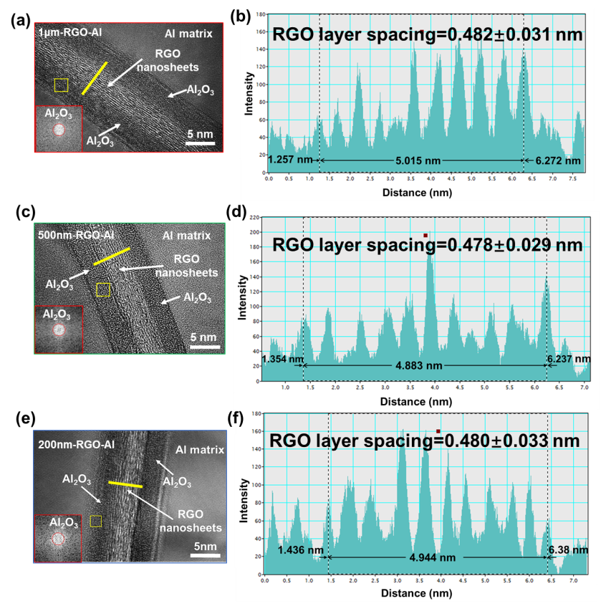
Fig. S1 (a), (c) and (e) are representative HRTEM images taken at the inter-lamella interface of the RGO-Al composites with the Al lamella thickness of 1 μm, 500 nm and 200 nm, respectively. (b), (d) and (f) show the intensity profiles along the yellow line perpendicular to the RGO layers in (a), (c) and (e), respectively. The average RGO layer spacings based on 5 intensity profiles obtained from 5 different positions of RGO layers for each of the three RGO-Al composites are marked in the corresponding intensity profiles.

Methods for the measurement of the RGO coverage on the RGO−Al composite powders
In order to quantitatively evaluate the coverage of RGO on the RGO−Al composites powders, we first obtained SEM images (20000×) of RGO−Al composite powders with ball-milling time of 1 h, 2 h, and 4 h, respectively, as shown in Fig. S2(a) − (c). And then the original SEM images were converted to their binary images using the image analysis software Image-Pro Plus 6.0 (Fig. S2(d)−(f)), where the dark parts are the surface covered by RGO. The area covered by the RGO were about 20% in all sample sets by analyzing more than 10 binary SEM images of the three RGO−Al composite flake powder with balling time of 1 h, 2 h, 4 h, respectively. Therefore, the total coverage at the resulting inter-lamella interfaces in the as-fabricated composites was at most 40%.

Fig. S2. (a), (b), and (c) are the typical original SEM images of RGO−Al flake powder with ball-milling time of 1 h, 2 h, and 4 h, respectively. (d), (e), and (f) are the corresponding binary SEM images of RGO-Al flake powders with ball-milling time of 1 h, 2 h, and 4 h, respectively.

Fig. S3. Typical cross-sectional TEM images of as-fabricated Al samples with Al powder ball milling time of (a) 1 h, (b) 2 h, and (c) 4 h, respectively.

Fig. S4. The grain size distribution in parallel with (d_{L}) and perpendicular to (d_{T}) the lamella (rolling) direction of elongated Al grains in the as-fabricated unreinforced Al samples with Al powder ball milling time of (a, d) 1 h, (b, e) 2 h, and (c, f) 4 h, respectively.

Methods for the measurement of average aspect ratio of RGO
Since the RGO layers of the three sets of composites (Al lamella thicknesses of 1 μm, 500 nm and 200 nm, respectively) underwent the same fabrication process, they shared similar thickness (~5 nm) and aspect ratios. Here the determination of the average aspect ratio of RGO layers in the composite having 200 nm Al lamella thickness is presented for illustration. The details of the measurement can be described as follows: first, the morphology of RGO−Al composite flake powders was obtained by SEM, and then we selected any two SEM images with the same magnification of 20000× [Fig. S5(a₁) and Fig. S5(a₂)], which were then converted to their corresponding binary images using the image analysis software Image-Pro Plus 6.0 [Fig. S5(a₃) and Fig. S5(a₄)]. Subsequently, we superimposed the binary SEM images of any two of the RGO−Al composite flakes using the image processing software (Adobe Photoshop CS5). The binary SEM image of superimposed RGO−Al composite flakes is shown in Fig. S5(a), where the dark parts are the surface covered by RGO. The size distribution of RGO nanosheets at the inter-lamella interfaces was evaluated by using Image-Pro Plus 6.0, as shown in Fig. S6. The average size of RGO in the lamella interfaces was 186±7 nm. Combined with the thickness of RGO (~ 5 nm), the average aspect ratio of RGO was evaluated to be 37.2±1.9.

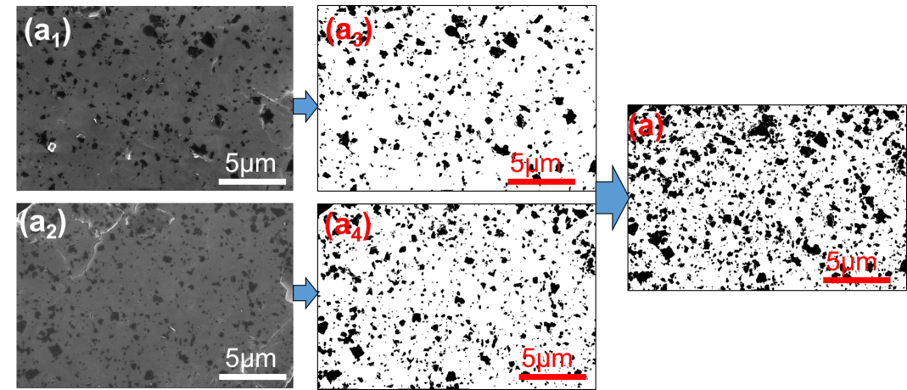
Fig. S5. (a₁) and (a₂) are any two SEM images of RGO−Al flake powders; (a₃) and (a₄) are the corresponding binary images of (a₁) and (a₂) obtained by using the image analysis software (Image-Pro Plus 6.0); (a) is the binary SEM image of superimposed RGO−Al composite flakes using the image processing software (Adobe Photoshop CS5).

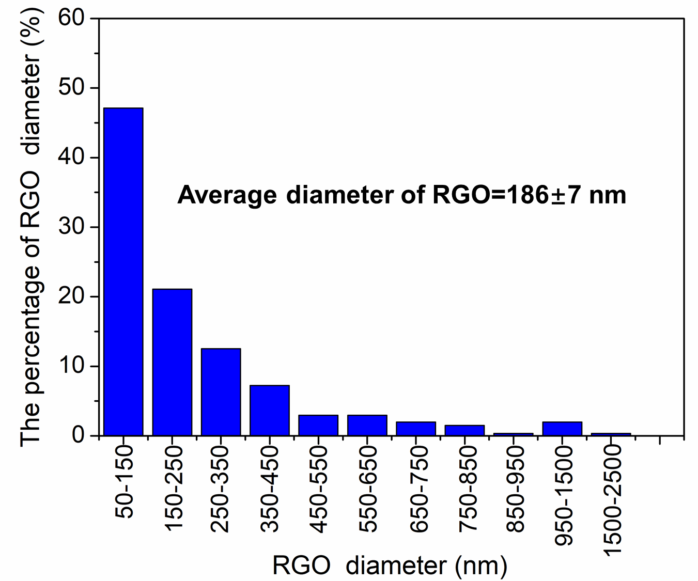
Fig. S6. The size distribution of RGO nanosheets at the lamella interfaces of as-fabricated RGO−Al laminated composites with 200 nm Al lamella thickness.

Fig. S7. Typical dark field (DF) TEM images of the dislocation structure in the interior of an individual Al lamella, taken from post-deformation unreinforced Al matrix with the Al lamella thickness of (a) 1 μm, (b) 500 nm and (c) 200 nm, respectively. (a) (b) (c) were taken under double-beam condition from the [011] zone axis and the (200), (11$\overline{1}$) and (02$\overline{2}$) diffraction vector of Al, respectively. The diffraction vectors are indicated by yellow arrows. The densely entangled lines in Al lamella interior of (a) and (b) are entangled dislocation lines.

References
[1] Z. Li, Q. Guo, Z. Li, G. Fan, D.B. Xiong, Y. Su, J. Zhang and D. Zhang: Nano Lett., 2015, vol.15, pp. 8077–83.
[2] Z. Li, G. Fan, Z. Tan, Q. Guo, D. Xiong, Y. Su, Z. Li and D. Zhang: Nanotechnology, 2014, vol. 25, pp. 325601.
[3] X.L. Guo, Q. Guo, Z.Q. Li, G.L. Fan, D.-B. Xiong, Y.S. Su, J. Zhang, C.L. Gan and D. Zhang: Scripta Mater., 2016, vol. 114, pp. 56–59.

