Supplementary Material
50F | 50M
Figure 1: HIC of impact at different speeds (centerline).

50F | 50M
Figure 2: HIC of impact at an offset of 25% tram width at different speeds.

50F | 50M
Figure 3: Probability for AIS1 head injury (DAMAGE) at centerline.

50F | 50M
Figure 4: Probability for AIS1 head injury (DAMAGE) at an offset of 25% tram width.

50F | 50M
Figure 5: Probability for AIS2 head injury (DAMAGE) at centerline.
50F | 50M
Figure 6: Probability for AIS4+ head injury (DAMAGE) at centerline.

50F | 50M
Figure 7: Probability for AIS4+ head injury (DAMAGE) at an offset of 25% tram width.

50F | 50M
Figure 8: Lateral deflection of HBM after impact.

Figure 9: Injury risk for femur proximity for impact on baseline and modified tram front for 50th percentile female HBM.

Figure 10: Injury risk for femur proximity for impact on baseline and modified tram front for 50th percentile male HBM.

Figure 11: Injury risk for femur shaft for impact on baseline and modified tram front for 50th percentile female HBM.

Figure 12: Injury risk for femur shaft for impact on baseline and modified tram front for 50th percentile male HBM.

Figure 13: Injury risk for tibia shaft for impact on baseline and modified tram front for 50th percentile female HBM.

Figure 14: Injury risk for tibia shaft for impact on baseline and modified tram front for 50th percentile male HBM.
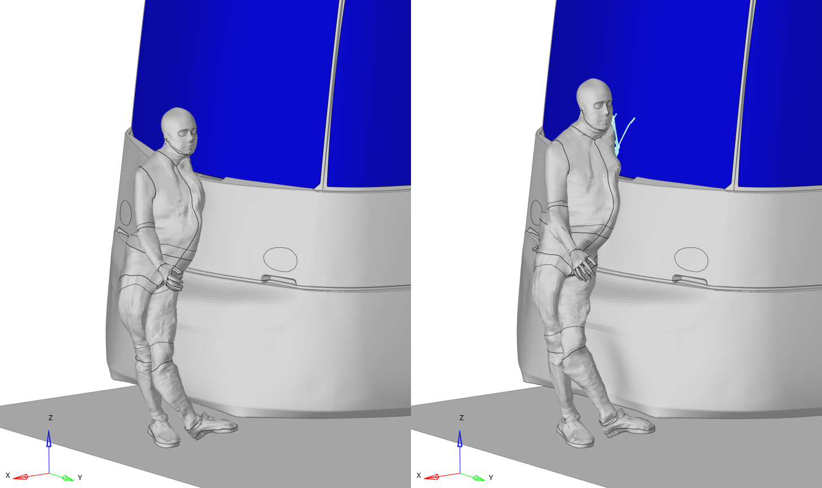
Figure 15: Centerline impact of 50F (left) and 50M (right) HBM on baseline tram front at 30ms simulation time (tram speed: 50 kph).
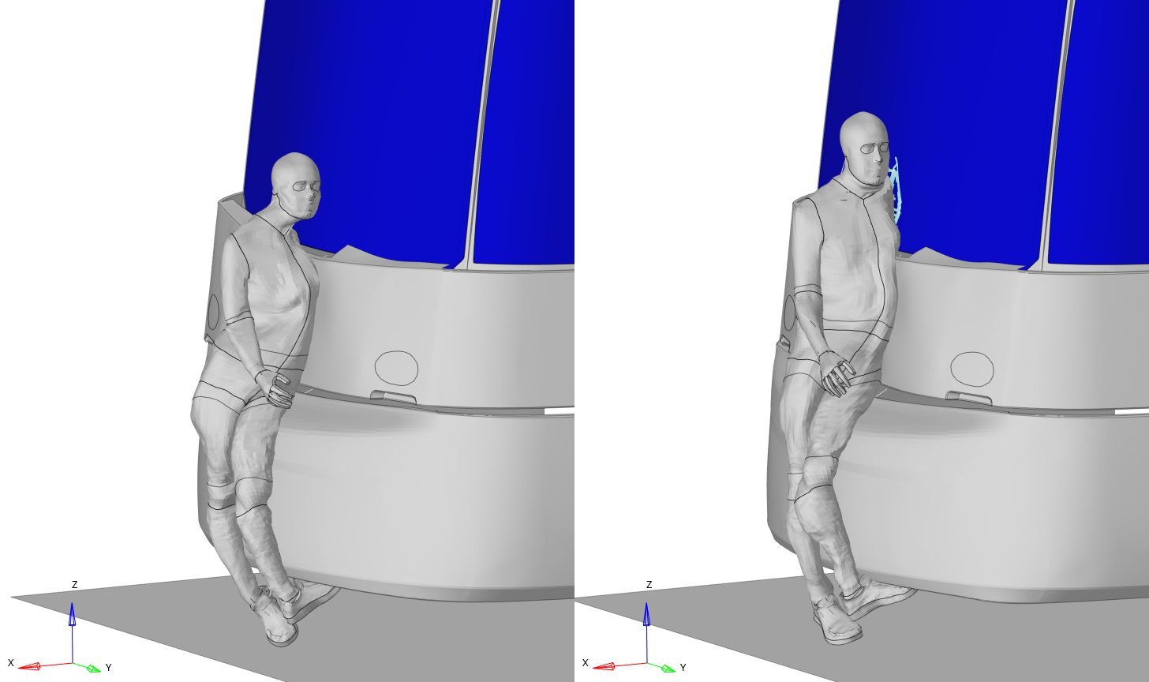Figure 16: Centerline impact of 50F (left) and 50M (right) HBM on modified tram front at 30ms simulation time (tram speed: 50 kph).
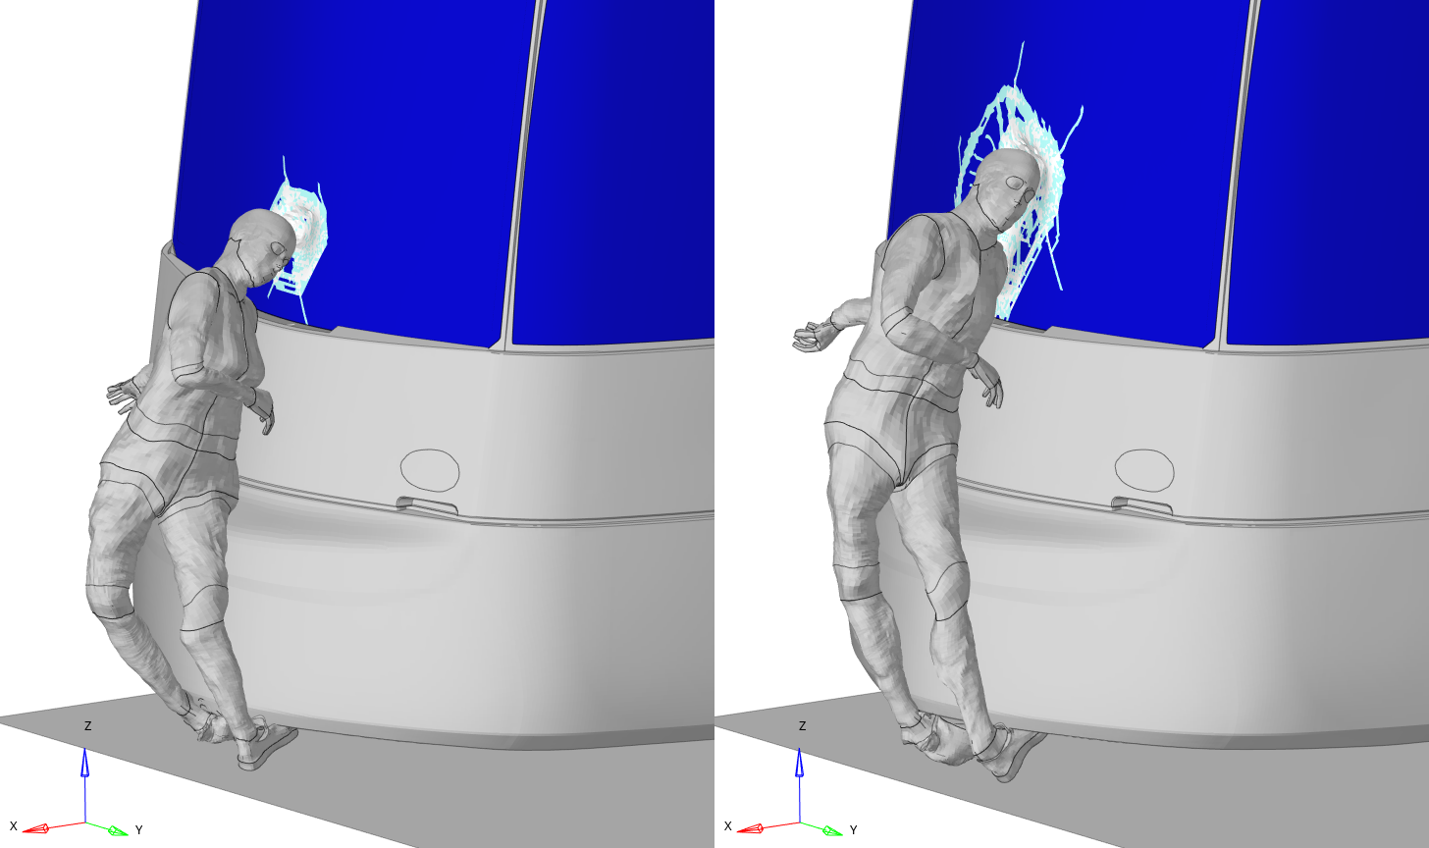
Figure 17: Centerline impact of 50F (left) and 50M (right) HBM on baseline tram front at 60ms simulation time (tram speed: 50 kph).
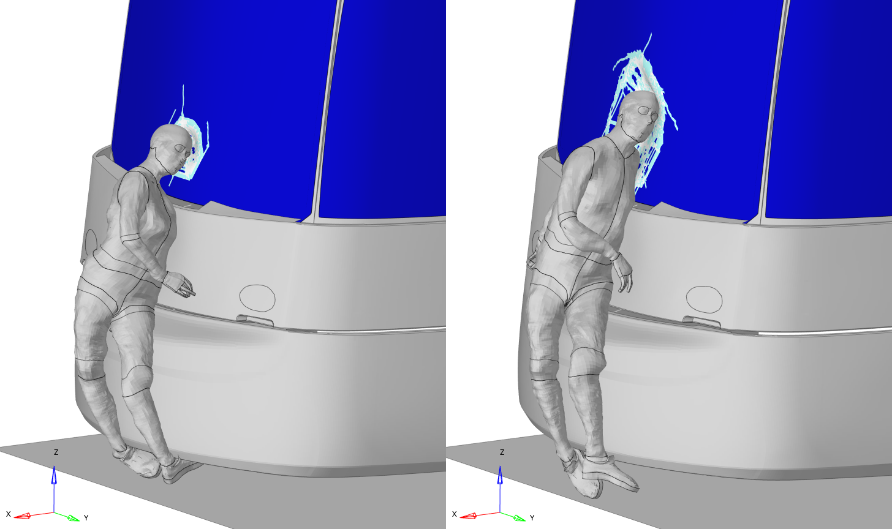
Figure 18: Centerline impact of 50F (left) and 50M (right) HBM on modified tram front at 60ms simulation time (tram speed: 50 kph).
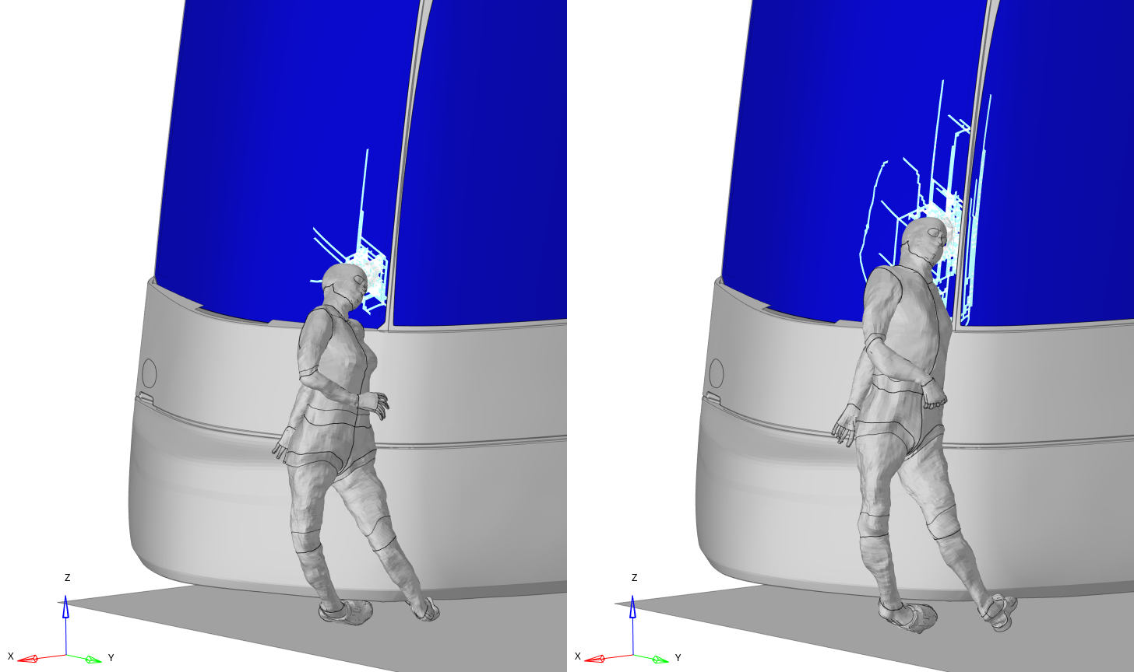
Figure 19: 25% offset impact of 50F (left) and 50M (right) HBM on baseline tram front at 60ms simulation time (tram speed: 50 kph).
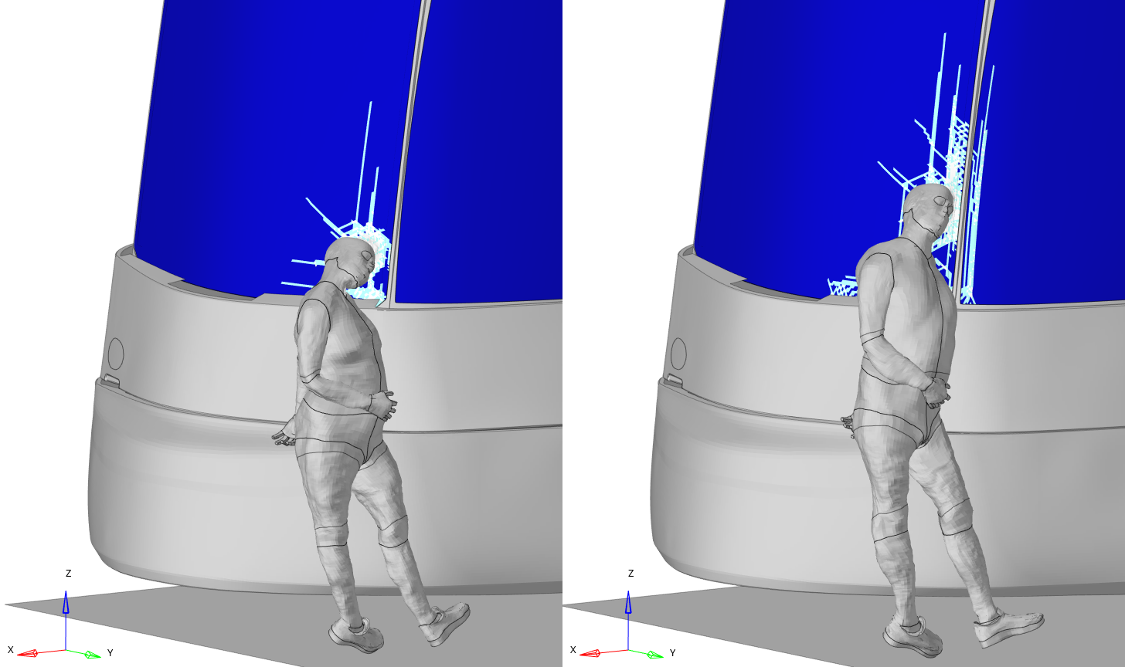
Figure 20: 25% offset impact of 50F (left) and 50M (right) HBM on modified tram front at 60ms simulation time (tram speed: 50 kph).
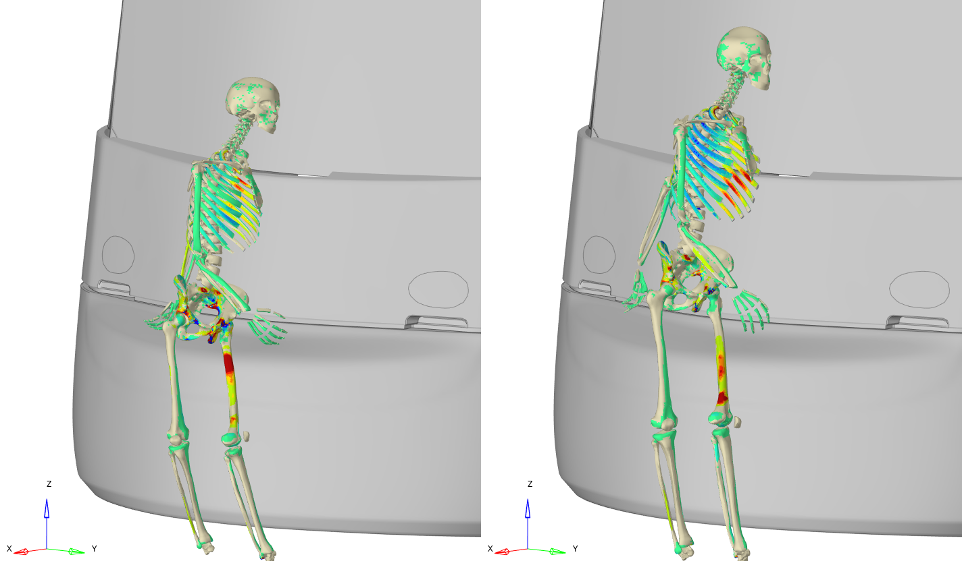
Figure 21: Centerline impact of 50F (left) and 50M (right) HBM on baseline tram front at 60ms simulation time (tram speed: 25 kph).
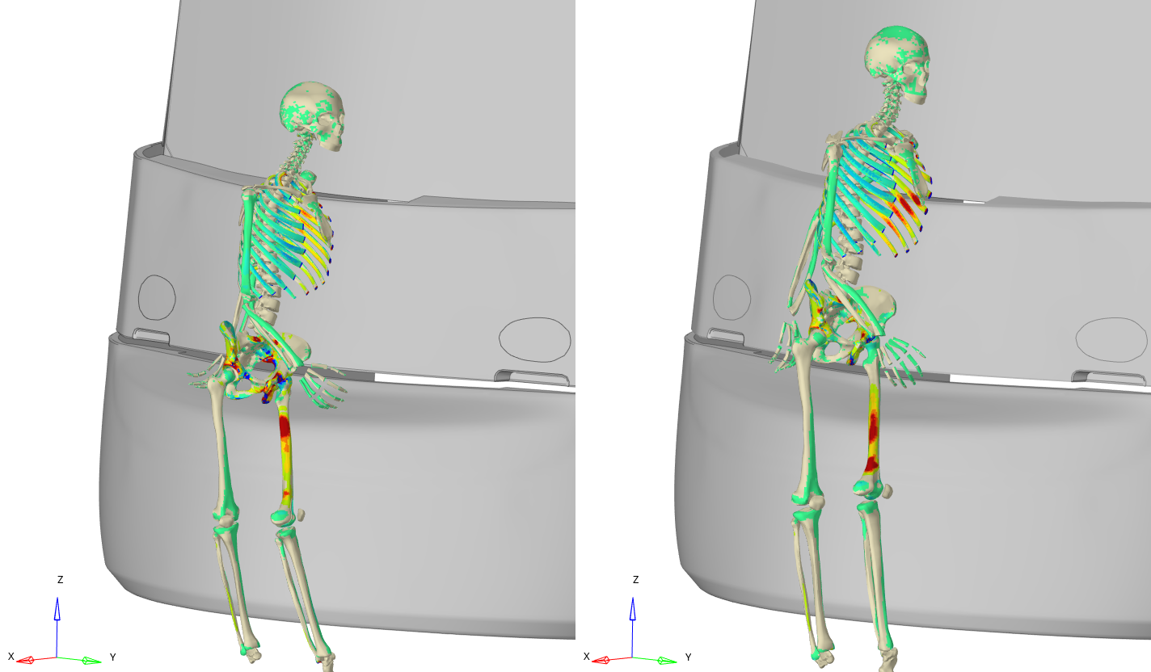
Figure 22: Centerline impact of 50F (left) and 50M (right) HBM on modified tram front at 60ms simulation time (tram speed: 25 kph).

Table 1: Occurrence probability for different collision speeds of tram to pedestrian collisions based on Lackner et al. (2022)
Collision speeds tram Range [km/h] | Occurrence probability
0 – 10 | 0.0253
10 – 15 | 0.0805
15 – 20 | 0.1149
20 – 25 | 0.1471
25 – 30 | 0.1241
30 – 35 | 0.0943
35 – 40 | 0.0897
40 – 50 | 0.3034
50 – 60 | 0.0207

Table 2: Results of the overall injury assessment for pedestrian to tram scenarios based on the predicted injuries and the occurrence probability.
Concussion injuries
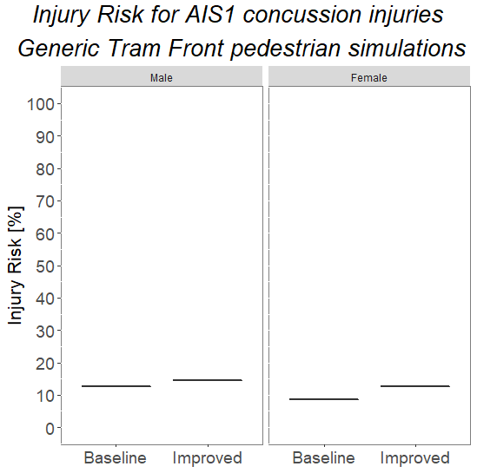 | 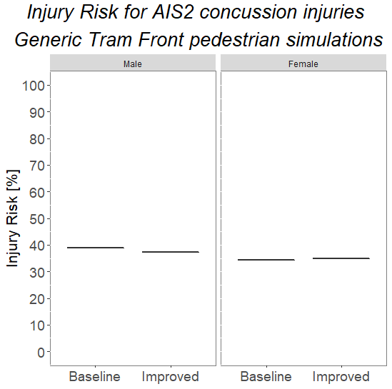 |  | 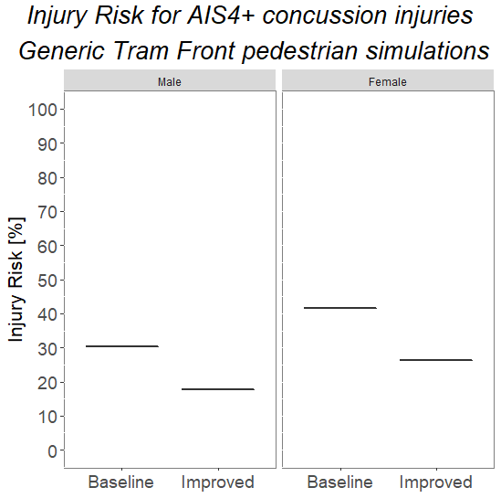
Other skull/brain injuries
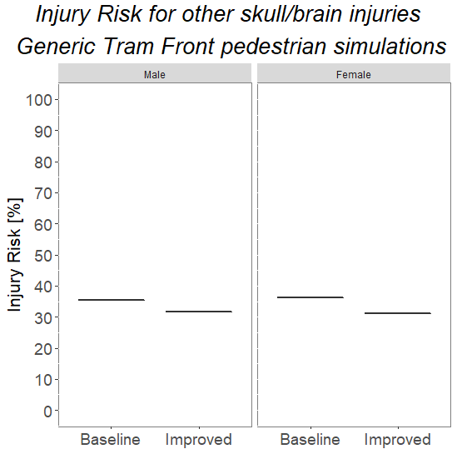
Rib injuries
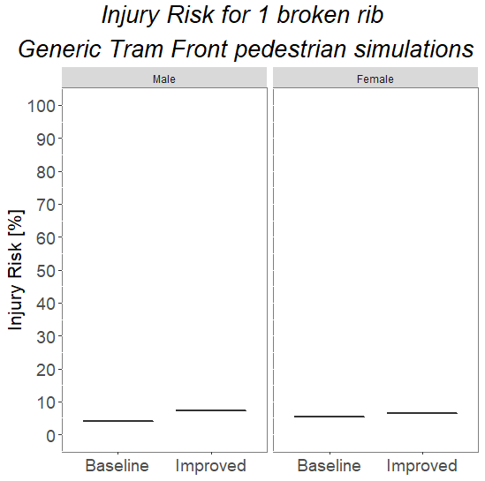 | 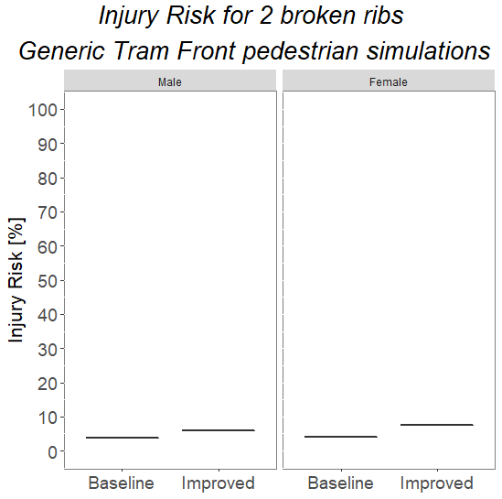 |  | 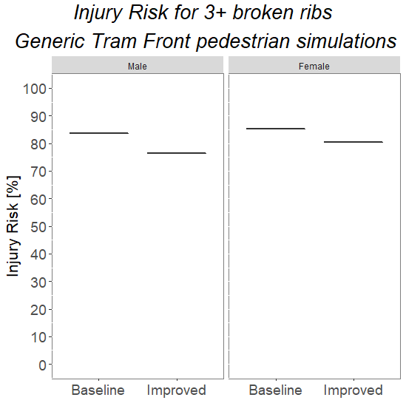
Hip injuries
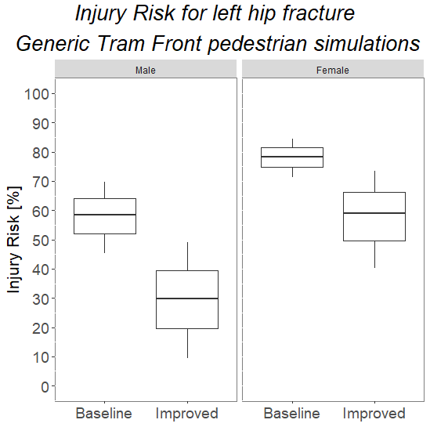 |  | 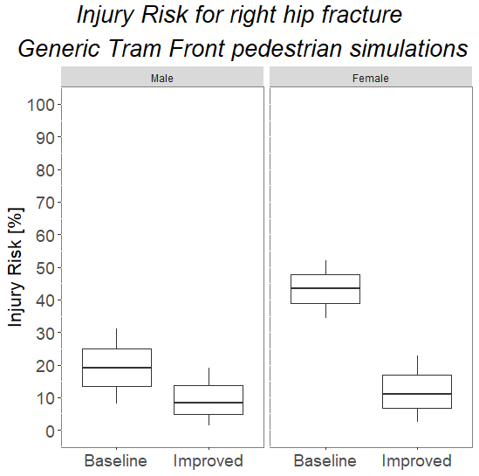
Femur injuries
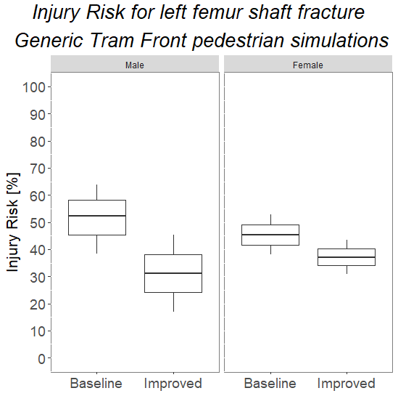 |  | 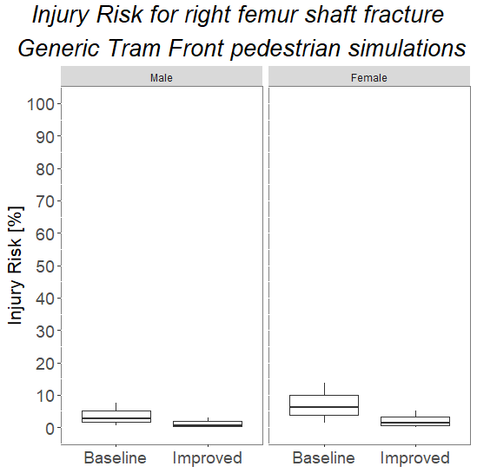
Tibia injuries
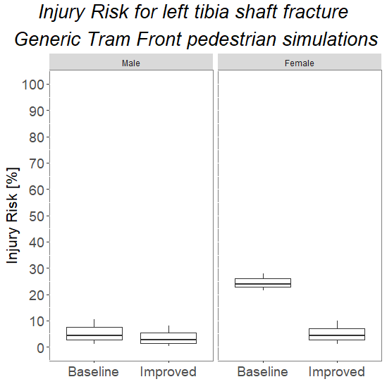 |  | 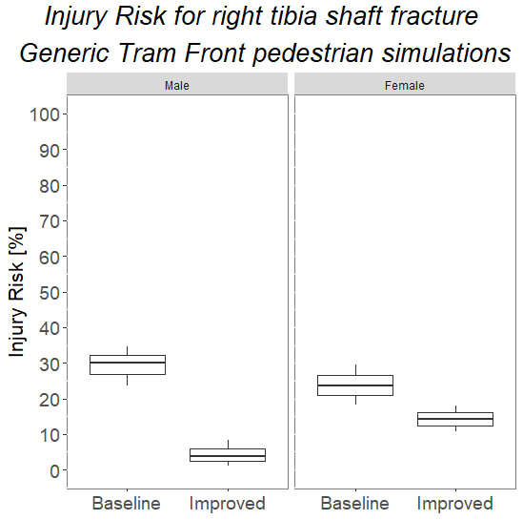

Table 3: Results of the overall injury assessment for pedestrian to tram scenarios based on the predicted injuries and the occurrence probability.
