Local Interactions and Homophily Effects in Actor Collaboration Networks for Urban Resilience Governance

Qingchun LI,1 Ali MOSTAFAVI2

¹ Ph.D. Candidate, Zachry Department of Civil and Environmental Engineering, Texas A&M University., College Station, TX 77843-3136; e-mail: qingchunlea@tamu.edu
² Associate Professor, Zachry Department of Civil and Environmental Engineering, Texas A&M University, College Station, TX 77843-3136; e-mail: amostafavi@civil.tamu.edu

SUPPLEMENTARY INFORMATION:

Survey question to collect the collaboration data:

The next question focuses on understanding the collaborations and relationships among key organizations and how they work together in dealing with catastrophic events such as Hurricane Harvey. In the months or years prior to Hurricane Harvey, to the best of your knowledge, did you or any other employee from your organization collaborate or work directly with any of the organizations listed below on flood mitigation efforts? If so, how frequent has been such collaboration? Note: You may leave a row blank if you have not had any interaction with an organization. | 1 Daily  2 Weekly  3 Monthly  4 Several times per year  5 Not at all

Survey questions to identify respondents’ preferences to the developed policy actions:

Here are some policy actions that could be taken to reduce the dangers of future flooding in the Houston area. To the best of your knowledge, please indicate your organization’s level of opposition or support for each of the following policy options. | 1 Strongly Oppose  2 Oppose  3 Neutral  4 Support  5 Strongly Support

The Markov Chain Monte Carlo diagnostic plots of ERGMs
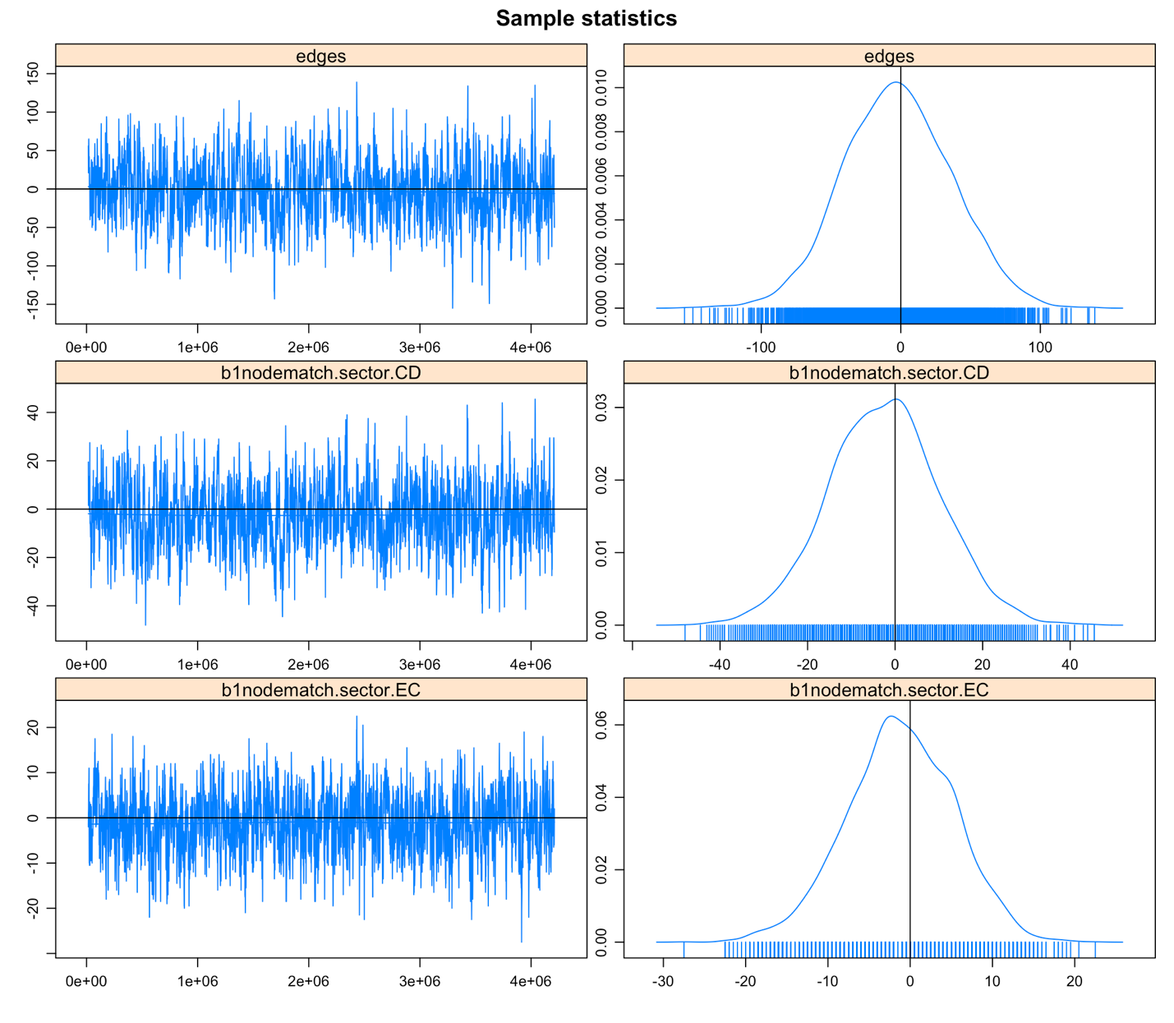
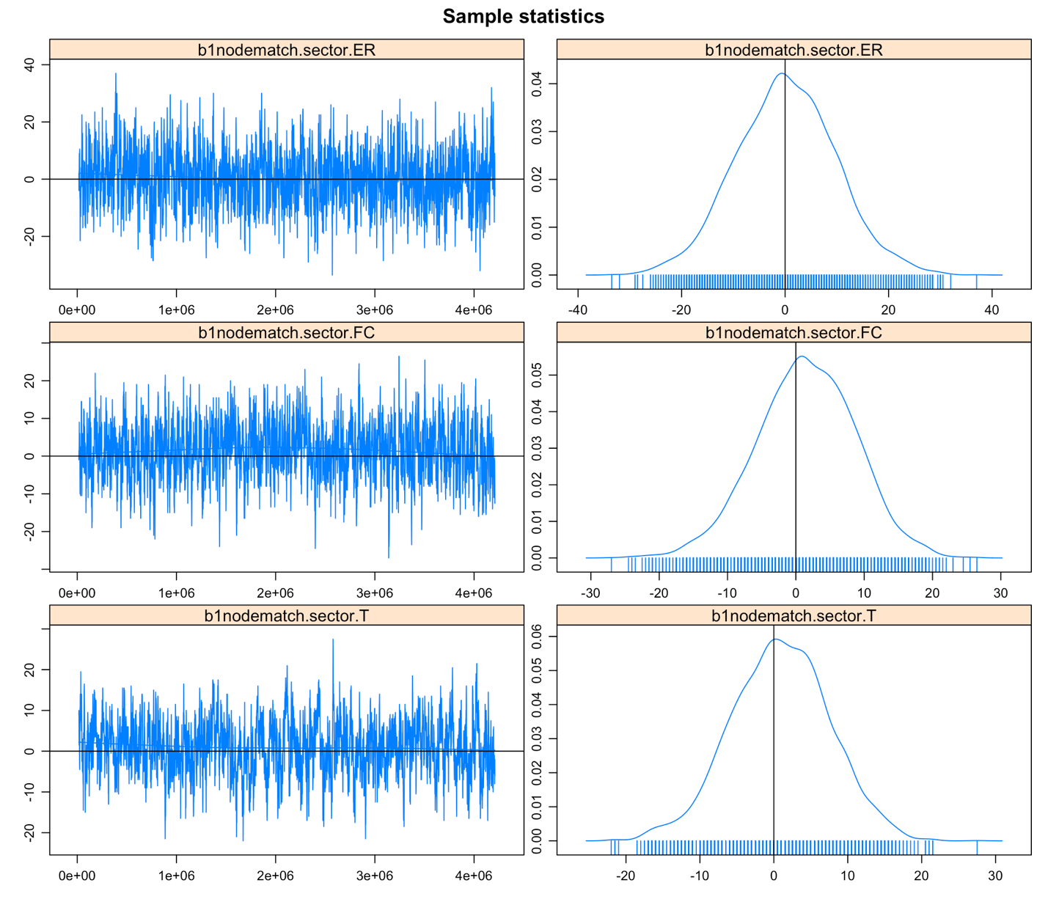
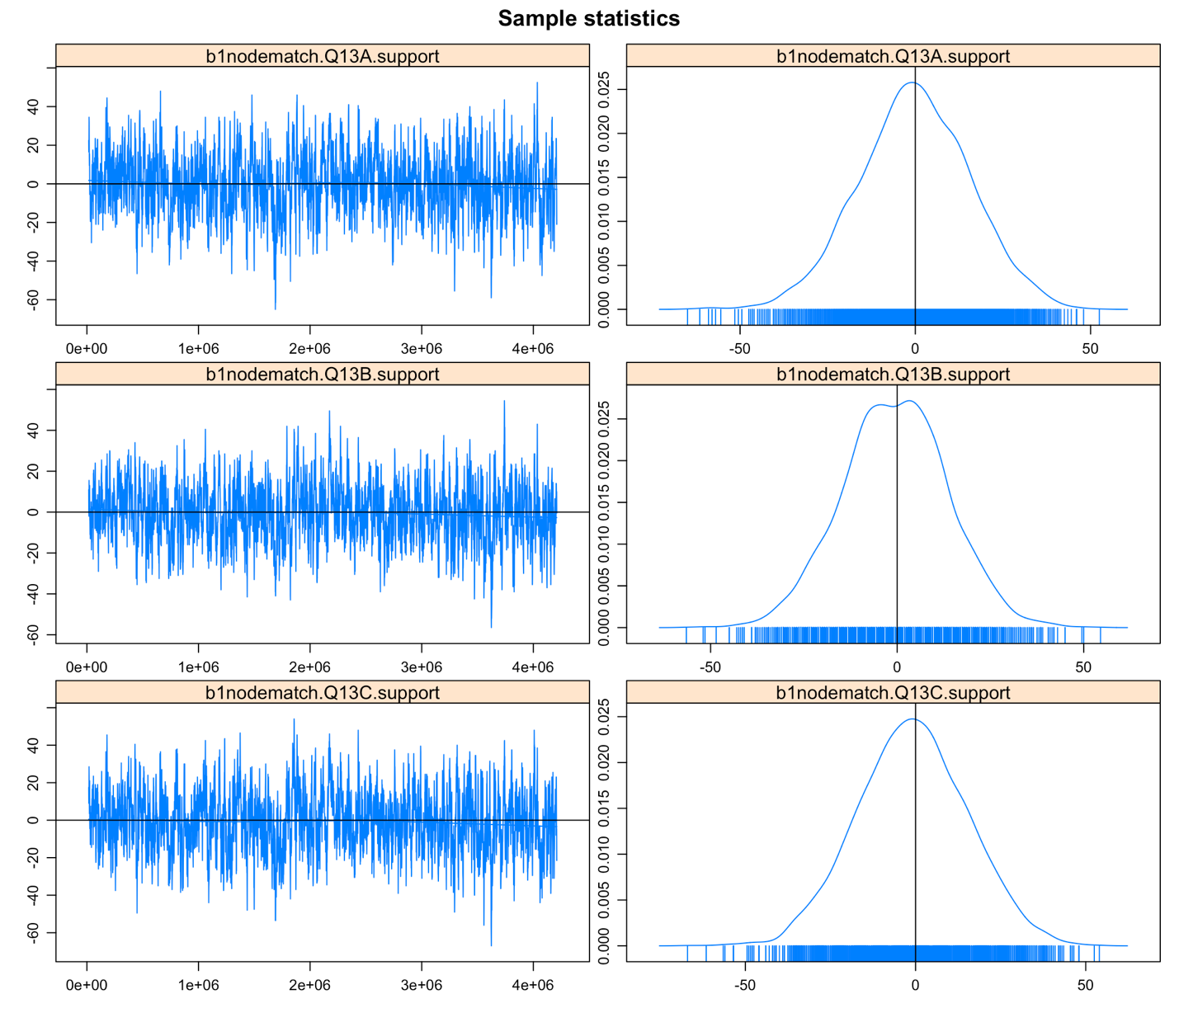
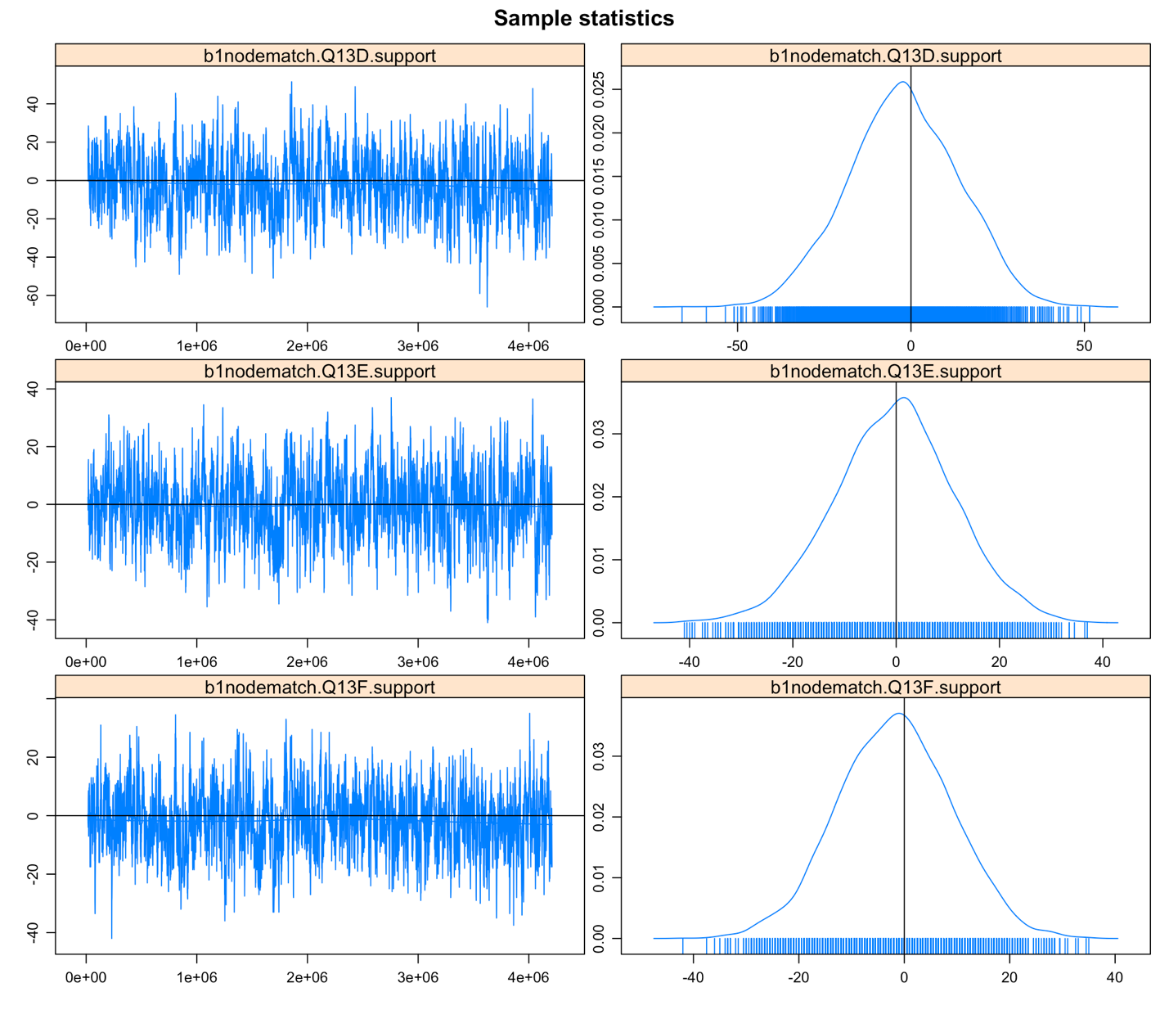
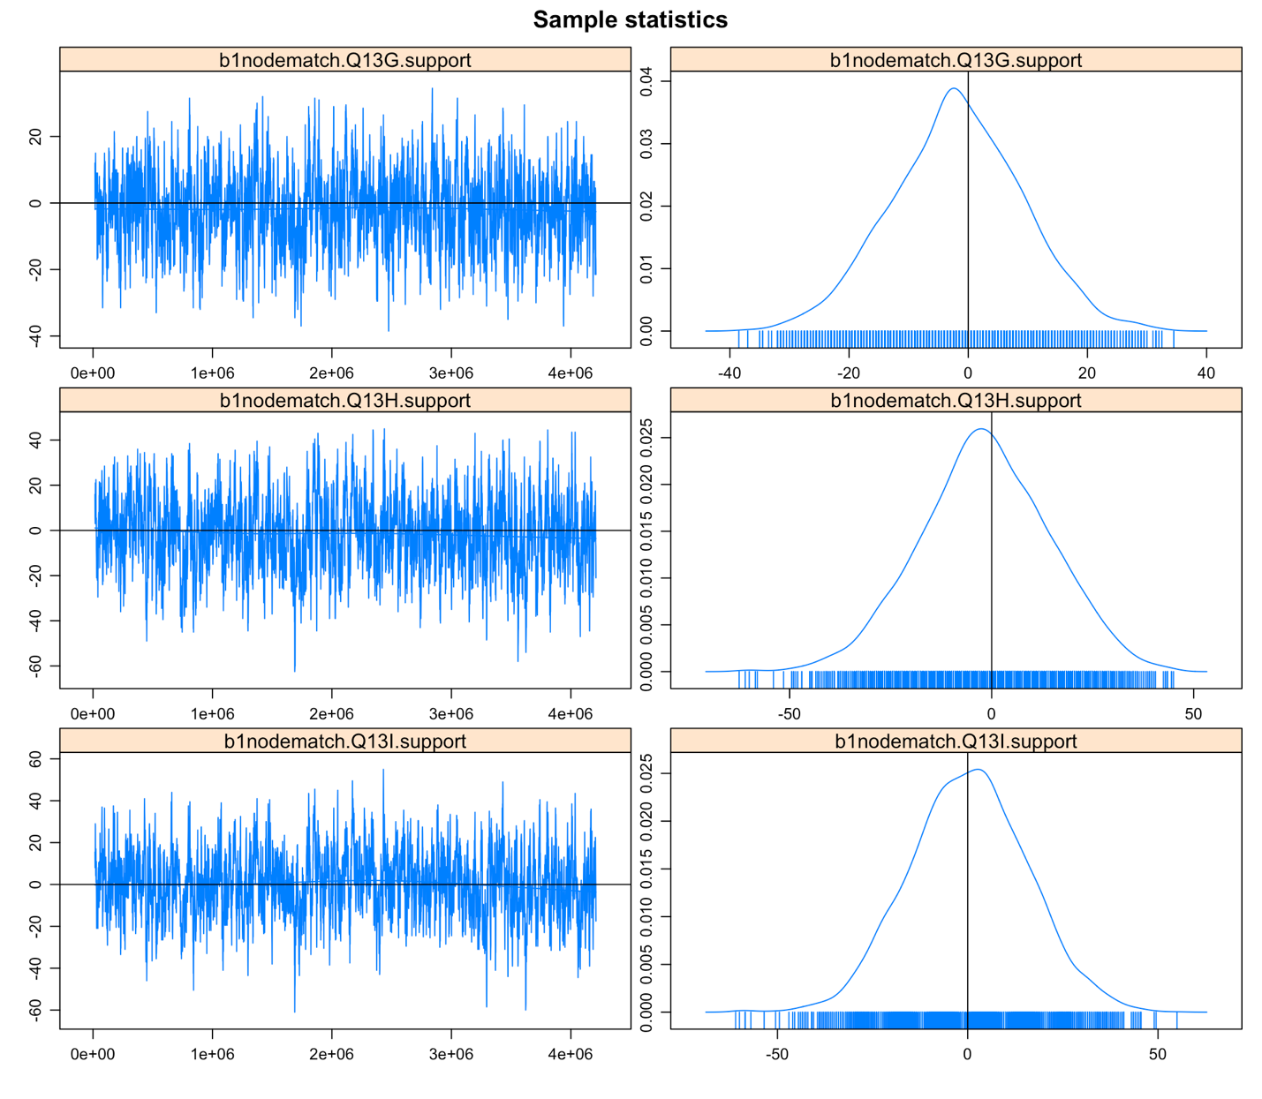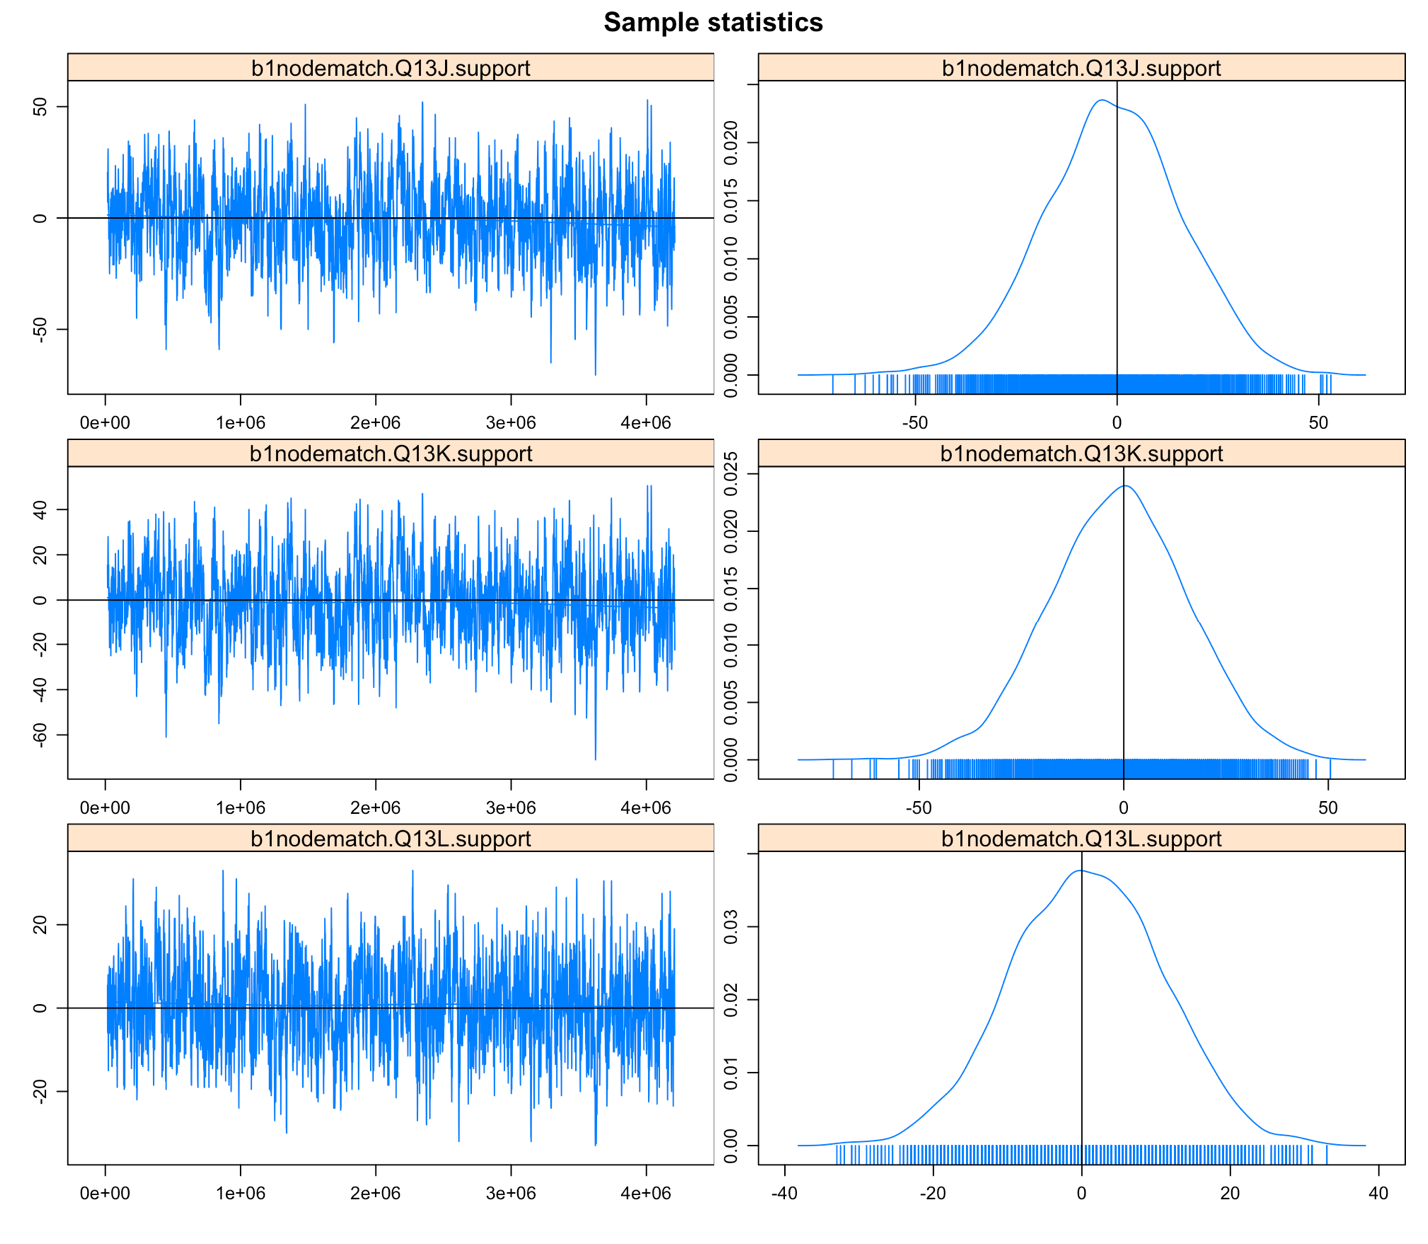
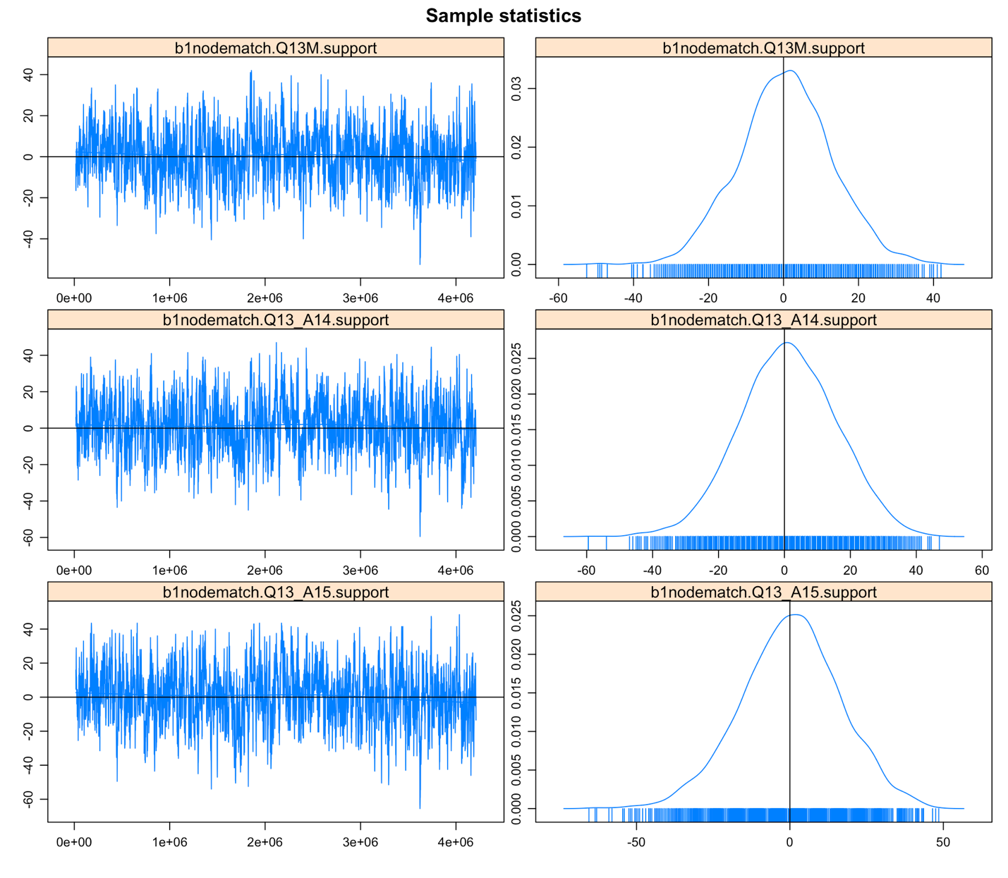

Figure S1. The MCMC diagnostic plots ERGMs: survey questions Q13A~Q13A16 in the figure represent flood risk reduction policy actions P1 ~ P16 (Table 1) in the paper.

